Theatre Network Australia
Annual Report 2021

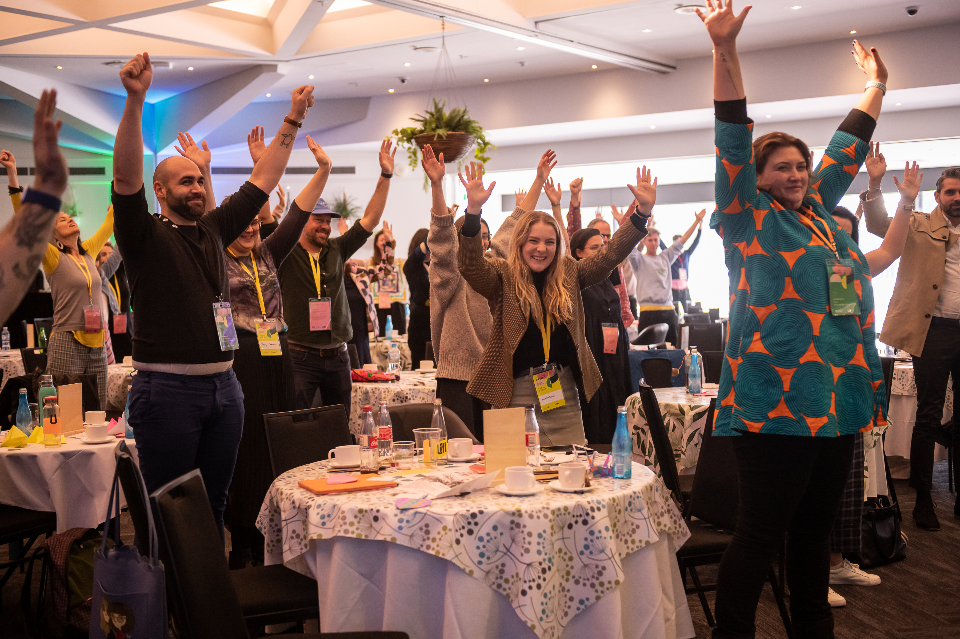

Neighbourhood Gathering at APAM in Adelaide. Photo by Sam Oster – Silvertrace Photos.

Acknowledgement of Country

Wherever we are in Australia, TNA acknowledges the traditional custodians of the unceded lands, and we give thanks for the care and custodianship of the land and waterways by Aboriginal and Torres Strait Islander people for tens of thousands of years.
We especially acknowledge the people of the Kulin nation where our office is based, on the southern banks of the Birrarung river.
We pay our respects to Elders past and present.

Contents

About TNA 4

Reports 5

Advocacy 11

Research and Resources 13

Capacity Building 17

Networks and Connections 24

Celebration and Support 30

Communications 32

Governance and Management 34

About TNA

Founded by the sector in 2009, TNA strengthens artists and arts organisations, influences cultural policy, facilitates critical debate and networking, and advocates for a safe, healthy and relevant sector.

TNA believes in the central role that creativity plays in a society.

- We work towards a more diverse and fairer performing arts sector that puts First Nations people first.
- We value independent artists, small to medium companies and large organisations, and we want greater interconnections between them.
- We believe in life-long learning. We support different models of working, and we value flexibility.
- We advocate for fair pay and conditions for our sector. We know that risk and experimentation are important.
- We foster ongoing, respectful and challenging conversations that connect us, open new ideas, and lead to a stronger sector.

In practical terms this means TNA:

- Runs industry forums
- Delivers workshops on current issues for the sector
- Drives advocacy campaigns in partnership with other service organisations and the sector
- Undertakes and promotes research and benchmarking
- Provides advice to industry, the education sector and government
- Provides information and resources through our popular E-News and the online resource library.

We design our work to address the gaps, and our approach is underpinned by a spirit of care, deep listening, and trust in the sector’s capacity to make progress.

‘I am grateful for the significant role that TNA plays in bringing people together, facilitating learning opportunities, and meaningfully promoting and advocating for artists and arts workers. TNA are a great bridge, between people, ideas, and to new ways of doing things.’
- Kam Greville, Arts Wellbeing Collective

Reports

Chair’s Report

I acknowledge the First Nations people of Australia – the oldest living culture in the world who for over 60,000 years have built our cultural history across art, song, dance, and storytelling.

In this context, we have so little time to make a commitment to our artists during our own working lives, which is why it has been an absolute privilege and pleasure to join the TNA Board ten years ago, and subsequently, to become the Chair, alongside my former roles as General Manager of Playbox and the Geelong Arts Centre.

From this work, I understand how the artistic success of our nation has been built on the work of our First Nations artists, and more recently, what we now call the small to medium sector and independent artists across all artforms. They are the risktakers, without whom there is no commitment to our stories, exploration of form, equity, and diversity.

But it must be said that when joining TNA, I never anticipated a decade of such debilitating and significant upheaval.

Thirteen years ago, TNA started as a project-based organisation to raise the profile of the sector as the founding companies witnessed the beginning of a significant funding decline. Two factors were in play – the growing recognition of the small to medium sector as a vital (but vulnerable) part of the sector alongside the major organisations, and reduced Australia Council funding.

This was exacerbated by the transfer of funds from the Australia Council to the Department in Canberra in 2014/2015. The numbers say it all. Between 2013 and 2016, the number of Australia Council grants for individuals dropped by a staggering 70 per cent, from 1,340 to 405 and, since then, over 70 small to medium companies have been defunded.

This is one of the many reasons we have seen the work of TNA become increasingly important. Rather than feeling powerless to help in the face of an unprecedented undermining of the fundamentals, in TNA we have an advocacy body with an industry-based board and staff that have stepped up activity and support.

We have an advocacy body that has ensured that the sector is at the table for policy development and is driving peak body and grass roots advocacy.

But its work goes beyond policy and advocacy. During the pandemic disruptions, TNA staff took their lead from members who were asking for help, and quickly adapted to provide analysis and clarification on the mass of information relating to operations during the pandemic and support available. Furthermore, TNA’s Crisis Cash campaign supported over 360 artists with money to cover urgent costs.

In other initiatives, TNA’s salary survey and the independents’ survey not only highlight the impact of underfunding on pay and conditions for staff and arts workers, but they also provide benchmarks for salary and conditions improvement strategies.

TNA has also shown sector leadership with the development of its Equity Action Plan (EQAP), based on the knowledge that we must embed transformational change and pursue genuine justice and equity within all areas of our work, including governance, staffing, programming, and engagement.

TNA programs including peer-learning, the VIPI program and the Victorian and Australian Theatre Forums, have looked to the future with support for the next generation of leaders.

Finally, what we have learnt in the past two COVID years is that it is critical that the three tiers of Governments work in partnership with the artists, their audiences, and donors to ensure the arts remain essential to our lives wherever we live. Artists and audiences are in every community across this vast country.

The Federal Government’s welcome COVID-19 support of $500 million for various programs was in no small part due to a sustained advocacy effort by the whole performing arts sector, which highlighted not only the undeniable damage that COVID-19 inflicted on the industry, but also the unmet need for Government support with the success rate for applicants still very low.

Now, with the announcement and distribution of final RISE funds, there is great concern about the ongoing viability, let alone sustainability and growth, of the sector. We know that due to the impact of COVID-19, the sector has lost jobs, skills and companies and it needs an urgent injection of funds to rebuild. It is clear the hardest hit has been the small to medium companies and independent artists without which we put our major companies at risk. We need investment to be made within a robust national plan, so that it is strategic, long-term and sustainable.

Despite all the welcome pandemic interventions, the Federal Parliamentary Inquiry agreed in their bipartisan report – Sculpting a National Cultural Plan: Igniting a post-COVID economy for the arts – that without a National Plan there is no strategic way forward. Furthermore, there are still many fundamental issues to be addressed, not the least of which are unfunded excellence, indexation of grants, cancellation insurance, cross portfolio initiatives, mental health support, a living wage and sick leave for casual arts workers.

To the TNA staff—Josh, Yuhui, Steph, Wen-Juenn and Nicole (and others over the years), who are tireless in their dedication to the sector – congratulations on everything you achieved in 2021 against all odds. This Annual Report has the details of the many TNA programs – it is amazing to again recognise how this dedicated team achieved so much in yet another tough year.

I also thank all the TNA Board members I have had the privilege of working with for their fearless advocacy and support over the years. We now have board members across the country who provide insight into the differing regional needs and issues.

Thank you also to our two major funding partners, Creative Victoria and the Australia Council for the Arts, and in particular all of the dedicated people in those agencies who managed emergency COVID-19 funding programs with unprecedented demand. Thank you also to the Myer and Besen Foundations for their support that has allowed TNA to diversify its programs, and thanks to the hundreds of donors and supporters for Crisis Cash and other TNA initiatives over the years.

Most importantly, I thank you, our members, for being the heart and soul of our organisation. Thank you for your generosity and frankness in discussing your challenges, which inform our work to ensure TNA can support you after the most turbulent two years we have ever experienced.

Jill Smith AM
Chair

Executive Director’s Report

I will focus this report on thanking people – TNA’s work during 2021 was enabled and enhanced by so many people that it feels appropriate to acknowledge them explicitly.

Firstly, thanks to our members for sticking with us and keeping us informed about the issues you faced day in and day out. Your stories and insights are what keep us grounded and committed to our goals. Thanks to the wider performing arts sector for getting through another tough year – our partners, participants and attendees, our officemates at APAM, our contractors, our funders, our media colleagues, the politicians, and advisers we work alongside, and all the amazing champions and donors of our Crisis Cash campaign.

TNA’s Chair Jill Smith AM has been on the TNA Board for ten years, including as Co-Chair from 2018 and Chair from 2019 to 2022, so I want to express my deepest and warmest appreciation for her dedication to TNA and the sector. Jill brought her passionate advocacy for the performing arts to her role with both intensity and diplomacy. Where necessary Jill will fight hard, especially for better conditions for independents and small to medium companies, but she keeps the arguments professional, strategic and forward looking, making the case with evidence and data.

As Chair of the board, Jill has empowered the TNA team, supporting us to go further and innovate programs as needed – this has been especially vital during the pandemic. When the team rolled out the Crisis Cash campaign for independents in 2020 and 2021, Jill used her extensive networks to help us raise money for over 360 $1,000 bursaries. As my go-to person for testing ideas and getting a sense check, Jill has been so supportive and responsive, making my work at TNA satisfying and helping me stay optimistic in the hard times. On behalf of the board, staff, members and the wider sector, we thank Jill for everything, and we wish her the very best in her many other roles and advocacy work in the arts and beyond.

My deep thanks to the rest of the TNA Board, especially the hard-working executive Erica McCalman, Caroline Bowditch and Lou Oppenheim. I thank departing board members Catherine Jones, Sam Routledge, Brad Spolding, Annette Vieusseux and Lyn Wallis. As always, the TNA board members bring deep and honest insight from their respective roles in the sector, and we thank them warmly for giving their time for the benefit of the sector.

As always, I give enormous thanks to the TNA team. Like most organisations there was a lot of change. Simone Schinkel, TNA’s incredible General Manager of almost five years, left at the beginning of the year to take up the CEO role at Music Victoria. Her work at TNA catapulted the organisation’s capacity and resilience, and we are deeply grateful forever. Rani Pramesti left TNA to move out of the arts. Rani's work on VIPI’s first two years was exemplary – she co-designed and rolled out a program which has been very successful and will have ripple effects throughout the independent sector for years to come. Tessa Leong also left TNA to focus on her role at Griffin and we thank her for her incredible support of our independents and creating the second Independent Theatre Workers report.

With three new excellent staff members in place – Joshua Lowe, Steph Cox and Wen-Juenn Lee, alongside myself and Yuhui Ng-Rodriguez as the old guard, and contractors Jonathan Homsey, Melinda Hetzel and Sam Ryan, we smashed through a huge amount of work – four programs as part of the ATF 2021 Deconstructed; the 2021 Small to Medium Salary Survey; four new databases; a leadership program for Indies; the final 120 Crisis Cash bursaries; dozens of info and peer learning sessions; and the Producers’ Mentorship, Unlocking Capacity and Salon programs of VIPI. We undertook further advocacy on support for our sector hit again by COVID, working towards performing arts being included in Support Act and giving advice to funding agencies on support programs, as well as being a partner on Creative Victoria’s Sustaining Creative Workers funding.

We also worked behind the scenes to help ensure the outcome of a bi-partisan recommendation for a National Cultural Plan as the top outcome from the Federal Inquiry into Creative Industries and Institutions. We created a video, with artist Amelia Ducker, showcasing work created with, for and by young people for international audiences through APAM and ASSITEJ International. We strengthened our relationships with the circus and physical theatre community through consultation, a Producers Club, and ongoing advocacy on the needs of the Victorian sector in light of the changes to Circus Oz. At the end of the year, we worked alongside fifteen other national peak bodies on united advocacy towards the 2022 federal election, then took the lead in developing messaging campaigns, toolkits and advocacy workshops to empower our sector.

We feel proud of the work we achieved, but we are aware that our sector isn’t out of the woods. The pandemic is with us for months and years ahead, and we know that we will need to keep on distilling information, advocating for support for the most vulnerable people, groups, and organisations, and finding ways to keep you connected and engaged and resilient. We will keep sharing the evidence that art and culture are essential to rebuilding a vibrant and healthy society; and that art and culture are not just found in the grand halls, but are everywhere; in our schools, in our workplaces, in public spaces, and in our homes.

Nicole Beyer
Executive Director

Treasurer’s Report

I am pleased to report that TNA (Theatre Network Au Inc.) has returned a small surplus of $8,639 for 2021, on a turnover of $933,636. This now means that the organisation has total reserves of $182,042 of which $87,000 is committed to TNA’s future work, specifically programming deferred from previous years due to the impact of COVID-19 shutdowns.

Given the ongoing challenges and volatility faced by our community as a result of the pandemic, and likely reductions in earned income sources in the immediate future, the Board is planning deficit budgets for 2022, and possibly into 2023. Therefore, our reserves will continue to enable TNA to successfully deliver its broad range of Victorian and national activities, supporting the sector to move from response and crisis mode back into an ongoing normalised operating model.

Revenue was reduced by $243k compared to 2020, with expenses also reducing by $166k. These impacts reflected the variability of business activity across both years due to the ongoing impacts of COVID-19 pandemic – in how and when activities were delivered, as well as the mixture of Government and other support available. The organisation continued to manage the VIPI program, as well as the 1000 x 1000 Crisis Cash donation campaign, facilitating $120k of support for individuals. Staffing levels were again supported in part by the Federal Government JobKeeper program.

I congratulate the executive team for their outward focused, strategic and financially sustainable management during another challenging and turbulent year, and for providing the organisation a strong foundation on which to continue its contribution to the sector as it rejuvenates.

Finally, we are sincerely grateful to all our partners, including our core recurring funding partners the Australia Council for the Arts, who allow us to service the national agenda, and Creative Victoria, for our home state programs and support of Victorian companies and independent artists and producers.

The 2021 audit was undertaken by Sean Denham and Associates and a full copy of the audited statements is available on request.

Lou Oppenheim
Treasurer

Advocacy

‘TNA is doing a remarkable job to keep artists motivated and feeling valued in this crisis.’
- Christos Linou, Independent

Advocating for the sector, in particular emphasising the needs and public value of the small to medium and independent sector, is one of TNA’s key roles.

TNA’s 2021 advocacy work included a focus on:

- COVID-19: TNA continued work consistently and clearly collating and sharing the devastating impacts that COVID-19 has had on the whole performing arts sector. We spoke up in the media, presented evidence to policy makers and politicians, and presented evidence of sector impact at roundtables/meetings with MPs, funding bodies, and philanthropists. We advocated for Support Act to be extended to all performing arts workers and advised on the criteria and the applications.

- Federal Election 2022: TNA began work preparing the sector for a potential late 2021/2022 federal election. Champions of Arts and Culture Meetups was a series of meetings every three weeks for members to hear about TNA’s advocacy approach and build their own skills to undertake local advocacy in their electorates. Two meetings were held in 2021, kicking off this program.

- Unified advocacy: Along with other peak bodies, TNA drove an effort to bring greater unity and collaboration amongst national peak bodies. Fifteen peak body representatives participated in a masterclass by consultants SEC Newgate, leading to an outcome of united messaging, to be rolled out in 2022.

- Victorian advocacy: TNA takes on an additional Victorian advocacy role as part of our dedicated Victorian program. In 2021 this included meetings with the Arts Industry Council Victoria (AICV); funding program advice to Creative Victoria; advocacy regarding the Creative Enterprise Program and Creative Ventures Program; advocacy regarding delayed funding announcements; and representing the sector at Industry Coordination Centre briefings regarding restrictions and support for the sector.

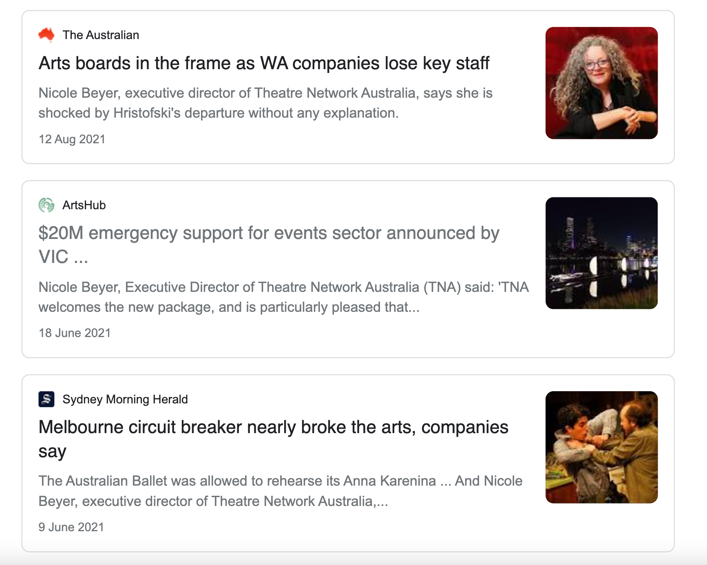

Media examples of TNA representing sector issues during 2021.

‘I would like to thank TNA for all their work throughout this whole mess. Your advice and advocacy has been extremely valuable. A massive virtual high five to you all. Keep up the incredible work.’
- Matt Kelly, The Listies

‘The work of TNA – its advocacy, programs, initiatives and opportunities has been invaluable in keeping both myself and others feeling informed, connected and aware of the strategic directions and goals, and issues concerning the arts sector and creative industries as a whole.’
- Nilgun Guven, Vitae Veritas / Rawcus Ensemble

Research and Resources

TNA 2021 Salary Survey Report for Not-for-Profit Small to Medium Arts Organisations

TNA’s annual Salary Survey Report for Not-for-Profit Small to Medium Arts Organisations captures the salaries, benefits, professional development budgets, tenure, and representation of small to medium organisations in the performing arts sector. In addition to benchmarking, it advocates for remuneration that is in line with similar roles in other sectors.

The 2021 Report, the seventh one conducted by TNA, garnered 87 valid responses. It found that the salaries of all surveyed roles have increased since 2019. Average salaries of General Managers/ Executive Producers increased 7% to $87,492, and Artistic Directors increased 5% to $86,309. We also found that although 70% of organisations increased the salary of at least one staff member in 2021, the financial strain was reflected in professional development budgets which decreased by 10% from 2019.

Diversity across organisations has stagnated; employment of Deaf and Disabled people in respondent organisations (2.7%) is still far below the rate of Deaf and Disabled people of working age (15 to 64) in the general population (9%). Employment of CaLD people in respondent organisations (10.5%) is also far below the rate of CaLD (non-Anglo-Celtic) people in the population (38%), and also lower than the rates recorded by the Australia Council’s Towards Equity report (16%), which reports data on all leadership of all funded organisations.

Advocacy Toolkit

TNA created a new Advocacy Toolkit, which aims to empower artists and arts workers, and give them the tools to be effective advocates, both for themselves and for the arts sector as a whole. The toolkit covers the basics of the three levels of government, who to contact, how to contact them, and a range of tips for advocacy messaging.

Circus and Physical Theatre (CaPT) Strategy 2021-2024

In collaboration with the CaPT committee, TNA created a CaPT Strategy. We contribute to a diverse, thriving, and sustainable CaPT sector by engaging deeply, supporting knowledge development, connecting people with opportunities and networks, and embedding CaPT advocacy into our programs.

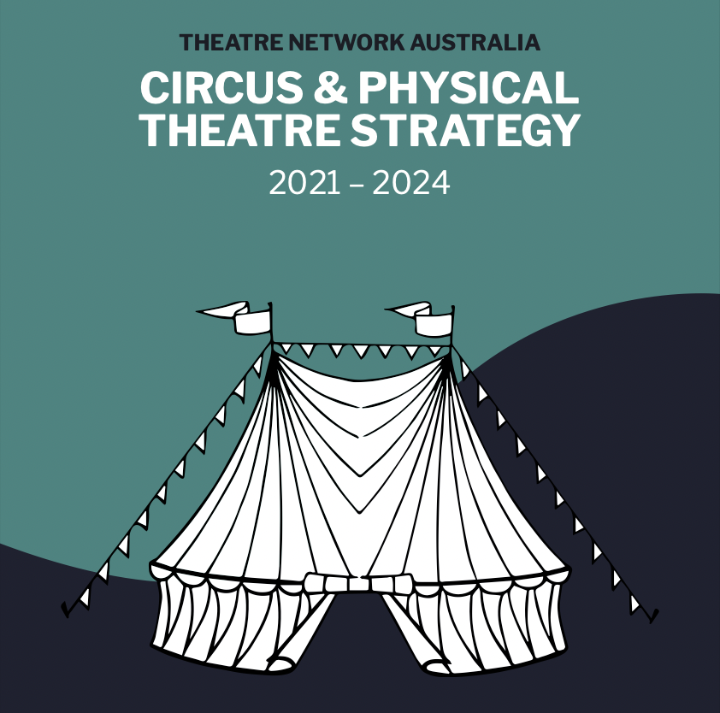
The Theatre Network Australia Circus and Physical Theatre Strategy 2021 –2025.

‘TNA works tirelessly towards understanding and addressing the issues that face the CaPT sector and the work they do with the CaPT Advisory Committee has resulted in a mobilised circus sector and supported the development of a cohesive and unified circus voice.’

- Devon Taylor, Women*s Circus

‘TNA plays a vital role in the support and facilitation of programs that will enhance the Australian arts sector.’

- Rowan Heydon-White, Circa

Resources for the Sector

TNA continues to provide an extensive library of sector-specific databases and resources:

- TNA sector resources: a range of resources collected by TNA to assist performing arts organisations and independents.

- TNA Member List: a list of all current 500+ TNA members by artform

- Policy Database: New in 2021. A database to assist performing arts organisations when developing their own policies, plans, and procedures.

- Australian Youth Circus Sector (AYCS) / training database: New in 2021. A database for Australian youth circuses, circus schools and training centres.

- Performing with/ for / by Young People Companies: New in 2021. A database of companies that create and present artistic work with, for, and/or by young people.

- CaPT Performing Companies Database: New in 2021. A database of Australian Circus & Physical Theatre (CaPT) performing companies.

- CaPT Resources: New in 2021. A list of Circus and Physical Theatre resources.

- Producers’ Database: A database for independent performing arts producers who support independent artists, independent collectives, and independent companies.

- Designers’ Database: A response to the gender inequity within technical design in the performing arts, this list of female, non-binary and trans designers is intended as a resource for theatre companies, collectives and individuals to hire more diversely in these areas.

‘I want to say how fabulous and valuable your Producers’ Database is, we are constantly sending people to check it out, or to sign up to it.’

- Selene Bateman, Auspicious Arts Projects

University Partnerships

University of Queensland – Creating Out Loud: Developing sustainable peer-mentoring to rebuild the arts post COVID-19
TNA continues our partnership with UQ researcher Dr Kate Power and Lead Industry Partners: Queensland Ballet, La Boite Theatre, Arts Nexus, and National Association of Visual Arts, on an Industry Reference group for this research project, evaluating the use of “Working Out Loud” (WOL) Circles within the arts sector.

‘Thank you for joining the Industry Reference Panel for my Advance Queensland Industry Research Fellowship, Creating Out Loud, which uses design thinking principles to develop a theoretically-informed and industry-tested peer coaching program for the arts. Your insight into the needs of the arts and culture sector, your extensive networks, and your enthusiastic support for the pilot project design and roll-out have already been critical to the success of this research.’
- Dr Kate Power, Business School, The University of Queensland

University of Melbourne – Creative Convergence, an Australian Research Council-funded Linkage Project (Final year)
This project aimed to gain a better appreciation of how young people seek out, interact with, and engage with theatre and other social media. Through evaluating arts engagement with young people in regional Victoria, partners sought to change our understanding of what a theatre event is in contemporary times for young people and how insights might be applied nationally and internationally. TNA partnered with The University of Melbourne research team and other project partners: Arena Theatre Company, Arthur, Bell Shakespeare, Geelong Performing Arts Centre, HotHouse, Melbourne Theatre Company (MTC), Creative Victoria and Regional Arts Victoria.

Capacity Building

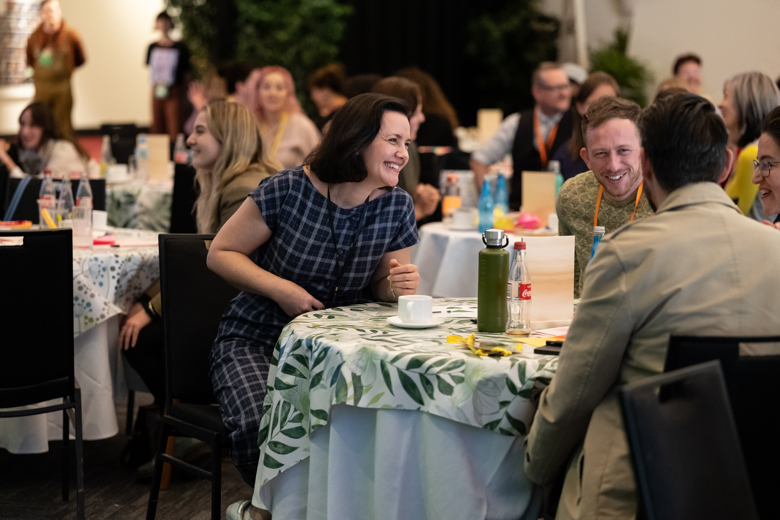

Neighbourhood Gathering at APAM in Adelaide. Photo by Sam Oster – Silvertrace Photos.

Capacity Building Online

In 2021 TNA has continued to adapt to the rapidly changing conditions of COVID 19, presenting opportunities for the sector to connect online. These included: small executive leader meetups, TNA Champions of Arts and Culture Meetups, APAM panel discussion ‘Arts Advocacy – We Are Essential,’ an information session on RISE funding, peer discussion on the Victorian Creative Enterprises Program, and a peak body forum towards an arts and cultural plan.

Throughout TNA’s programs we ensure we address our five access and equity objectives:

- First Nations First
- Justice and Diversity
- Safe Theatres/Workplaces
- Access and Inclusion
- Gender Equity

Peer Discussion on the Creative Enterprises Program (23 September)
'Thank you again for taking the time to facilitate our peer discussion on the Creative Enterprise funding. So appreciated!'

- Tessa Spooner, La Mama

Executive Leader Meetups (May–August)
‘The executive leader meet ups have been a great opportunity to connect with colleagues. At this point in the pandemic there is an incredible cathartic need to share and laugh together. With all of us trapped inside our own organisational bubbles, sometimes you need an outside voice to reach out. Thank you to the team at TNA for being there and helping us get together – one Zoom at a time’.

- Ro Bright, Snuff Puppets

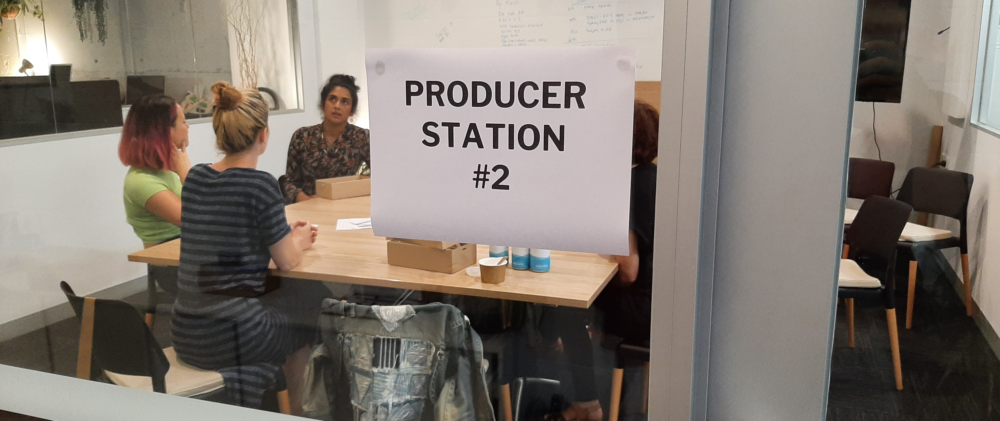

VIPI Salon: Producers’ Gathering 29 January at Theatre Network Australia, Southbank.

The Victorian Independent Producers Initiative (VIPI)

VIPI is a major sector development program that TNA began in mid-2019 and continued to deliver successfully throughout 2020 and 2021. This initiative was established to support independent producers, and through them, independent artists and companies in the performing arts. VIPI is an initiative of the Victorian Government through Creative Victoria, delivered in partnership with TNA, comprising three key programs: VIPI Salons, Producers Mentorship Program, and Unlocking Capacity Grants.

In 2021 TNA continued Rounds 1 and 2 of the Producers Mentorship Program and commenced Round 3. We rolled out Unlocking Capacity Grants: Round 2 and administered the application process for Round 3 grants, which continue into 2022.

VIPI 2021 Highlights:

VIPI Salon: Producers’ Gathering (29 January)
VIPI Salon: Cultural Safety in a Disability Context, facilitated by Caroline Bowditch from Arts Access Victoria (26 February)
VIPI Salon: Indie Artists x Indie Producers Gathering (23 April)
VIPI Networking at Showcase Victoria (19 May)
Unlocking Capacity Grants – Round 2 Recipients: Sonya Suares, Freya Waterson, Malia Walsh, Kath Papas
Producers Mentorship Program – Round 3 Cohort: Jenny Gay, Monique Grbec, Ching Ching Ho, Ripley Kavara, Luke Morris, Charice Rust, Melody Shotade, Aïsha Trambas

Unlocking Capacity and Producers Mentorship Program 2019–2021 (paid roles)
Total number of Independent Producers Funded | 29
Producers who identify as Culturally and Linguistically Diverse and/or People of Colour | 15
Producers who identify as Deaf/Disabled | 5
Producers who are based regionally | 3
Producers who are First Nations | 1
Total number of Producers from target groups | 24

‘I also wanted to highlight the role of TNA, as members of staff often brought great standpoints from their advocacy work and connections from their networks.’
- Lana Nguyen, Independent Producer

‘The acceptance of and redefining of the independent producing practice allowed me to build confidence and a sense of place within the sector, and from a regional context.’

- Tegan Nash, Independent Producer

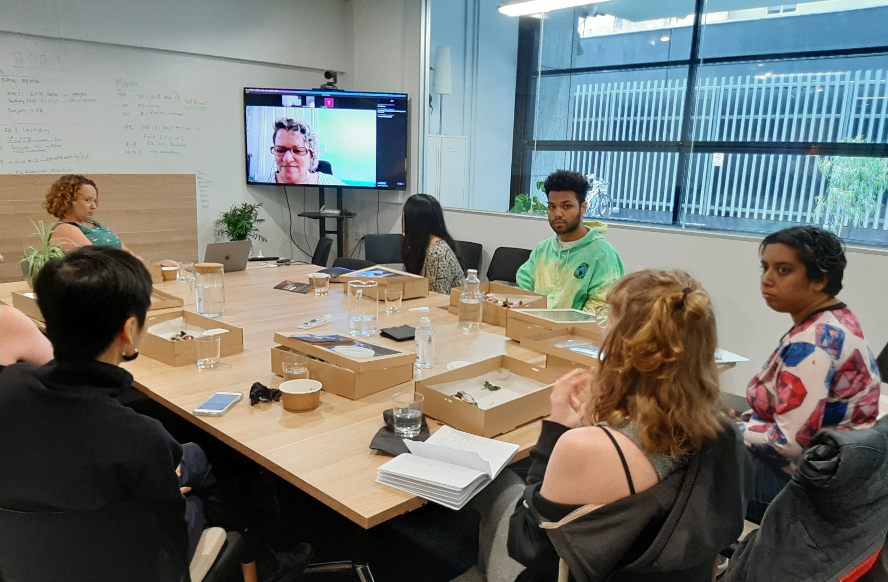

Power Play session 15 January at Theatre Network Australia.

Power Play (October 2020–March 2021)

The Power Play program continued, supported by Creative Victoria, as a paid strategic leadership program with the aim to develop and support ten independents in the performing arts: Ching Ching Ho, Bron Batten, Jack Sheppard, Deanne Butterworth, Lana Nguyen, Steph Cox, Harley Mann, Tiara S, Eliki Reade and Desiree (Dasha) Tan.

‘[Thank you] for allowing me to be part of a supportive and substantial community, a connection which has been lacking throughout my independent practice.’
- Ching Ching Ho, Independent

‘I was exposed to many amazing, transformative ideas around leadership, power, advocacy and support. There were so many great conversations, that came from this space, that inform my practice, and on top of that, I was paid and fed!’

- Eliki Reade, Independent

Circus and Physical Theatre (CaPT)

As the peak body for Circus and Physical Theatre in Australia, TNA is deeply committed to a strong future for this sector. TNA’s CaPT Advisory Committee holds deep and broad connections to independents, companies, and supporting organisations and stakeholders. In 2021, Program Manager, Steph Cox, in collaboration with the CaPT Advisory Committee developed several sector-specific bulletins, opportunities, and resources including two new sector databases.

CaPT Industry Panel: International Touring in 2022 – Realities and Expectations for Independent Circus Companies (10 November, online)
TNA invited a panel of CaPT artists and producers to share the current complexities of international touring. Panellists included Aisling Galligan (Underbelly Festival), Wolfgang Hoffmann (Aurora Nova), Danielle Kellie (Circa), Marty Evans (Circa), and Jake Randell (Gravity & Other Myths).

Circus Producers’ Club (August–October, online)
TNA hosted bi-monthly meetups, in person and online, where CaPT producers could connect, work through challenges, and share successes.

Victorian Circus Companies Forum (20 December)
TNA hosted a meeting of key Victorian Circus Companies to discuss sector’s needs, particularly in light of the possible closure of the Collingwood building managed by Circus Oz.

‘I really enjoyed [TNA’s] ‘Mapping the Sector’ discussion, it provided me with a much greater understanding of how the other half of decision-making operates. It gave me a broader view of how to use my tools for advocacy.’

- Harley Mann, Na Djinang Circus

Performance With / By / For Young People

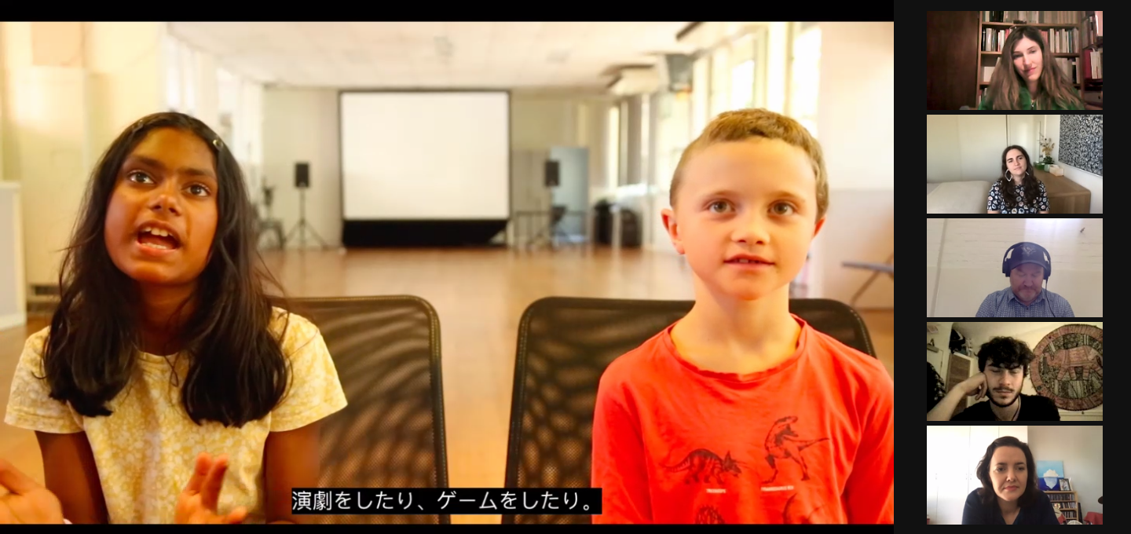

A screenshot from the online screening of TNA’s ASSITEJ Video, showing Joyee and Augie from House of Muchness.

ASSITEJ Video
With funding from the Australia Council, TNA commissioned a 15-minute video showcasing the incredible diversity of work made with, by, and for young people in Australia. We presented the video at the ASSITEJ International Congress in March 2021, the Australia Council’s China/Australia session at APAM in May 2021, and TNA’s Neighbourhood gathering at APAM at DreamBIG.

ASSITEJ Video and list of 55 participating artists and companies.

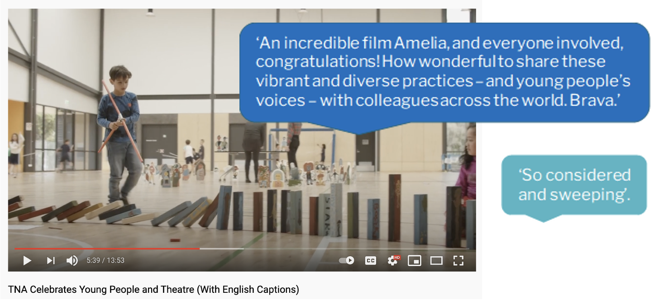

Screenshot and chat responses alongside the online screening of the ASSITEJ Video.

Visibility and Advocacy
During 2021 we worked in partnership with ATYP to develop a new database for companies making work with, for and by young people. This database creates greater visibility of the sector, showcases the great diversity of practice, and is a first port of call to investigate the over seventy companies included.

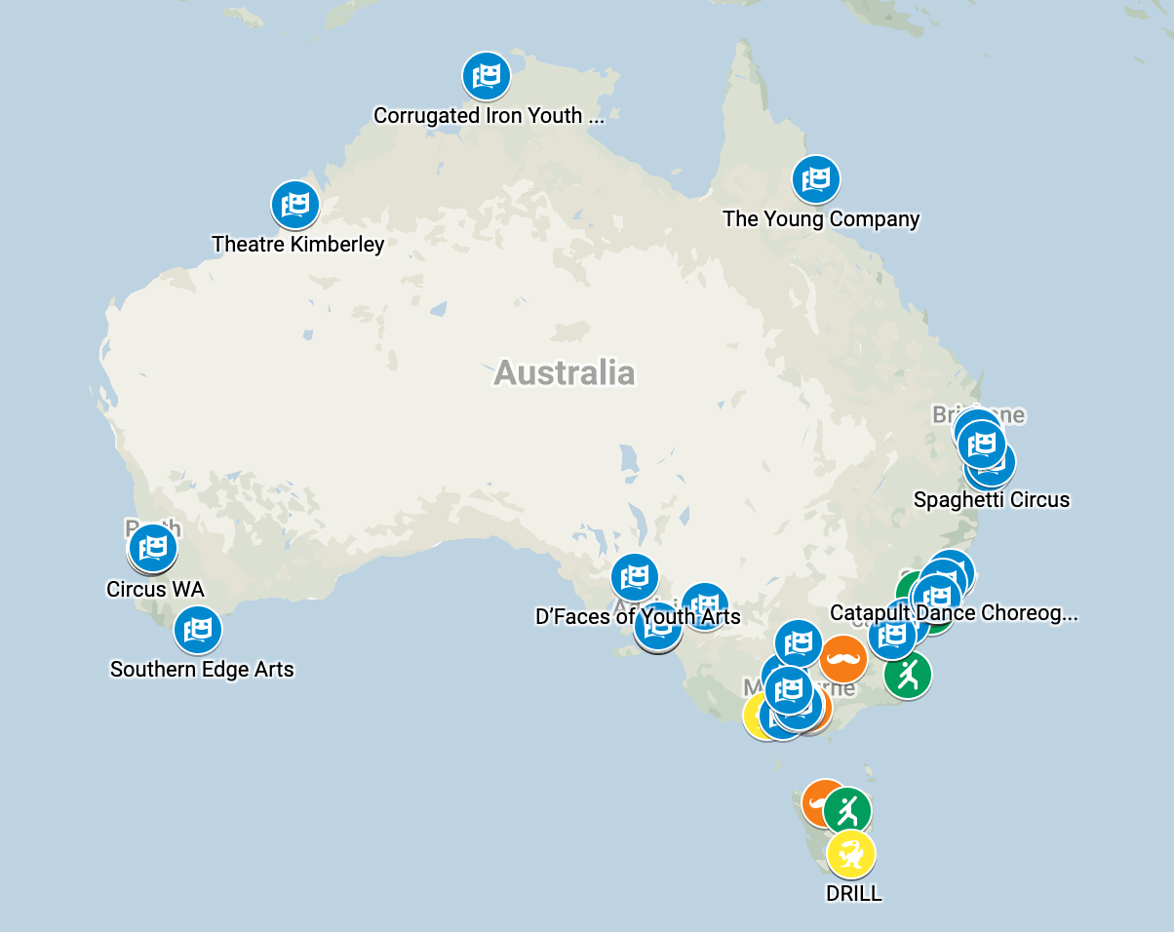

Screenshot of the live map associated with TNA’s new database of Australian companies that create professional artistic work with, for, and/or by young people.

During 2021 we also worked with this sector to advocate for a national Young People and Culture Strategy – through meetings with Australia Council leadership, inclusion in submissions and media coverage, and our work towards the 2022 federal election.

Networks and Connections

‘Thanks for supporting me to come to Neighbourhood. I felt cared for, catered for and welcomed. As a regional Victorian mostly working by myself … it was a lovely sense of being part of something big and precious and worthwhile.’

- Joanne Watt, Independent

‘I really feel elevated from learning, connecting with people and watching shows with friends and colleagues. It was the absolute complete package. Thank you again, this support was so brilliant.'

- Malia Walsh, Independent Producer

The Australian Theatre Forum – Deconstructed

The Australian Theatre Forum, run by TNA, is a landmark meeting place for Australian industry professionals. In 2021 ATF took place in a deconstructed, COVID-19 responsive form. We delivered four different events, in person and online, across the year.

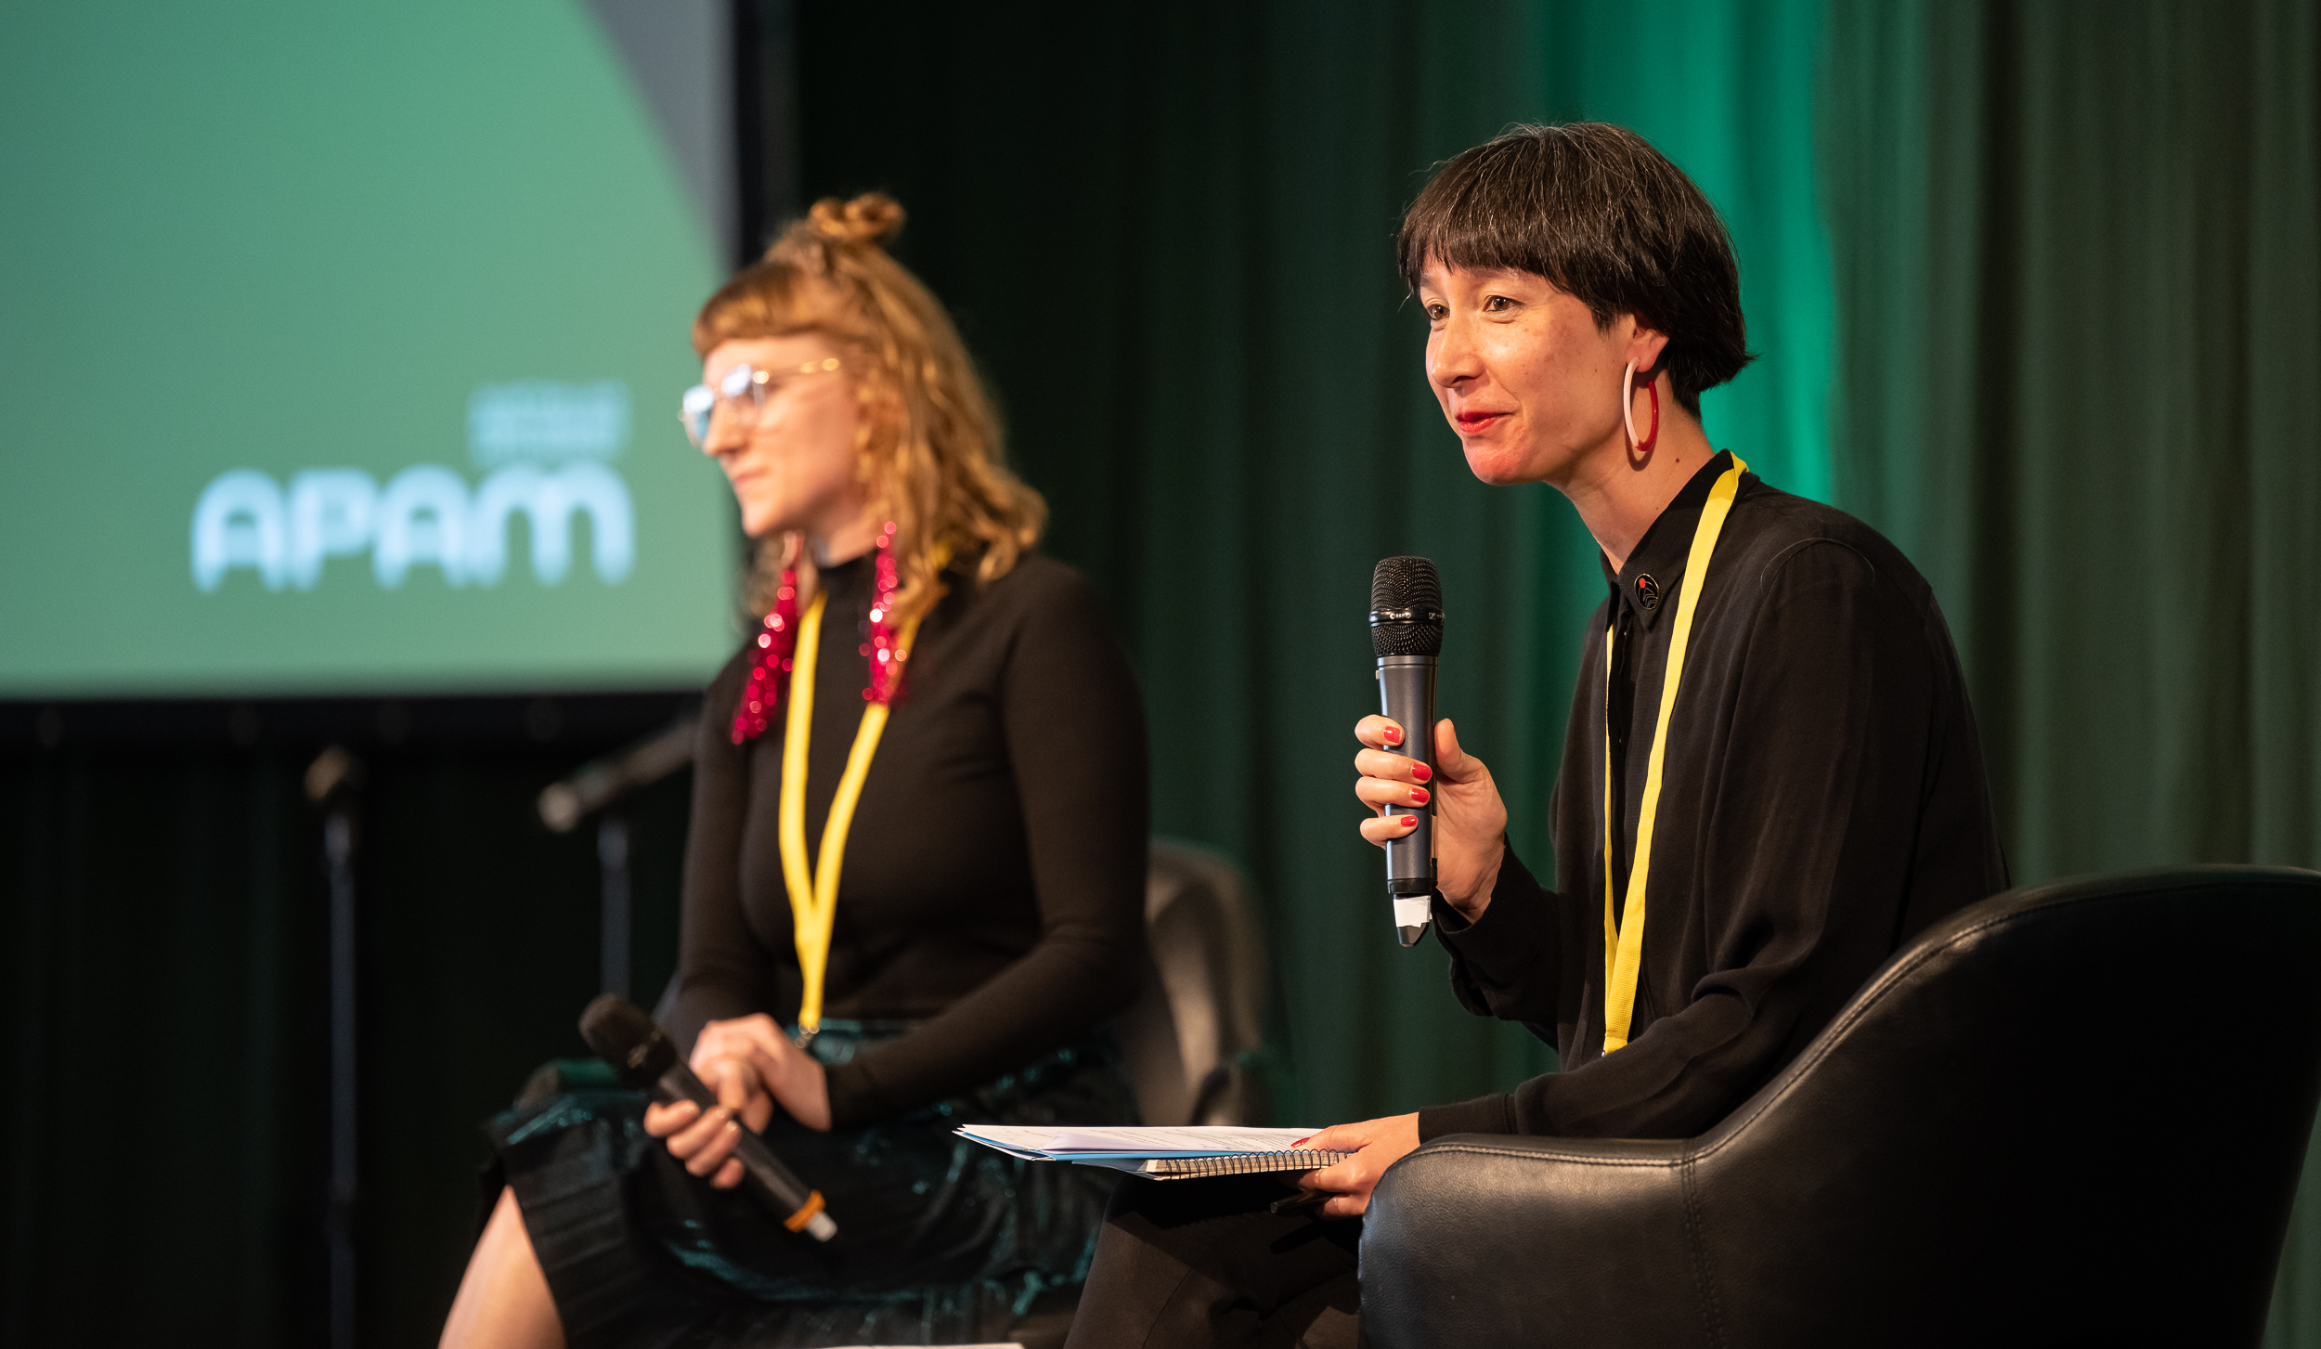

TNA staff members Steph Cox and Tessa Leong hosting Neighbourhood. Photo by Sam Oster - Silvertrace Photos.

ATF #1: Neighbourhood Adelaide, Adelaide Festival Centre (20 May 2021)
In partnership with APAM and DreamBIG Children’s Festival, we hosted an in person gathering for 85 delegates on the lands of the Kaurna people. Neighbourhood Adelaide gave delegates space for reflection, exchange, and revitalising our connections. The event featured artists included Yasmin Gurreeboo – Act Now Theatre, Sue Giles – Polyglot Theatre / ASSITEJ International, Joshua Campton – Independent Artist/Slingsby, Sasha Zahra – Windmill Theatre Company, Fez Fa’anana – Independent Artist, Michelle Ryan – Restless Dance Theatre, and Nikki Ashby – Country Arts SA.

ATF #2: Indie Career Pathways (4 August 2021)
Indie Career Pathways hosted 30 independent creatives to connect and listen to the journeys of established creative practitioners: Michelle Law (Writer), Melanie Lane (Performer & Choreographer), Victoria Falconer (Performer & Musical Director) and Emily O’Brien (Production Manager & Risk Consultant). Breakout rooms and a panel discussion allowed independents to actively engage with the guests.

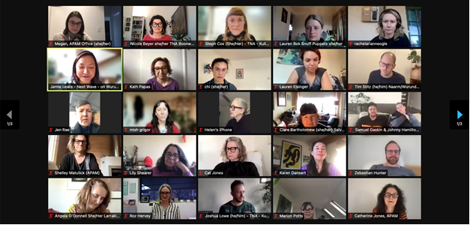

Delegates at ATF#3 – APAM @ Darwin August 2021 (Page 1 of 3)

ATF #3: Neighbourhood Darwin – moved online (16 August 2021)
In lieu of our planned in-person programming, Theatre Network Australia and APAM hosted an online participatory discussion: ‘Building a Plan for Beyond Survival’ and commissioned a series of video artist talks, which are now available through Next Wave.
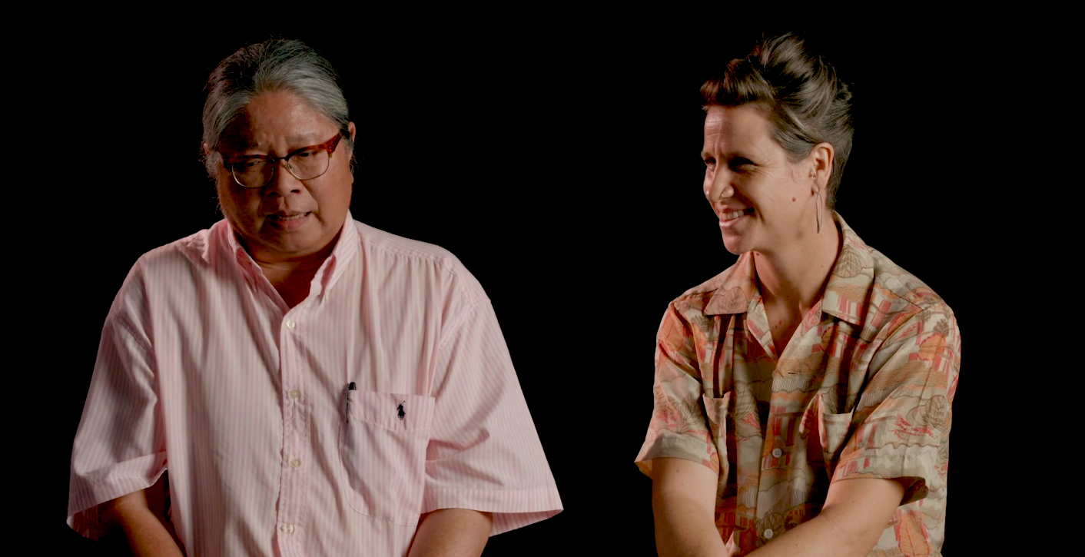
A screenshot from video artist talk by Bong Ramilo and Anna Weekes, Darwin Community Arts. These talks were commissioned by Theatre Network Australia and curated by Next Wave as part of Neighbourhood at APAM Darwin 2021.

ATF #4: Creating Out Loud – Online peer-learning program (5 October–17 November 2021)
In partnership with the University of Queensland, the fourth ATF gathering launched the first Creating Out Loud Program of online peer learning for performing arts company leadership and independent artists. Over seven sessions, 30 participants were guided through topics including facilitation, peer coaching, communicating value, sustainability, wellbeing, business models, and artistic practice.

‘This program has been such a great way to connect with other artists across distance, age, practice, gender and ability. I looked forward to it every week to get my networks expanded and my brain fed through connecting with industry peeps. Thanks TNA for keeping us connected, engaged, informed and talking. You keep us strong!'
- Simone O'Brien, SeedArts Australia

‘The fact that TNA was deeply involved in the program gave me a lot of trust and confidence that we, artists and arts workers, would be well looked after. […] Overall, I felt quite safe, heard and visible, which is not always the case in such contexts, especially for artists and arts workers from diverse and minoritised backgrounds.’
- Bao Ghislain Ngouansavanh, Back to Back Theatre

Membership

Following the dramatic increase in sign-ups of nearly 25% in 2020, TNA maintained a steady membership of over 500 members in 2021. This reflects the sector’s ongoing need for our network, advocacy, and programs.

In 2021, individuals made up 64% of TNA’s membership, representing our strong subscriber base within the independent sector.

Of the 181 organisational members, Theatre companies represented the largest group at 15% total membership, followed by Circus and Physical Theatre (CaPT) 7%.

TNA 2021 Membership Breakdown.

Reach

Membership
Individuals 323
Companies 181

Activities
Neighbourhood Gatherings 2
Online Panels & Presentations by staff 8
Peer learning & mentorship programs 4
VIPI Salons 3
VIPI Networking at Showcase Vic 1
Information sessions 3
Sector meet ups 22
Local Government member meetings 1
Meetings to advise on COVID-19 impact on sector 11
Media coverage 17
Industry surveys 2
Submissions 2
Policy & Resource listings 184

Participants
ATF #1: Neighbourhood Adelaide 85
ATF #2: Indie Career Pathways 22
ATF #3: Neighbourhood Darwin 62
ATF #4: Creating Out Loud 2021 30
CaPT Meet and Greet ASSITEJ gathering, Adelaide 67
ASSITEJ Video featured artists / companies 54
ASSITEJ Video screening: ASSITEJ World Congress / MIRAI Festival, Japan 44
ASSITEJ Video screening: APAM China Australia Session, Adelaide 55
VIPI Salons 71
Information sessions 156
VIPI Producers Mentorship Program 24
Powerplay Fellows (continued from 2020) 10
TNA Member of the Month, ‘Behind the Scenes’ Vision Australia Radio 8
Member & Artist listings 742

Recipients: Awards, Grants & Bursaries
Crisis Cash (in 2021) 120
Supported Indie attendances at market development events 36
Unlocking Capacity grants 4
TNA sponsored awards 2
SMASH Bursary 1

Circus and Physical Theatre (CaPT) Advisory Committee
TNA’s CaPT Advisory Committee was established in 2017 to maintain strong engagement and information exchange between TNA and the circus and physical theatre industry locally, nationally, and internationally. Meeting quarterly, the eight members are on a two-year tenure.
Committee members
Jascha Boyce (SA)
Alice Cadwell (NSW)
Steph Cox (VIC, until April)
Natano Fa’anana (QLD, until April)
Lisa Fa’lafi (NSW, from May)
Harley Mann (VIC)
Lisa McCready (QLD)
Loki Rickus (SA, from May)
Jo Smith (WA)
Devon Taylor (VIC)

ASSITEJ Advisory Committee
The acronym ASSITEJ comes from the original French: Association Internationale de Theatre pour les Enfants et le Jeunesse, meaning International Association of Theatre for Children and Young People. Established in 2020, the ASSITEJ Advisory Committee is made up of Theatre for Young Audiences and Youth Arts representatives from across the country. Together with ASSITEJ International President and Australian Representative, Sue Giles, we provide advocacy leadership for the ASSITEJ Australia Network.

Committee members
Sue Giles AM (ASSITEJ International President & Australian Representative)
Kevin Du Preez (NSW, from July)
Jay Emmanuel (WA, until June)
Helen Hristofski (WA)
Zac James (WA, from July)
Aleshia Johnson (ACT, from July)
Belinda Kelly (TAS, from July)
Robert Kronk (QLD, until June)
Romi Kupfer (VIC)
Christian Leavesley (VIC)
Tariro Mavondo (VIC)
Sarah Parsons (NSW)
Luke Rogers (ACT, until June)
Rhen Soggee (SA)
Susannah Sweeney (SA, until June)
Kyle Walmsley (NT, until June)
Louise Wellington (NT, from July)
Amanda Wright (NSW, until June)

Celebration and Support

Crisis Cash 1000 x 1000 & Support Act

In 2020–2021, TNA ran a campaign and raised $366,000 for one-off emergency payments for independent artists, production crew and producers in the performing arts who had been significantly affected by COVID-19. 71 Champion Companies joined TNA in promoting the campaign and Creative Partnerships Australia made their ACF platform available to us for no fee.

TNA also sat on the steering committee advising on criteria, application process and assessment for Support Act’s COVID-19 Crisis Relief Grants. The eligibility for these grants was extended so that the $20million of additional Federal Government funding was made available to all performing arts workers, who were financially affected by COVID-19 lockdowns and restrictions.

‘I nearly cried when it was notified that I would be receiving the payment. Thank you to TNA and all the other companies behind this initiative. It was an absolute Godsend in an incredibly stressful time.’

- Crisis Cash recipient

‘Congrats to you and the team on this initiative. I think in many ways it is hard to seem to succeed as a peak organisation, but you guys constantly display leadership and strategy for your sector and this is a stunning piece of sector wide support, advocacy and belief. I am so impressed’.

- David Ryding, City of Literature Office

Access for Indies

In line with our Access and Equity objectives, TNA recognises the financial barriers experienced by many independent artists and producers in attending market development events. Where possible, TNA seeks funding to support independents’ travel and accommodation costs, along with free or subsidised registration, to reduce some of these barriers. In 2021 funding was secured for 21 independents to attend APAM’s Neighbourhood Gatherings at DreamBIG Festival in Adelaide, and Darwin Festival, along with offering 51 subsidised tickets to the online program for ASSITEJ World Congress / MIRAI Festival, Japan, and eight registrations at Showcase Victoria 2021, Darebin Arts Centre, Melbourne.

‘It was really good to have my existing work recognised while also given the support, platforms, and connections to continue that work and build community.’
- Creatrix Tiara, Independent

2021 SMASH Bursary – The People of Cabaret

Awarded annually to one recipient per year from 2018, the bursary recognises both the existing and potential contribution of an outstanding Australian-based Independent Artist or Producer to the performing arts sector. The People of Cabaret is an organisation dedicated to amplifying, uplifting, nurturing and supporting artists who are Indigenous and/or Bla(c)k and/or people of colour (IBPOC) who work in cabaret.

Melbourne Fringe Awards 2021

TNA supported two awards at Melbourne Fringe, with free memberships, mentoring and hot-desking.

Best Emerging Performance Ensemble
How to Make a Western, YUMMY Productions
Best Adaptation from Stage to Screen Award
psyche404error, Margot Tanjutco

Communications

‘I always love this newsletter. Thanks a million!’

- Ian Pidd, Everybody NOW / Wanderer

‘We all love reading the TNA News – it’s unique in the industry. Keep up the great work!’

- Lliane Clarke, NIDA

Keeping the Sector Connected

In 2021, TNA’s role in delivering targeted and timely resources was just as important as ever. We continued to focus on sharing key information with artists and companies via email and across our digital platforms. We maintain a healthy average 46% open rate on our e-communications. In addition, TNA sent out many member-only or special bulletins to specific segments of our database.

Audience

E-News Subscribers 3,920
CAPT Bulletin Subscribers 475
ASSITEJ Bulletin Subscribers 760

Total Social Media Followers 8,869
Twitter 4,213
Facebook 2,712
Instagram 1,944

Communications

Number of E-News 10
Number of CAPT Bulletins 3
Number of ASSITEJ Bulletins 2
Member-Only Bulletins 17

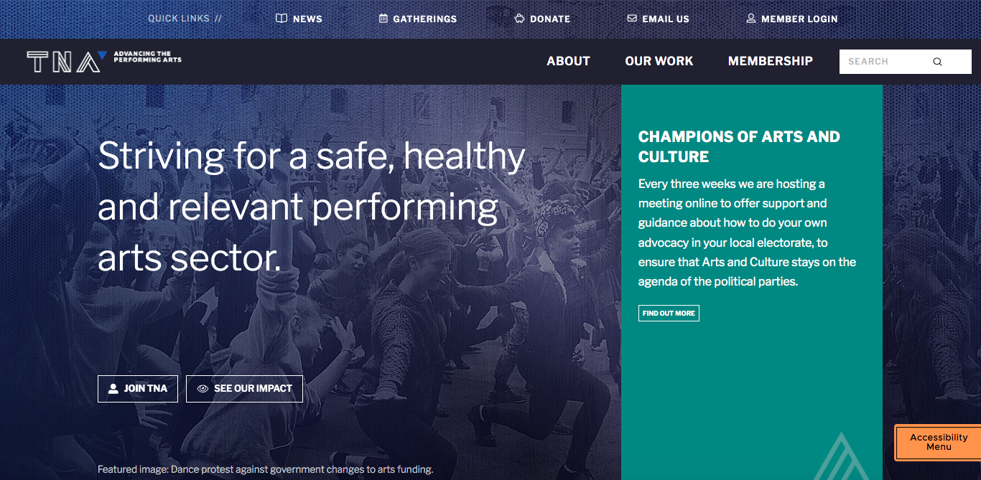

A screenshot of TNA’s new website.

New Website and Brand Refresh

During 2021 we launched a new logo and branding, along with a new website to better house the wealth of information it contains, with the aim of it being more user-friendly and accessible.

Behind the Scenes – Vision Australia Radio

TNA continued to update the sector and champion independent artists via our monthly radio spot on Vision Australia’s ‘Behind the Scenes’ program, hosted by Chris Thompson. Our ‘Member of the Month’ guests in 2021 were: Carly Findlay, Sue Giles, Jonathan Homsey, Harley Mann, Tariro Mavondo, Lana Nguyen, Kate Sulan and Devon Taylor.

Governance and Management

Operations

The relevance of TNA in the arts sector is made clearer in a crisis, and our increased membership numbers and our continued growth in grants and other income demonstrated this in 2021. Creative Victoria multi-year funding 2017-2020 was rolled over for an additional year into 2021, and we updated our Strategic Plan to reflect COVID impact. Key additions include a Responsive COVID-19 Framework, by which we can adjust our program delivery according to the future impacts, and greater recognition of the need for support for mental wellbeing and practical/financial supports for arts workers.

Staff turnover during 2021 was at its highest level in TNA’s history, with four staff leaving. We celebrate our staff moving to exciting new opportunities (in the case of two of them, it was to become CEO at another arts organisation), but it takes a toll on workload balance. ‘The Great Resignation’ as dubbed by the media, due to COVID-19, affected many of our member companies as well.

National Network

Reflecting our growing membership, TNA’s 2021 Board and Advisory Committees collectively have members from all eight states and territories, as well as regional and remote members. Members who are independent creatives and arts workers are paid for each meeting attended.

Finances

TNA’s total revenue in 2021 was $933,636, down from $1,170,197 in 2020, in part due to the large amount of donations received in 2020 for Crisis Cash, as well as government economic support.

Creative Enterprise Program funding was approved by Creative Victoria for 2022-2025 with a welcome increase – up to $145,000 p/a. Funding for TNA’s CaPT program is now included in our core funding. Along with the first year of our Australia Council Multi-Year Funding and income from the tail-end of JobKeeper, our Myer multi-year funding, donations income and other philanthropic support, TNA’s 2021 income was healthy and diverse.

In 2021 TNA received and gave out $120,000 of donations as bursaries as part of Crisis Cash, financially assisting artists and arts workers struggling due to the effects of the pandemic. VIPI reached peak activity, with $367,302 of TNA’s revenue received to run this program.

Even though TNA planned to post a deficit in 2021 (using unspent funds from 2020), we instead ended the year with a small surplus of $8,639, once again largely due to postponed activity.

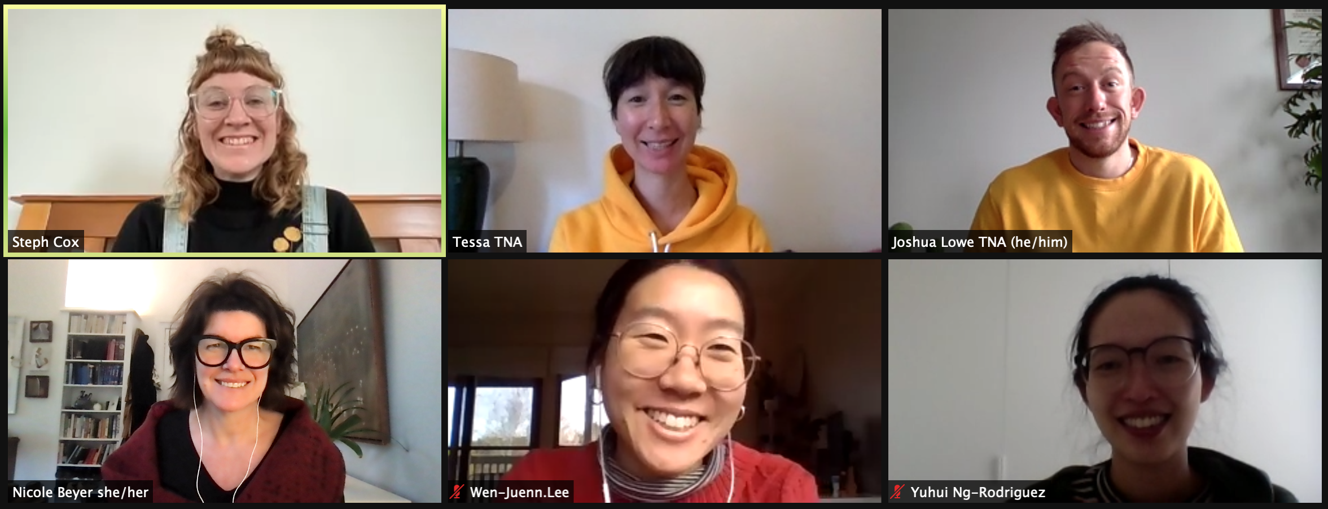

TNA staff members Steph Cox, Tessa Leong, Joshua Lowe, Nicole Beyer, Wen-Juenn Lee and Yuhui Ng-Rodriguez.

Staff

Nicole Beyer – Executive Director
Simone Schinkel – General Manager (until March)
Joshua Lowe – General Manager (from April)
Steph Cox – Program Manager – Safe Theatres, CaPT (from March)
Tessa Leong – Manager, Artist and Sector Development (until June)
Rani Pramesti – Program Producer, VIPI & Strategic Visioning (until August)
Yuhui Ng-Rodriguez – Manager, Sector Development & Membership (maternity leave July-December)
Wen-Juenn Lee – Manager, VIPI & Communications (from June)

Contractors

Kyla Davies – Graphic Design
Amelia Ducker – Filmmaker and Artist
Melinda Hetzel – Program and Reporting Support
Jonathan Homsey – Researcher
NGNY – Website Design and Build
Sam Ryan of SAYSO – Financial Management
Wild Hardt – Photography

Board

Jill Smith AM (Chair)
Caroline Bowditch (Co-Deputy Chair)
Erica McCalman (Co-Deputy Chair)
Lou Oppenheim (Treasurer)
Robyn Gawenda (from May)
Sue Giles AM
Andrea James
Catherine Jones (until May)
Cassie McGannon
Sam Routledge
Brad Spolding (until May)
Annette Vieusseux (until May)
Lyn Wallis
Zainab Syed (from May)

Life Members

Simon Abrahams
Sarah Austin
Alice Nash
Bethany Simons
Brad Spolding

2021 Partners

Advocacy Partners
APRA AMCOS
Arts Access Victoria
Arts Access Australia
Arts Industry Council (Victoria)
Arts Industry Council of South Australia
Ausdance National
BlakDance
Diversity Arts Australia
First Nations Performing Arts Sector Alliance
Live Performance Australia
Multicultural Arts Victoria
Music Victoria
National Association for the Visual Arts (NAVA)
Performing Arts Connections Australia
Regional Arts Australia
Regional Arts Victoria
Symphony Services Australia
Victorian Association of Performing Arts Centres (VAPAC)

Project Partners
APAM (Australian Performing Arts Market)
DreamBIG Childrens’ Festival
Adelaide Festival Centre
Next Wave
ASSITEJ International
Melbourne Fringe
Vision Australia Radio ‘Behind the Scenes’
Support Act
Australian Theatre for Young People (ATYP)
Champion Companies for Crisis Cash x 71 (see website for list)

Research And Education Partners
Deakin University’s Arts and Cultural Management Program
The University of Melbourne
University of Queensland

Funding Partners
Australia Council for the Arts
Creative Victoria
Sidney Myer Fund
Creative Partnerships Australia
City of Melbourne – Creative Spaces

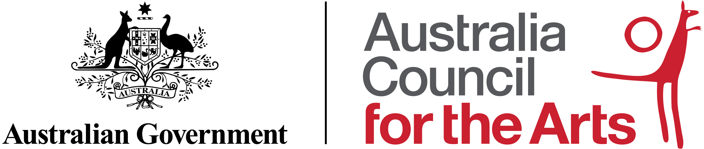

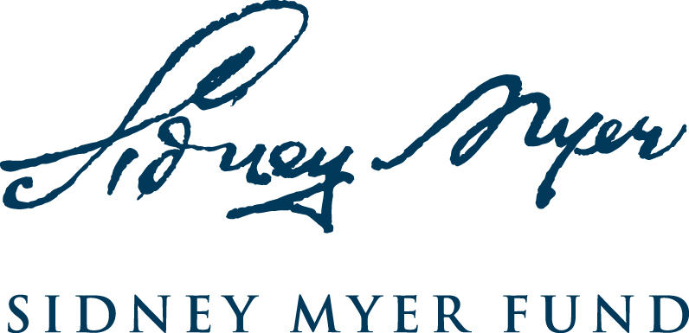

Contact Us
www.tna.org.au

Twitter: @theatrenetworka
Facebook: @theatrenetworkaustralia
Instagram: @theatrenetworkaustralia

G5 / 152 Sturt Street, Southbank VIC 3006
03 9947 1015
info@tna.org.au

