Theatre Network Australia
Annual Report 2022

Acknowledgement of Country

Wherever we are in Australia, TNA acknowledges the traditional custodians of the unceded lands, and we give thanks for the care and custodianship of the land and waterways by Aboriginal and Torres Strait Islander people for tens of thousands of years.
We especially acknowledge the people of the Kulin nation where our office is based, on the southern banks of the Birrarung river.
We pay our respects to Elders past and present.

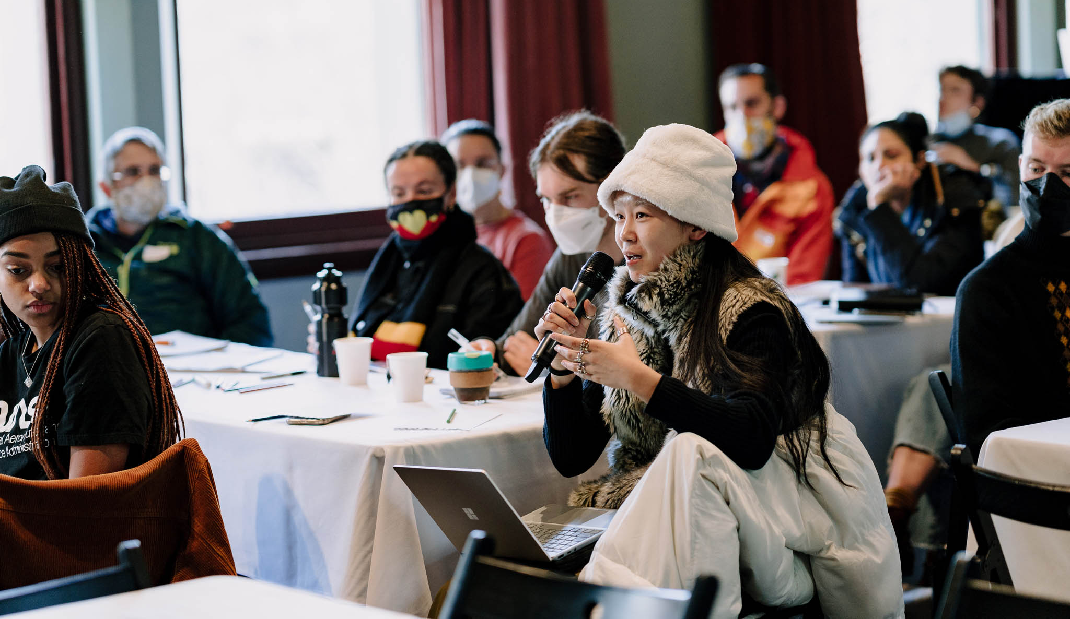

Victorian Independent Producers Initiative (VIPI) Salon, Fringe Common Rooms, 21-22 July. Photo: Wildhardt.

Contents

About TNA 4
Reports 5
Advocacy 9
Research And Resources 11
Capacity Building 14
Networks And Connections 22
Celebration And Support 29
Communications 32
Governance And Management 34
Contact Us 40

About TNA

Founded by the sector in 2009, TNA is a leading service organisation for the small to medium and independent performing arts sector. TNA strengthens artists and arts organisations, influences cultural policy, facilitates critical debate and networking, and advocates for a safe, healthy, and relevant sector.

TNA believes in the central role that creativity plays in a society.

- We work towards a more diverse and fairer performing arts sector that puts First Nations people first.
- We value independent artists, small to medium companies and large organisations, and we want greater interconnections between them.
- We believe in life-long learning. We support different models of working, and we value flexibility.
- We advocate for fair pay and conditions for our sector. We know that risk and experimentation are important.
- We foster ongoing, respectful, and challenging conversations that connect us, open new ideas, and lead to a stronger sector.

In practical terms, this means TNA:

- Runs industry forums and gatherings,
- Delivers workshops on current issues for the sector,
- Drives advocacy campaigns in partnership with other service organisations and the sector,
- Undertakes and promotes research and benchmarking,
- Provides advice to industry, the education sector and government,
- Provides information and resources through our popular E-News and the online resource library.

We design our work to address the gaps. Our approach is underpinned by a spirit of care, deep listening, and trust in the sector’s capacity to make progress.

‘Australia's creative arts industry is incredibly diverse and separated by vast distances. TNA connects us.’
— Jessica Blaxland Ashby

Reports

Chair’s Report

Art and Culture are EVERYWHERE and Art and Culture are ESSENTIAL.

This message was at the heart of TNA's campaign throughout 2022, and in the lead up to the federal election. Working with our 567-strong member-base, along with 19 other peak bodies and service organisations, we promoted a united message of the value of the arts and culture in this country.

As the sector faced the third year of living in a pandemic, this message was more critical than ever. We gathered in person again, to reconnect and share stories. Our member meetings, across four states, delved deep into the challenges of the present, while looking to the future, with the provocation, 'How to Be a Good Ancestor'.
Behind the scenes we focused on advocating for a stronger and healthier sector, amplifying the voices of independents and small-to-mediums in particular. We met with our members and asked what they needed. We listened and supported them in a myriad of ways. Our biennial Indie Survey Report, receiving almost 300 responses, allowed us to share the sobering reality of practising independent artists.
With our Equity Action Plan (EQAP) to guide us, we continued to embed principles of equity, justice, access and inclusion deeply within our programs, including key focus areas of Circus and Physical Theatre (CaPT), Performance with/for/by young people and independent producers. These kinds of programs are absolutely crucial, so that we can get the next generation of works programmed in festivals, into regional theatres and looking after young people.
Thank you to Jill Smith AM who handed me the Chair this year, after a decade with TNA. My thanks to the rest of the TNA board, especially Treasurer Lou Oppenheim, for her diligent and capable oversight of TNA’s growing finances, and to Deputy Chair Robyn Gawenda, who oversaw a strategic board review process in 2022. The TNA board is a powerful group of strategic thinkers who hold the vision for this incredible organisation.

And thanks to the amazing work of TNA's core staff — Nicole, Josh, Steph, Yuhui and Wen-Juenn. With the appointment of four new CaPT positions in 2023, we are very excited to witness the growth of the organisation, supported by these new team members.

Erica McCalman
Chair

Executive Director’s Report

Many members commented to us during 2022 that it was the worst year of the pandemic. Not only were they fatigued from living and working with so much uncertainty, there was an expectation that they get back to working as hard as ever, putting on all the projects that had been postponed, but with much less financial support available. In that environment, TNA’s work to support and speak up for the sector was as urgent as ever.

Our 2022 survey of nearly 300 independent artists, who were paid for their time, gave us the data to support these stories. One startling fact was that 51% of the respondents reported that they are either partially or fully retraining or changing careers.

In member meetings around the country, we heard from companies that the top two issues were: dealing with burnout and mental ill health amongst staff; and the dire shortage of production and technical (and even administration) employees. Cost increases have added another burden.

TNA’s advocacy on these issues is paramount. Along with the more formal submissions and campaigns, we also make it our daily work to raise these issues and seek solutions. As an example, in 2022 I had over 80 meetings with decision makers and politicians. Issues discussed included investment solutions for the independent and small to medium sector, addressing workforce shortages, mental wellbeing support, providing advice on mechanisms such as advisory groups, providing input into the National Cultural Policy development process, and providing pulse checks on the state of the sector.

Our peer learning programs, such as Creating Out Loud and Champions of Arts and Culture continued to provide opportunities for our sector to develop professional skills and learn from colleagues from around the country.

TNA’s work during 2022 also included consultation and development of our new program LeaderShift — a response to the urgent need to reduce the barriers for leaders from diverse backgrounds to take up executive roles in the performing arts. The extraordinary response to this program shows the deep unmet need for relevant and culturally appropriate leadership programs. TNA’s work ahead will include promoting investment in such programs by other organisations.

2022 was a year of turmoil for the circus and physical theatre sector, with the de-funding of Circus Oz and subsequent closure of the Collingwood building bringing major problems for the whole sector. Rehearsal and development space was severely lacking, companies and artists looked outside of Melbourne and Victoria for space, and there was ongoing anxiety about the relationship of Circus Oz to the wider sector. TNA undertook three sector impact consultations throughout 2022, provided the findings to Creative Victoria and the Australia Council, and provided as much information to the sector as we were able. We also played a role in designing short-term sector support programs, and with support from the Australia Council, kicked this work off in late 2022. With the Collingwood building still closed to the sector at time of writing, TNA will continue to push for a solution — so that the sector can once again have access to the unique, purpose built, significant property at Perry Street.

The end of 2022 promised the launch of a National Cultural Policy. TNA, along with 19 other peak bodies, had worked on our Art and Culture are ESSENTIAL and Art and Culture are EVERYWHERE campaign since 2021. We had also been working behind the scenes on the Parliamentary Inquiry into Cultural and Creative Industries for over a year. We were pleased that the resulting report — Sculpting a National Cultural Plan — had bipartisan support and heralded a stronger future for the arts. After the May federal election, Labor began work on the new policy, and in January 2023, Revive, Australia’s Cultural Policy, was launched. While there are areas for improvement in the policy — for example, to include the need for climate action, action on racial equity and international investment — it is a welcome strategic map for investment and action for the arts and cultural industries for the next five years.

TNA’s amazing team of core staff was supplemented by the addition of a new Steph — Steph Speirs replacing Steph Cox, another TNA staff member heading off to lead a company! We thanked Steph Cox for her passionate work supporting the Circus and Physical Theatre sector, which she continues to do in her role at the Women*s Circus. Steph Speirs, plus Josh Lowe, Yuhui Ng-Rodriguez, Wen-Juenn Lee, Melinda Hetzel, Sam Ryan and other contractors continue to be a wonderful group of people to work with and I thank them deeply.

We also recruited four new staff members to the Circus and Physical Theatre team, with some starting at the end of 2022 and some in 2023: Lauren Swain, Christian Schooneveldt-Reid, Charice Rust and Christy Flaws. This group of go-getting arts leaders will help revive the circus sector over the coming two years.

My warmest thanks to the TNA Board, especially the hard-working executive Erica McCalman (our new Chair), Robyn Gawenda (Deputy Chair) and Lou Oppenheim (Treasurer). I thank departing board members Andrea James and Sam Routledge. (We farewelled former Chair Jill Smith, and long-time board member Lyn Wallis in our 2021 Annual Report). New Board members Alex Desebrock and Nithya Nagarajan joined during the year, and Harley Mann, an Observer in 2021, was invited to join as a full board member from April. As always, the TNA board members bring deep and honest insight from their respective roles in the sector and become champions of our goals and values in their day-to-day work, giving their time for the benefit of the sector.

Nicole Beyer
Executive Director

Treasurer’s Report
I am pleased to report that TNA (Theatre Network Au Inc.) has returned a small deficit of $6,284 for 2022, on a turnover of $848,895. This means that the organisation now has total reserves of $182,042, of which $10,000 is reserved for core staff accessibility costs if needed, and $40,000 is committed to TNA’s future work, specifically programming deferred from previous years.

Given the ongoing challenges and volatility faced by our community as a result of the pandemic, and likely reductions in earned income sources in the immediate future, the Board had planned for a more significant deficit in 2022 (in the order of $41.5k), whilst ensuring sufficient funds to continue to deliver its broad range of Victorian and national activities.

This positive turnaround to this much smaller deficit result is testament to the ongoing vigilance, strategic management of activities and effective financial management from the hardworking TNA team. I congratulate the executive team for their outward focused, strategic and financially sustainable management and for providing the organisation a strong foundation on which to continue its contribution to the sector as it continues to rebuild and adjust following pandemic impacts across the last few years.

TNA’s total revenue in 2022 was $848,895 (2021: $933,636), with the decrease primarily due to the cessation of our multi-year support from the Sidney Myer Fund and JobKeeper. There were also changes in programs auspiced by the organisation, with 2022 being the first year of the Creative Victoria Creative Enterprise Program funding ($145,000 p/a), and the final year of the VIPI Producer’s Mentoring Program. Variability in our results related to these programs will continue going forward, particularly with funding and responsibilities associated with additional CaPT activities commencing in 2023. In addition, the organisation received additional funding Creative Victoria as part of its Sustaining Creative Organisations initiative.

Finally, we are sincerely grateful to all our partners, including our core recurring funding partners the Australia Council for the Arts, who allow us to service the national agenda, and Creative Victoria, for our home state programs and support of Victorian companies and independent artists and producers.

The 2022 audit was undertaken by Sean Denham and Associates and a full copy of the audited statements is available on request.

Lou Oppenheim
Treasurer

Advocacy

‘TNA's advocacy and genuine desire for diversity and access — organisationally and across our industry as a whole — is exemplary.’
— Andrea James, Griffin Theatre Company

Advocating for the sector, in particular emphasising the needs and public value of the small to medium and independent sector, is one of TNA’s key roles. We provide high level policy advice to government; represent burning sector issues; provide funding program input and feedback; provide advice on mechanisms such as advisory group design and communications strategies; advocate on urgent sector issues such as space/venue loss; and gather intel for opportunities for the sector. We also provide decision makers and funders, such as philanthropists, a sector pulse check and show where intervention and investment will be beneficial.

TNA’s 2022 advocacy work included a focus on:

Listening to and representing the sector
Through meetings and gatherings with our members and the wider sector, we gathered intel and heard more deeply from members. This helped us to achieve specific outcomes for parts of our sector, such as reduced reporting requirements, and to explore solutions together. In 2022, through one-on-one meetings, forums, and surveys, we heard directly from over 800 of our members and other sector representatives. We then attended roundtable meetings, funding body meetings and other gatherings where we shared the sector’s issues and aspirations and looked for specific solutions to their concerns. This included over 80 meetings and roundtables.

National Cultural Policy and Federal Election
TNA worked with 19 other arts peak bodies throughout 2022, to promote a united message of the value of the arts and culture in the lead up to the federal election. We led a campaign using Art and Culture are EVERYWHERE and Art and Culture are ESSENTIAL. This was rolled out and shared by media, along with many of TNA’s members and other peak bodies. After Labor was elected and the National Cultural Policy process was announced, we kept the united pressure on the Expenditure Review Committee, highlighting the need for investment in the sector.

In 2022 we had 39 meetings with our colleagues in other peak and service organisations. In these meetings, we collaborated on advocacy, gained an understanding of the bigger picture arts sector, and shared TNA’s values and approaches.

TNA provided regular advice to leadership at the Australia Council for the Arts on sector communications, research, ongoing sector needs, and the National Cultural Policy. We also helped the eight new National Performing Arts Framework organisations advocate for and achieve reduced reporting obligations.

Victorian advocacy
TNA takes on an additional Victorian advocacy role as part of our dedicated Victorian program. In 2022 this included meetings with the Arts Industry Council Victoria (AICV) on shared advocacy; funding program advice to Creative Victoria; advocacy regarding the Collingwood building and the need for spaces for the Circus sector; and representing the sector at Creative Victoria’s Healthy Workplaces Advisory Group. In the lead up to the November State election, we ran a forum on the election process and how to vote well. We also wrote to MPs that were key to the arts:

“Labor’s strategy Creative State 2025 prioritises safeguarding jobs, developing employment pathways, and securing Victoria’s reputation as a global cultural destination. But it can’t fulfil those important goals without ongoing, targeted investment, with a focus on rebuilding the grassroots artists and small companies that make up the heart of the creative industries.’

— TNA’s letters to Victorian MPs, 3 November 2022

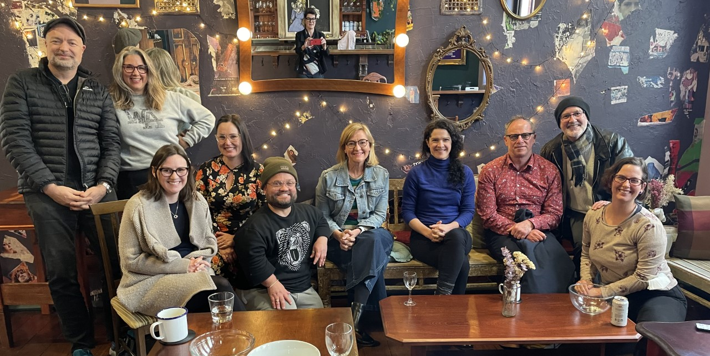

TNA members-only meeting in Perth, August.

Research and Resources

‘It is always so valuable to read the research that TNA has gathered. I will share this with my CaPT colleagues in WA.’
— Meredith Bell, Theatre Kimberley

This Is How We Do It 2022: Indie Survey Report

THIS IS HOW WE DO IT 2022: TNA’s Report on the Working Trends of Independent Artists and Creatives in the Performing Arts in Australia analyses results from 297 valid responses from independent artists and creatives to an online survey conducted in May and June 2022. In this third survey, additional questions were included to track new trends, such as those resulting from the ongoing impact of COVID-19. It also continued to gather information on working conditions, financial arrangements, personal and business management, and individually set working rates. TNA hopes that the report leads to greater understanding, appreciation and valuing of independents’ dedication and practice. Top-level findings and observations were shared by TNA’s Yuhui Ng-Rodriguez with members at a speed briefing 27 October, at a VAPAC members meeting on 11 October, with funding bodies and other peak bodies, and at TNA’s Victorian Performing Arts Forum on 22 August. An article in Arts Hub covered the key findings.

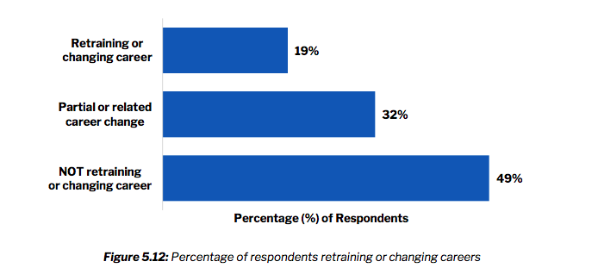

Findings from TNA’s Indie Survey Report: THIS IS HOW WE DO IT (p. 48) show that 51% of indie artists are considering a career change.

Resources for the Sector

TNA continues to provide an extensive library of sector-specific databases and resources:

- TNA sector resources: a range of resources collected by TNA to assist performing arts organisations and independents.

- TNA Member List: a list of all current 567 TNA members by artform.

- Policy Database: a database to assist performing arts organisations when developing their own policies, plans, and procedures.

- Australian Youth Circus Sector (AYCS) / training database: a database for Australian youth circuses, circus schools and training centres.

- Performing with/ for / by Young People Companies: a database of companies that create and present artistic work with, for, and/or by young people.

- CaPT Performing Companies Database: a database of Australian Circus & Physical Theatre (CaPT) performing companies.

- CaPT Resources: a list of Circus and Physical Theatre resources.

- Producers’ Database: a database for independent performing arts producers who support independent artists, independent collectives, and independent companies.

- Designers’ Database: a response to the gender inequity within technical design in the performing arts, this list of female, non-binary and trans designers is intended as a resource for theatre companies, collectives, and individuals to hire more diversely in these areas.

'I received your email about the new AYCS + Training Centre’s database you’ve created on the TNA website, I think that’s a fantastic idea and I’d love to be involved in any way possible!’
— Elise Jaworowski, Cirque Fit

University Partnerships

Deakin University — ‘Leading Change: Audience Diversification in the Arts'

TNA is a partner on Deakin University’s research project — Leading Change: Audience Diversification in the Arts, along with State/Territory Government departments and other peak/professional bodies: Arts Access Australia, Australian Museums and Galleries Association, Australian Public Galleries Association, and Performing Arts Connections Australia. TNA supported Deakin researchers in inviting over 1,300 publicly funded Australian arts organisations to participate in a survey investigating the impact of organisational behaviour on the social profile of audiences. The results will be published in 2023.

University of Queensland — ‘Creating Out Loud’: Developing sustainable peer-mentoring to rebuild the arts post COVID-19

TNA continued our partnership with UQ researcher Dr Kate Power and Lead Industry Partners: Queensland Ballet, La Boite Theatre, Arts Nexus, and National Association of Visual Arts, on an Industry Reference group for the research initiative ‘Creating Out Loud’ to develop sustainable peer-coaching for the arts and culture sector.

‘I feel as if a chunk of my hope and optimism has been given back to me. I love to see this program widely available and well resourced. It is vital we connect artists and foster community where the focus is on learning and growth.’
— Erica Brennan, Independent, on ‘Creating Out Loud’ 2022

Capacity Building

‘TNA makes a fantastic contribution to the performing arts. I think people don't realise exactly how much TNA does behind the scenes to just keep the industry buoyant — if you took away TNA, it would be like removing stitches from a garment. It would fall apart. […] To me, TNA is like a silent arts partner.’
— Clare Mendes, Melbourne Writers Theatre

Supporting Equity and Inclusion

TNA strives to promote equity, justice, access, and inclusion across all of our programs. Our Equity Action Plan (EQAP) guides this work. Throughout TNA’s programs, we ensure we address our five access and equity objectives:

- First Nations First
- Justice and Diversity
- Safe Theatres/Workplaces
- Access and Inclusion
- Gender Equity

All of our Position Descriptions align to these objectives, and we report on the EQAP outcomes annually. The 2022 EQAP Report is available on the TNA website. Our three short term and two long-term targets were all at least partially achieved. The key areas of achievement were with board, staff and contractor recruitment, and areas for improvement are around championing our approaches more broadly to the sector.

A Stronger Sector

TNA continued to build the capacity of the sector through a number of targeted initiatives, both in person and online. We hosted sector meetups with other peak bodies and specific advocacy groups, including circus and physical theatre, dance, and performance with/for/by young people. Direct members services continued to include funding round support, panels/presentations, information sessions, one-on-one member meetings, and regular advice and support.

Champions of Arts and Culture Meetups (January–May)

TNA invited members to be a part of a combined advocacy effort to ensure that Arts and Culture stayed on the agenda of the political parties in the lead up to the federal election in May. We hosted an online meeting every three weeks — a total of eight meet-ups — offering support and guidance about: how to do your own advocacy in your local electorate, to present different policy ideas and approaches, and to offer a way for members to tell us what is important to them. Invited speakers included Bill Browne (The Australia Institute), Ros Abercrombie (Regional Arts Australia), Penelope Benton (NAVA), and Jo Dyer (Independent Candidate for Boothby, SA).

‘Just wanted to reiterate how valuable and inspiring this series is.’
– Lyall Brooks, Lab Kelpie, on Champions of Arts and Culture Meetups

Invite your Victorian MPs Initiative (June)

In the lead up to the Victorian state election TNA created an extensive database to match up TNA members with details of their local electorate and sitting MPs. We aimed to take some of the work out of political advocacy by delivering the names and emails of MPs straight to our members’ inboxes. This year, rather than asking them to join an extensive campaign, we had just one ask: invite your MPs to see your work.

‘Thank you for this extremely helpful information. […] This is an invaluable service and support to me as a member and relatively new to things.’
— Sarah Hunt, National Theatre
‘Thanks for doing this work. So incredibly helpful!! And such a great reminder.’
— Caroline Bowditch, Arts Access Victoria

The Victorian Independent Producers Initiative (VIPI)

VIPI is a major four-year sector development program that TNA has delivered since mid-2019. This initiative was established to support independent producers, and through them, independent artists and companies in the performing arts. VIPI is an initiative of the Victorian Government through Creative Victoria, delivered in partnership with TNA. It comprises three key programs: VIPI Salons, the Producers Mentorship Program, and Unlocking Capacity Grants.

In 2022, TNA continued Round 3 of the Producers Mentorship Program, with eight producers meeting monthly for professional development workshops and peer-learning until July, then ten producers meeting monthly in the second half of the year. Round 3 of the multi-year Unlocking Capacity Grants was also rolled out, with seven grants given. For 2022, we ran nine salons in-person and online —seven of which formed a series presented as part of a two-day program, with a focus on supporting emerging producers.

VIPI 2022 Highlights:

VIPI Salon Series: Producing Fundamentals (21–22 July, Fringe Common Rooms/online), including Artist x Producer Coaching Breakfast (21 July).
Speakers: Pauline Cady, Ade Djadjamihardja, Jessica Iuliano, Fleur Kilpatrick, Kush Kuiy, Jamie Lewis, Erica McCalman, Lana Nguyen, Efren Pamilacan, John Paxinos, Eliki Reade, and Sonya Suares.

VIPI Salon: Indie Artists x Indie Producers Gathering (29 March, Footscray Community Arts Centre).

VIPI Salon: Intercultural Producing, facilitated by Lia Pa’apa’a (QLD) (24 November, online).
Speakers: Kush Kuiy (VIC), Grace Vanilau (VIC), and Britt Guy (NT).

Unlocking Capacity Grants – Round 3 Recipients: Alison Halit, Brett Nathan Clarke, Dylan Singh, Efren Pamilacan, Eliki Reade, Lana Nguyen and Laura Milke Garner.

Producers Mentorship Program – Round 3 Cohort: Jenny Gay, Monique Grbec, Ching Ching Ho, Ripley Kavara, Matisse Laida (August–December), James Emannuel McKinnon (August–December), Luke Morris, Charice Rust, Melody Shotade (January–July), and Aïsha Trambas.

Unlocking Capacity and Producers Mentorship Program 2022 (paid roles)
Total number of Independent Producers Funded | 25
Producers who identify as Culturally and Linguistically Diverse and/or People of Colour | 11
Producers who identify as Deaf/Disabled | 2
Producers who are based regionally | 3
Producers who are First Nations | 3
Total number of Producers from target groups | 17

‘The entire program was incredibly useful. I would not have been able to invest in my professional development in such a focused way without it.’
— Aïsha Trambas, Producers Mentorship Program Round 3 Participant

‘So grateful for the chance to connect with other theatre makers and producers under the warm and welcoming auspices of TNA. The workshop felt very needed, very practical and helped me clarify what I need for my effective creative practice right now, post pandemic.’
— Cathy Hunt, Independent at Producing Fundamentals Workshop

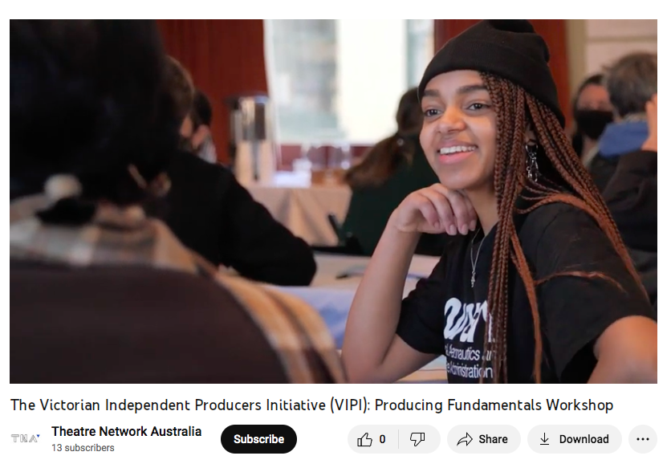

VIPI Producing Fundamentals Workshop: video. Videographer: Cobie O.

Circus and Physical Theatre (CaPT)

As the CaPT peak body in Australia, TNA is deeply committed to a strong future for this sector. TNA’s CaPT Advisory Committee holds deep and broad connections to independents, companies, and supporting organisations and stakeholders. In 2022, TNA entered into an agreement with the Australia Council for the Arts to run three significant capacity building initiatives for the CaPT sector over the next two years: Australian First Nations Circle, CaPT Independent Producers Initiative, and the Safe & Sustainable Circus Rigging Initiative.

The Circus and Physical Theatre (CaPT) Sector Forum and Support

TNA partnered with NICA to host a forum as an opportunity for members of the community to come together and discuss the upcoming funding round, as well as to share visions for the future, potential projects, collaborations and endeavours.

In May, TNA hosted the CaPT Producers Club, an informal opportunity for CaPT independent producers to come together, share knowledge and connect.
In preparation for the mid-year Australia Council funding round, TNA offered a suite of support services for the Victorian CaPT Sector, including an application workshop in July, as well as one-on-one support and advice.

‘[The CaPT Sector Forum] was so great, well done to all for pulling it together.’
— Harlow Carey, Gravity Dolls

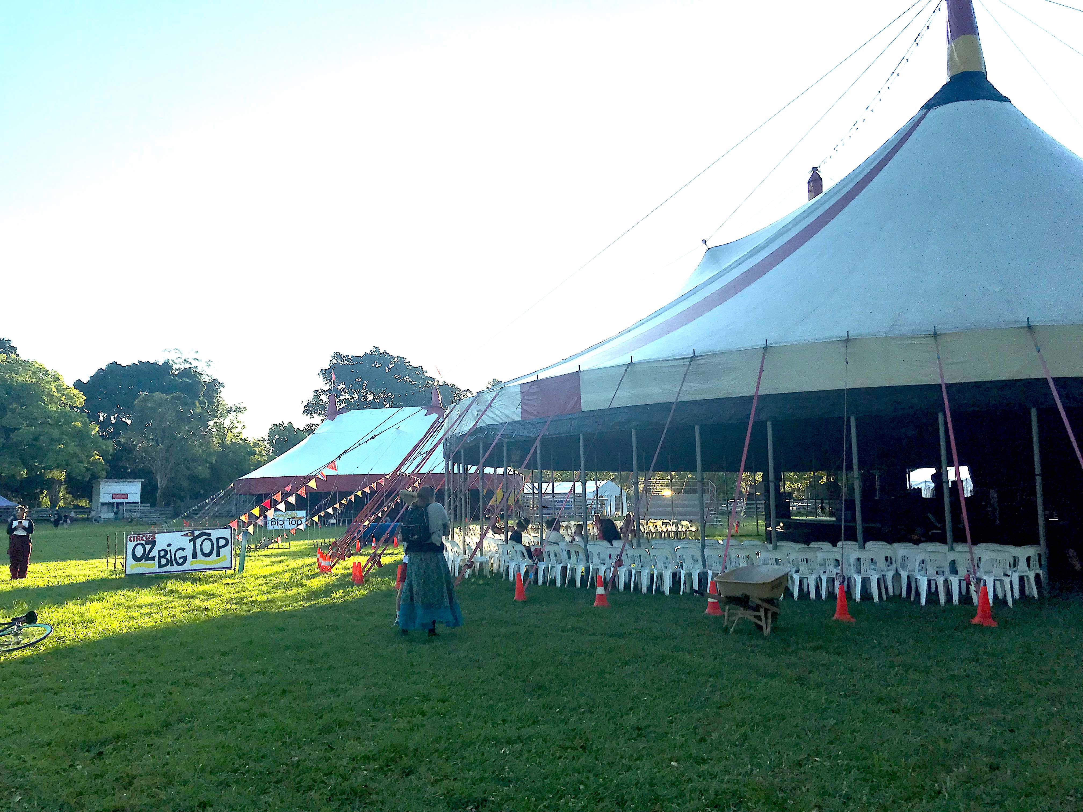

National Circus Festival & Youth Circus Symposium, NSW, 27 Sept–2 Oct.

TNA at CaPT Sector Events

In 2022, TNA Program Manager, Steph Speirs, along with members the CaPT Advisory Committee, represented TNA at important sector gatherings including at: Australian Performing Arts Market (APAM) at CIRCFest Meanjin (QLD), National Circus Festival and Youth Circus Symposium (NSW), and Melbourne Fringe (VIC). With the support of APAM, TNA also secured Australia Council funding to support eight independent CaPT practitioners to attend as delegates to these events.

‘It is of great benefit to me as an independent artist to attend these sector gatherings, as it allows me to continue developing my professional connections within the industry, as well as developing my knowledge about the workings of the sector.’
— Mitch Jones, Independent

Performance With/For/By Young People

Visibility and Advocacy

TNA continued to support the quarterly Performance with/for/by Young People Sector online gathering, hosted by Australian Theatre for Young People (ATYP). We also worked in partnership with ATYP to update our Performance With/For/By Young People Database, showcasing the great diversity of practice within the sector.

TNA elevates young voices directly by programming and supporting young people as speakers at our sector gatherings. In 2022 this included young people from Yirra Yaakin’s Youth Ensemble (WA Gathering, Perth) and House of Muchness (VIC Gathering, Melbourne).

In 2022 we continued to advocate for a focus on young people and culture in the upcoming National Cultural Policy. We did this through meetings with funding bodies and MPs, our federal pre-budget submission, media coverage and our work towards the 2022 federal election.

TNA’s ASSITEJ Committee began sending a quarterly communique to executive staff at the Australia Council, keeping them informed on key issues for the sector.

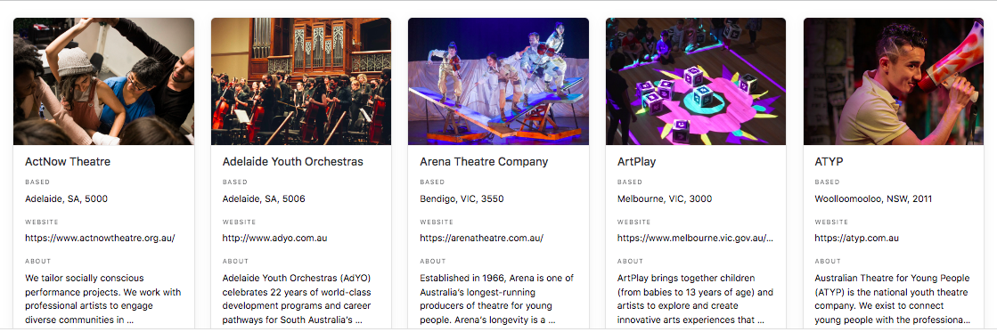

TNA’s Performance With/For/By Young People Database.

Bibu First Nations Delegation (May)

TNA, in collaboration with ASSITEJ International President and Australian Representative, Sue Giles AM, Narangga/Kaurna artist, Jacob Boehme, and Wongi/Yamatji/Murri facilitator, Zac James, brought together a group of eight Australian First Nations artists to attend the Swedish Bibu Festival's online offerings held on 17–22 May. Delegates included Mayella Dewis (VIC), Andrea Fernandez (WA), Marlanie Haerewa (WA), Barbara Hostalek (WA), Pauline Lampton (QLD), Rita Pryce (QLD), Paul Tanner (SA) and Sani Townson (NSW). TNA ran an outreach and development intensive in the week leading up to the festival and facilitated the delegation to participate in the online program across the five days of the festival. Delegate, and Artistic Director of The Pryce Centre Rita Pryce (QLD), was subsequently selected as the Australian nominee to attend the Theatre for Young Audiences (TYA) Directors Exchange 2023 in Germany.

FUSE First Nations Delegation and Sector Delegates Support (July)

TNA also supported a delegation to attend FUSE, the National Youth Performing Arts Summit, at ATYP in Sydney, 18–20 July. Four First Nations delegates — Mayella Dewis (VIC), Andrea Fernandez (WA), Barbara Hostalek (WA), Zac James (WA) — and six other sector delegates — Lisa Apostolides (Byron Youth Theatre, NSW), Lesley Graham (DRILL, TAS), Penny Harpham (Western Edge, VIC), Romi Kupfer (Independent, VIC), Sarah Pasons (Outback Theatre For Young People, NSW), and Kyall Shanks (Yellow Wheel, VIC), along with TNA General Manager, Joshua Lowe — attended. Delegates met with young people and representatives of youth organisations from around the country and contributed to important sector conversations.

Youth Dance Australia (YDA)

In 2022 TNA supported YDA to formalise and organise their network. We engaged facilitator Kate Sulan to work with YDA committee members over two facilitated sessions to clarify their purpose and operations moving forward. TNA also developed and continues to host the YDA website, hosts the online quarterly gatherings, and pays independent/unsalaried committee members a fee to attend.

Networks and Connections

‘These networking opportunities are so vital for us Perth mob as we are so far away from the rest of the major cities and companies. […] TNA has a wonderful reputation in the arts community.’
— Andrea Fernandez, Independent

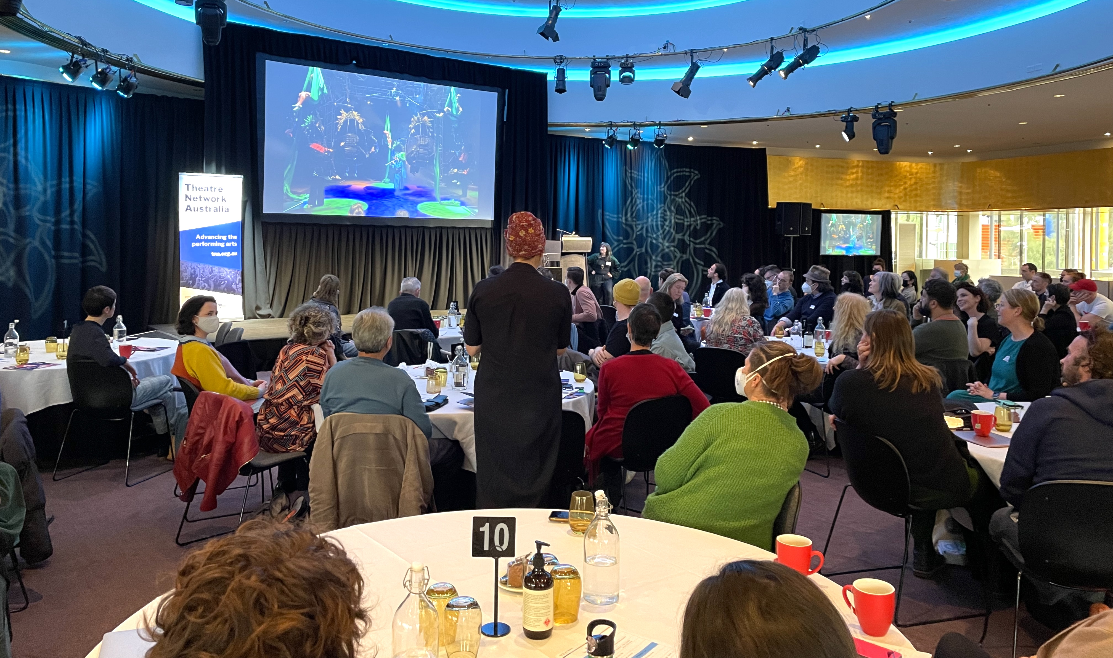

Victorian Performing Arts Forum (VPAF), Arts Centre Melbourne, August 22.

TNA’s Sector Gatherings — NSW, Regional VIC, TAS, VIC & WA

TNA was able to return to in-person events in 2022, hosting sector gatherings on Gadigal Country (Sydney), pakana/palawa Country (Hobart), Wadawurrung Country (Ballarat), Whadjuk Nyoongar Country (Perth), and Wurrundjeri Woiwurrung/Boon Wurrung Country (Melbourne).
The roundtable gathering for our Tasmanian members focussed on joint solutions to key sector issues. Attendees at the state forums were invited to discuss how we could empower our future generations of artists, audiences and participants, in response the theme, ‘How to Be a Good Ancestor’.

- TAS (9 June, Terrapin HQ, nipaluna) hosted by Terrapin, offered local members a facilitated conversation around key sector issues: securing staff and crew; the programming backlog; and rebuilding confidence and morale after two years of COVID-19. 12 members attended the meeting.

- VIC (22 August, Arts Centre Melbourne, Naarm) in partnership with Arts Centre Melbourne. Speakers: Tony Birch (unable to attend due to illness), Sonia Lindsay (Deloitte Access Economics), Abel and Tilda (House of Muchness), Sam Strong (Creative Victoria), Edwina Lunn (Arts Centre Melbourne), Caroline Bowditch (Alter State and Arts Access Victoria), Harley Mann (Na Djinang Circus), Ellie Griffiths (Oily Cart, UK), Sue Giles (Polyglot), along with updates from TNA and others across the sector. 117 delegates attended the forum.

- WA (24 August, State Theatre Centre, Boorloo) was held alongside Performing Lines WA’s Kolyang Creative Hub. Speakers: Conway Chunnery and Maisie Mulvany (Yirra Yaakin’s Youth Ensemble), Annette Madden (Australia Council), Jeremy Smith (Performing Lines WA), Ella McNeill (Director of Arts & Culture at Minderoo Foundation), Nicole Beyer (TNA). 48 delegates attended the forum in person, with 5 additional delegates joining online from regional WA.

- NSW (24 October, Carriageworks, Warrane) in partnership with Theatre Network NSW (TNN), Performance Space, and Carriageworks to host an in-person sector gathering during Liveworks Festival of Experimental Art. Speakers: Dino Dimitriadis, Sēini ‘SistaNative’ Taumoepeau, Bec Dean (Create NSW), Annette Madden, (Australia Council), Margie Breen (TNN), Nicole Beyer (TNA). 84 delegates attended the forum.

- Regional VIC (11 November, Ballarat Mining Exchange, Ballaarat) in collaboration with Ballarat Council and The Mining Exchange. Speakers: Pippa Bainbridge (Punctum), Malcolm Sanders (Regional Arts Victoria), Jo Kruse (Her Majesty’s Theatre, Ballarat), along with updates from TNA. 25 delegates attended the gathering.

‘Access is one thing, but inclusion is altogether something else... Who is breaking their back to enable the change needed, and slowly dismantle ableism?’
— Provocation at TNA’s WA gathering by Jeremy Smith, Performing Lines WA

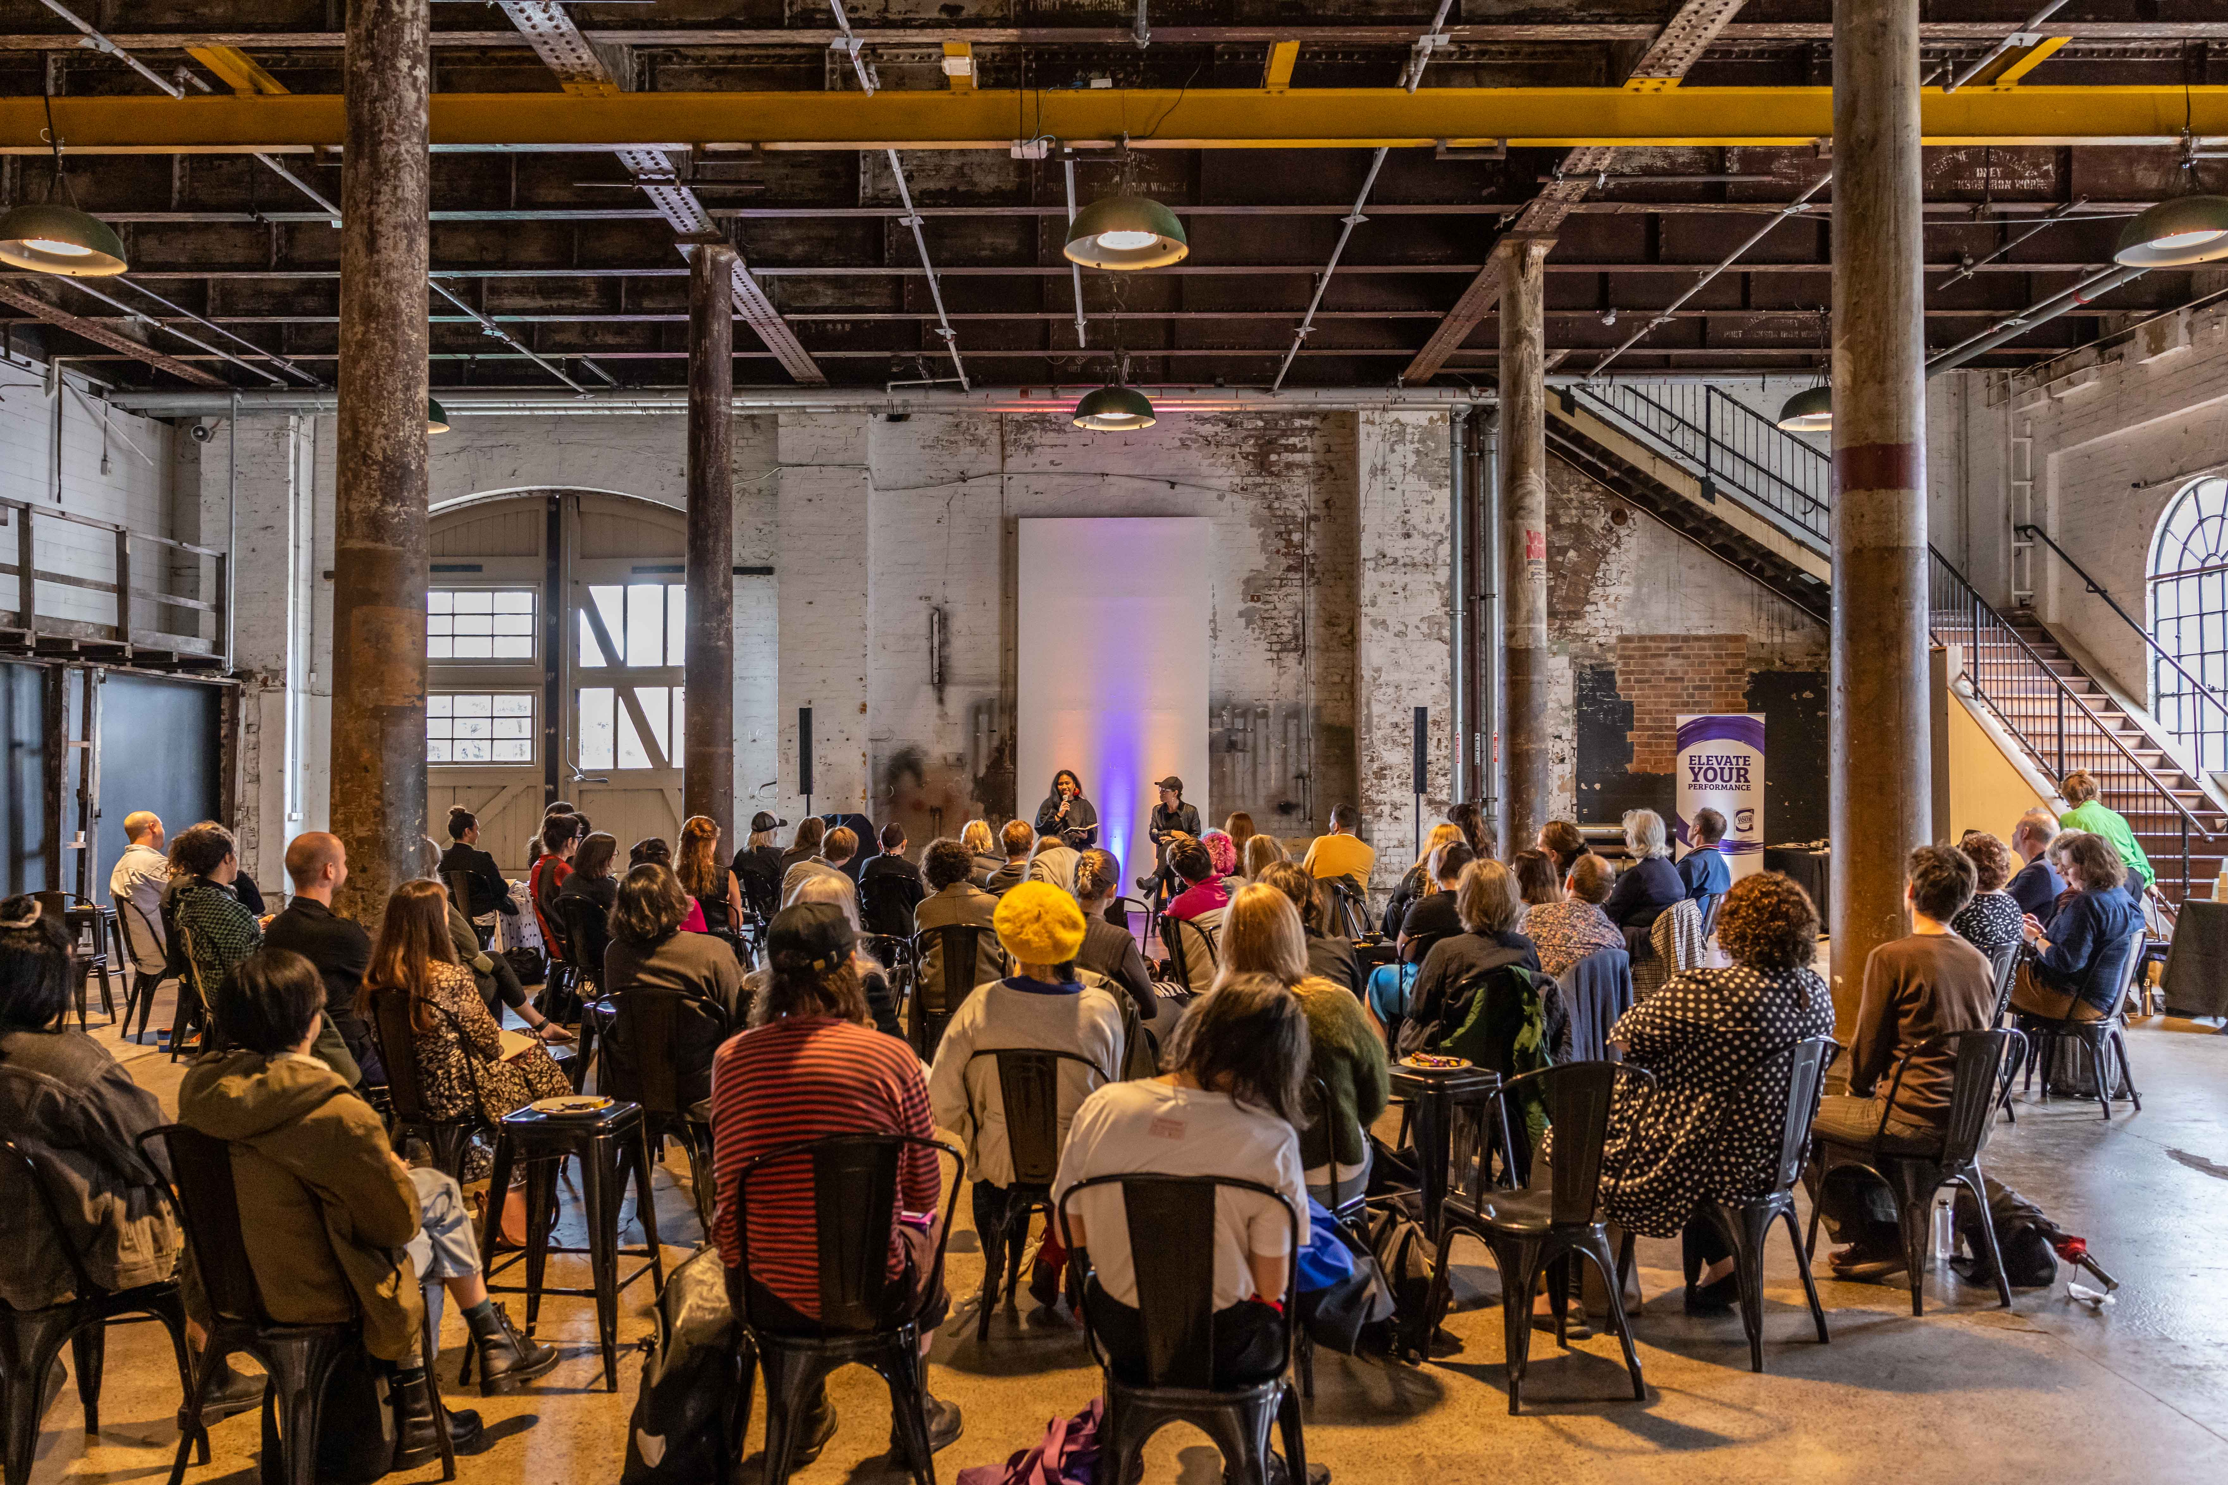

NSW Sector Gathering, 24 Oct, Carriageworks. Photo: Katherine Griffiths.

‘Creating Out Loud’ Peer Learning Program

TNA has run many of our programs in a peer-learning format since 2009. ‘Creating Out Loud’ is a new peer learning program that provides a framework to rethink current practices, extend and deepen professional networks, both within and beyond the arts and culture sector. Presented in partnership with University of Queensland, ‘Creating Out Loud’ brings Dr Kate Power’s academic expertise to our approach, enhancing our work and providing real world examples for Dr Power’s research.

Following the 2021 pilot program, we delivered a second, more intensive program in 2022. The 20 paid participants met online for 7 sessions over 9 weeks, utilising the ‘Creating Out Loud’ discussion guides. These guides were launched to the sector in a webinar on 14 July 2022 and are now available online as a free resource. Dr Kate Power will continue this program in 2023 in partnership with Australia Council for the Arts.

‘This was a fantastic experience that broadened my perspective on the arts. It was very valuable for me to re-evaluate my own practice and how I could incorporate ideas about sustainability (within the industry, and for myself) and how best to support others.’
– Sze Tsang, Independent on ‘Creating Out Loud’ 2022

Membership

TNA membership grew by 63 (12.5%) in 2022, including a net gain of 18 organisations and 45 independents. We had a strong increase in new members from Tasmania and in dance companies in particular.

Our 368 individual members made up 65% of membership, continuing our strong subscriber base within the independent sector.

Theatre companies represented the largest group at 14% of our total 199 organisational members, followed by Presenters, Producers and Industry Development Organisations 6.5% and Circus and Physical Theatre Companies 5.1%.

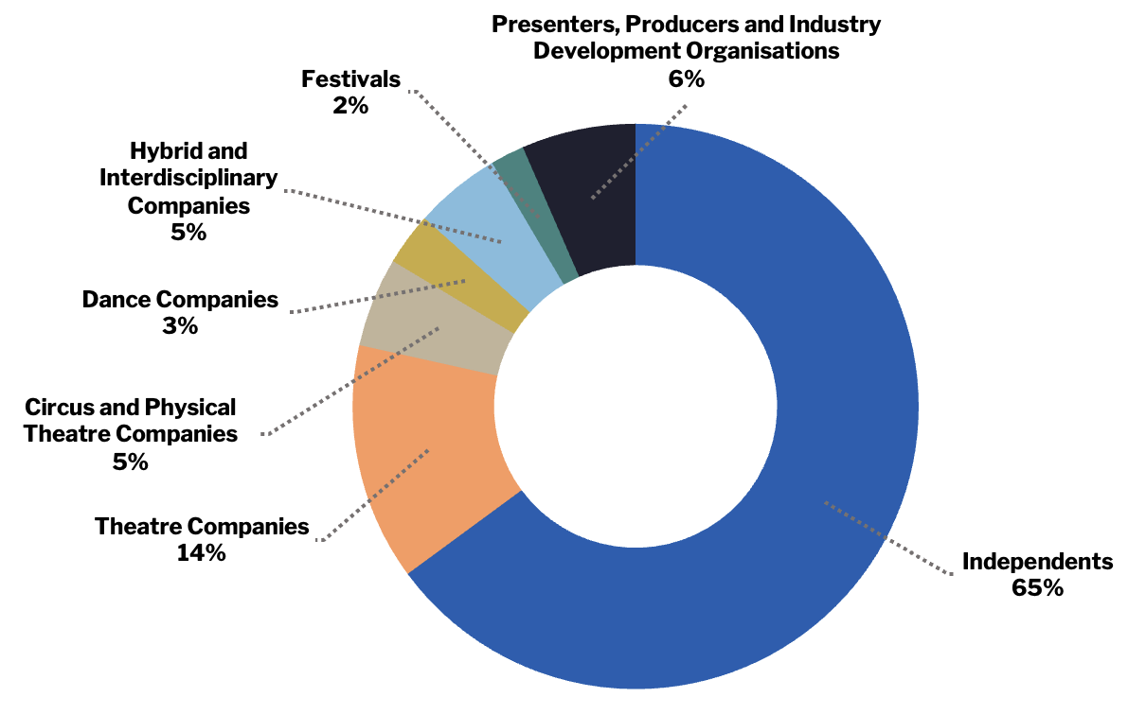

TNA 2022 membership breakdown by artform.

‘Thank YOU all so much. I appreciate each of you enormously, and the amazing work you do.’
— Christian Leavesley, Arena Theatre Company

Reach

Activities
Sector Gatherings (NSW, Regional VIC, TAS, VIC, WA) 5
Formal Presentations by staff 5
Participation by staff in sector events 15
Peer learning & mentorship programs 3
VIPI Salons 9
Information sessions 10
Sector meet ups 35
Government meetings 14
Sector Consultation Meetings 56
Media coverage 34
Industry surveys 1
Government Submissions 2
Policy & Resource listings 156
One-on-one meetings with other peak bodies & service organisations 39
One-on-one member meetings 148
Funding body meetings 53
Mentor meetings 10

Participants
Sector Gathering NSW 84
Sector Gathering Regional VIC 25
Sector Gathering VIC 117
Sector Gathering WA 48
Members’ Roundtable TAS 12
CaPT Forum 25
VIPI Salons 88
Members & Artists in TNA Listings 882
TNA Member of the Month, ‘Behind the Scenes’ Vision Australia Radio 10
Information sessions 32

Recipients: Awards, Grants & Bursaries
Supported Indie attendances at market development events 48
Unlocking Capacity grants (through Creative Victoria) 7
TNA sponsored awards 7
First Nations Emerging CaPT Mentorship 1
SMASH Bursary 1
NICA Observer placement 1

Circus and Physical Theatre (CaPT) Advisory Committee

TNA’s CaPT Advisory Committee was established in 2017 to maintain strong engagement and information exchange between TNA and the circus and physical theatre industry locally, nationally, and internationally. Meeting quarterly, the eight members are on a two-year tenure.

Key conversations from the CaPT Committee’s work in 2022 included Imagining Circus Futures — a planning process which led to the creation of a suite of programs TNA could offer. This fed into the three new Australia Council funded programs now being offered.

Committee members

Meredith Bell (WA)
Anni Davey (VIC)
Lauren Eisinger (NSW)
Lisa Fa’lafi (NSW)
Darcy Grant (SA)
Harley Mann (VIC)
Loki Rickus (SA, from May)
Freyja Wild (TAS)
Linda Corazza (2022 NICA observer)

ASSITEJ Advisory Committee

The acronym ASSITEJ comes from the original French: Association Internationale de Theatre pour les Enfants et le Jeunesse, meaning International Association of Theatre for Children and Young People. TNA is the ASSITEJ centre for Australia, one of 83 centres globally.

Established in 2020, TNA’s ASSITEJ Advisory Committee is made up of Theatre for Young Audiences and Youth Arts representatives from across the country. Together with ASSITEJ International President and Australian Representative, Sue Giles AM, we provide advocacy and leadership for the sector. Along with our ASSITEJ Advisory Committee, we coordinate international opportunities for artists, such as the Theatre for Young Audiences (TYA) Directors’ Exchange and showcase Australian performance with/for/by young people internationally. A highlight of the Committee’s work in 2022 was the selection process for an Australian representative at the Director’s Seminar in Germany in 2023. From a large number of applicants, the Committee selected Rita Pryce and Rita’s application was subsequently approved by ASSITEJ Germany.

Committee members
Sue Giles AM (ASSITEJ International President & Australian Representative)

Kevin Du Preez (NSW)
Penny Harpham (VIC)
Helen Hristofski (WA)
Zac James (WA)
Aleshia Johnson (ACT)
Belinda Kelly (TAS, from July)
Romi Kupfer (VIC)
Christian Leavesley (VIC)
Sarah Parsons (NSW)
Rhen Soggee (SA)

Celebration and Support

‘Being an independent artist, who also works voluntarily as the AD of a small, mostly unfunded youth dance company means that I'm often not able to travel for summits or conferences such as this.’
— Kyall Shanks, Independent/Yellow Wheel

Access for Indies

In line with our Access and Equity objectives, TNA seeks to reduce the financial barriers experienced by many independent artists and producers in attending market development and professional development events. In 2022 funding was secured to support 35 independents to attend FUSE, the national youth performing arts summit (ATYP, Sydney, NSW); Swedish BIBU Festival for professional performing arts for young audiences (Online); CIRCFest, a 10-day celebration of circus and physical theatre (Meanjin, QLD); and Showcase Victoria (Darebin Arts Centre, VIC). Additionally, TNA offered travel/access support or free registration to 21 independents to access TNA-hosted events.

First Nations Emerging CaPT Mentorship — Maggie Church-Kopp

This mentorship is awarded to an Australian First Nations CaPT artist in the early years of their professional practice and includes a bursary to support engagement with the professional industry. The 2022 Emerging Artist Mentee, Maggie Church-Kopp, is an Arrernte woman, born and raised in Mbantua (Alice Springs). She has been hanging off trapezes since before she could walk and is an ensemble member of First Nations circus, Na Djinang.

SMASH Bursary — Samantha Martin

Awarded annually to one recipient per year from 2018, the bursary recognises both the existing and potential contribution of an outstanding Australian-based Independent Artist or Producer to the performing arts sector. The 2022 recipient, Samantha Martin, is an independent creative producer and arts worker, with a career spanning cultural festivals, technical production, public art, independent film and screen, circus arts, and community development. She has been recognised for her work in founding grassroots, social impact cultural projects including the chronically ill and disability-led circus company, Get Well Soon, Safer Venues WA, Melbourne Fringe’s 2018 Venue of the Year ‘Camp Conscious Collective’, and The Invisible Illness Project.

NICA Observership — Linda Corazza

This opportunity forms part of the NICA Outstanding Student Leader Award (presented the year prior). The recipient is invited to attend all of TNA’s CaPT Advisory Committee meetings as an observer. Through these meetings, they make valuable connections with industry leaders from across Australia, gain insight into current sector challenges and opportunities, and contribute to discussions as an emerging practitioner. The 2022 recipient, Linda Corazza, is an acrobat who specialises in hand-balancing, group acro and corde lisse.

‘The TNA observership was a great opportunity to get to know more about the industry I am about to enter. Everyone on the board was so welcoming to me, I never felt like an outsider or as though my presence wasn’t valued. It was […] reassuring to know that the leaders in our industry are always working to make circus careers as accessible and sustainable as possible.’
— Linda Corazza, NICA Observer 2022

Awards

As part of our commitment to supporting artists across the sector, TNA supports a number of awards with Green Room Awards Association (GRAA), Melbourne Fringe and National Institute of Circus Arts (NICA). Each awardee received free TNA membership, mentoring and hot-desking. The NICA Outstanding Student Leader award includes a CaPT Committee Observership opportunity for a final year student.

Green Room Awards 2022

Dance Best Production
I am Maggie by Jonathan Homsey as part of Arts Centre Melbourne Take Over for Melbourne Fringe 2020

Independent Theatre Award for Best Direction
Benjamin Nichol and Izabella Yena Kerosene Jack Dixon-Gunn in association with Theatre Works
Contemporary and Experimental Performance Award for Curatorial and Artistic Direction
Let’s Take Over 2021 Darebin Arts Speakeasy Darebin Arts Speakeasy

Melbourne Fringe Awards 2022

Best Emerging Circus or Physical Theatre Performer
Salarywoman by Chiharu Valentino

Best Performance Ensemble
The Beep Test by Neylon & Peele

NICA Awards 2022

NICA Outstanding Student Leader
Amy Stone

NICA Graduate Award
Grace Robins

Communications

‘Thanks for the great bulletin! I'm really finding them useful.’
— Carmen Maddison, Boilover Performance Ensemble

Keeping the Sector Connected

TNA continued to deliver targeted and timely resources to artists and companies via email and across our digital platforms.

In 2022, we added 315 subscribers to our monthly E-News, with our impressive open rate continuing to grow, peaking at 58%. Our ASSITEJ Bulletin subscribers increased 24% and CaPT Bulletin subscribers increased 54%.

In addition, TNA sent out many member-only or special bulletins to specific segments of our database.

TNA was mentioned in the media at least 34 times in 2022.

Audience

E-News Subscribers 4,235
CAPT Bulletin Subscribers 731
ASSITEJ Bulletin Subscribers 939

Total Social Media Followers 8,869
Twitter 4,145
Facebook 3,586
Instagram 2,162

Communications

Number of E-News 11
Number of CAPT Bulletins 8
Number of ASSITEJ Bulletins 2
Member-Only Bulletins 8

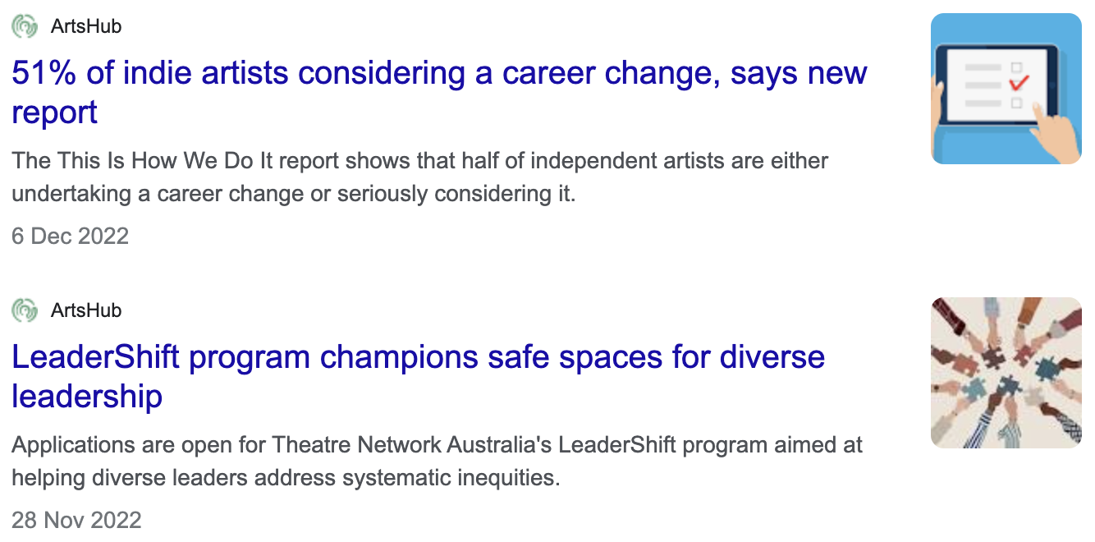

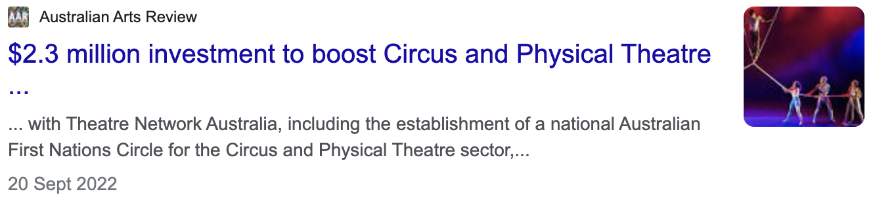

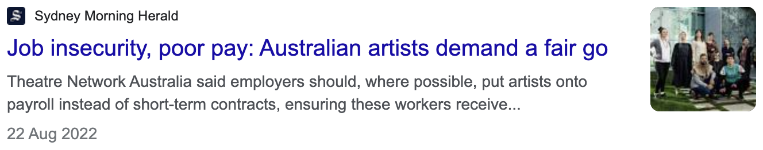

Media examples of TNA representing sector issues during 2022.

Behind the Scenes — Vision Australia Radio

TNA’s monthly radio spot on Vision Australia’s ‘Behind the Scenes’ program, hosted by Chris Thompson, continued to update the sector and champion artists. Our ‘Member of the Month’ guests in 2022 were: Simon Abrahams, Karla Conway, Carly Findlay, Monique Grbec, Zac James, Mitch Jones, Katerina Kokkinos-Kennedy, Michele Lee, Jessica Olivieri and Ilana Russell.

Governance and Management

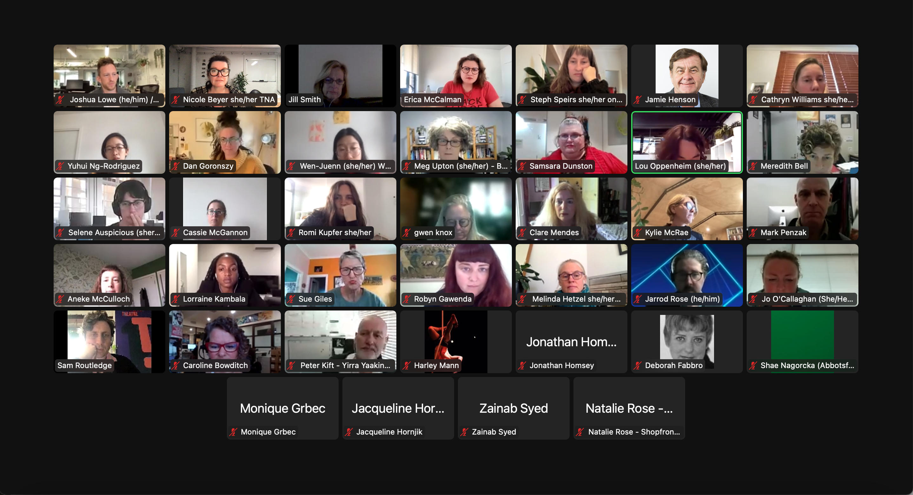

TNA’s Annual General Meeting, 6 May.

Operations

In early 2022 TNA secured multi-year funding from Creative Victoria for 2022–2025 with a small increase from our previous funding agreement. In addition, we received Sustaining Creative Organisations funding from Creative Victoria to increase TNA’s reserves.

We farewelled Steph Cox who left to take up the position of CEO of Women’s Circus, welcomed Steph Speirs into the role of Program Manager (CaPT and Events), saw Yuhui Ng-Rodriguez return from maternity leave to take up the role of Manager, Sector Development and Memberships, and Wen-Juenn Lee to expand her communications role to include management of VIPI.

Governance
In 2022 we farewelled our Chair Jill Smith AM after ten years of service on the Board, with Erica McCalman stepping into the role. TNA’s 2022 Board and Advisory Committees collectively have representation from all eight states and territories, as well as regional and remote members. Members who are independent creatives and arts workers are paid for each meeting attended. We promoted TNA’s Independent Sitting Fee (for board members not on a salary) to our sector colleagues, and it was presented as a best practice model in the work of governance expert, Kate Larsen. Organisations taking up this model include the National Association for the Visual Arts (NAVA).

As TNA continues to grow as an organisation we are constantly updating and refining our processes and systems of operations, including Board and staff inductions, financial reporting and transparency, and new ways to collect, interpret and report data.

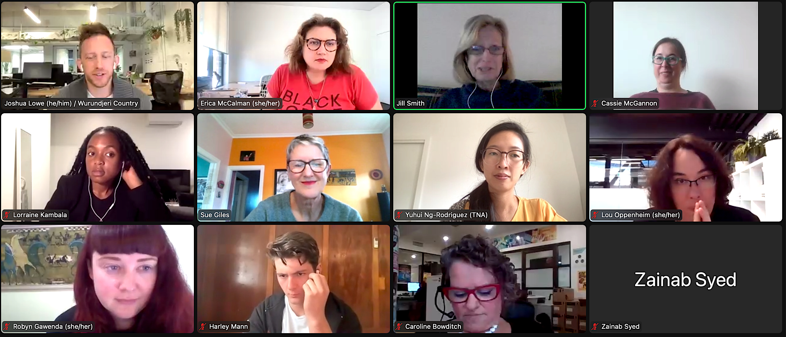

Meeting with members of TNA’s Board and Staff.

Finances

TNA’s total revenue in 2022 was $848,895, down from $933,636 in 2021 due primarily to the wind up of our multi-year support from the Sidney Myer Fund and JobKeeper.

2022 was the first year of our Creative Victoria Creative Enterprise Program funding ($145,000 p/a) which is a small increase from previous funding and now includes funding for TNA’s CaPT program in our core funding. TNA also received Sustaining Creative Organisations funding from Creative Victoria, of which we allocated $45,928 pa for the 2022, 2023 and 2024 budgets.

This year was the last year of the VIPI Producer’s Mentoring Program, with $354,119 of TNA’s revenue received to run VIPI, which will finish up altogether in 2023. In late 2022 it was announced that TNA would receive $498,993 over the two-year period 2023–2024 from the Australia Council to support several new CaPT initiatives, including four new part-time staff for the CaPT program.

TNA posted a modest deficit in 2022 of $6,284. The Board had approved a deficit budget to invest some reserves from previous years in more activity as we opened up after lockdowns. With some conservative budgeting, this deficit was smaller than planned.

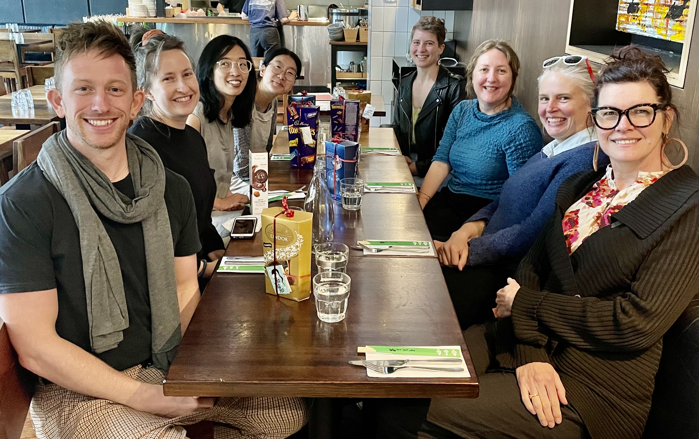

TNA Staff at end of year lunch, 6 December.

Staff

Nicole Beyer – Executive Director
Joshua Lowe – General Manager
Steph Cox – Program Manager – Safe Theatres, CaPT (until March)
Steph Speirs– Program Manager – CaPT and Events (from March)
Yuhui Ng-Rodriguez – Manager, Sector Development & Membership
Wen-Juenn Lee – Manager, VIPI & Communications
Charice Rust – Program Producer, CIPI (from Dec)

Casual & Contract Staff

Sam Ryan of SAYSO – Financial Management
Zac James – Bibu Online First Nations Delegation Facilitator
Melinda Hetzel – Program and Reporting Support
Kate Sulan – Sector Wellbeing Consultant

Board

Jill Smith AM (Chair until May)
Erica McCalman (Co-Deputy Chair / Chair from May)
Caroline Bowditch (Co-Deputy Chair until May/Board member from May)
Robyn Gawenda (Deputy Chair from May)
Lou Oppenheim (Treasurer)
Alex Desebrock (from July)
Sue Giles AM
Andrea James (until June)
Harley Mann (from April)
Cassie McGannon
Nithya Nagarajan (from May)
Zainab Syed
Sam Routledge (until May)
Lyn Wallis (until Feb)

Life Members

Simon Abrahams
Sarah Austin
Alice Nash
Bethany Simons
Jill Smith AM
Brad Spolding

2022 Partners

Advocacy Networks

National Peak Body Consortium
APRA AMCOS
ARIA
Arts Access Australia
Ausdance National
Australian Festival Association
Australian Museums & Galleries Association
Australian Music Centre
Australian Society of Authors
BlakDance
Diversity Arts Australia
First Nations Media Australia
Indigenous Art Code
Live Performance Australia
National Association for the Visual Arts
Performing Arts Connections Australia
PPCA
Regional Arts Australia
Screen Producers Australia
Symphony Services Australia
Theatre Network Australia

Arts Industry Council Victoria (AICV)
Arts Access Victoria (AAV)
Ausdance Victoria
Australian Museums and Galleries Association Victoria (AMAGA)
Express Media
Multicultural Arts Victoria (MAV)
Music Victoria
National Exhibitions Touring Support Victoria (NETS Victoria)
Public Galleries Association Victoria (PGAV)
Public Libraries Victoria
Regional Arts Victoria (RAV)
Songlines
The Push
Theatre Network Australia
VAPAC
Writers Victoria

Other Advocacy Partners
A New Approach
Arts Industry Council of South Australia
Australian Theatre for Young People

Project Partners
TNA works in a multitude of ways to support the sector, including partnering in big and small ways with our colleagues in other organisations. The following list includes organisations we connected with in 2022 to present an event, produce outcomes, or worked with to provide resources, awards or other sector support.

Arts Centre Melbourne
ASSITEJ International
Australian Performing Arts Market (APAM)
Australian Theatre for Young People (ATYP)
Ballarat Mining Exchange (City of Ballarat)
Bibu Performing Arts Biennale, Sweden
Carriageworks
Creating Out Loud Industry Reference Group
Creative Victoria
Creative Victoria’s Healthy Workplaces Advisory Group
Melbourne Fringe
National Circus Festival & Youth Circus Symposium
National Institute of Circus Arts (NICA)
Next Wave
Performing Lines WA
Performance Space/Liveworks Festival of Live Art
Showcase Victoria
State Theatre Centre WA
Theatre Network NSW
Vision Australia Radio ‘Behind the Scenes’
Youth Dance Australia
Youth Circus Australia Network

Research And Education Partners
Deakin University’s Arts and Cultural Management Program
University of Queensland

Funding Partners
Australia Council for the Arts
Creative Victoria
Sidney Myer Fund
Minderoo Foundation
Creative Partnerships Australia
City of Melbourne – Creative Spaces
Besen Family Foundation

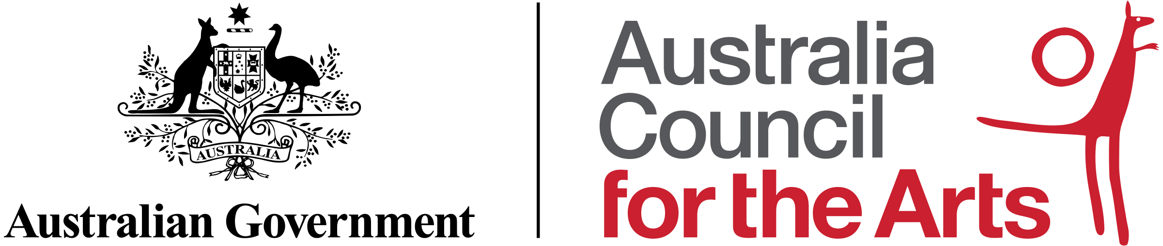

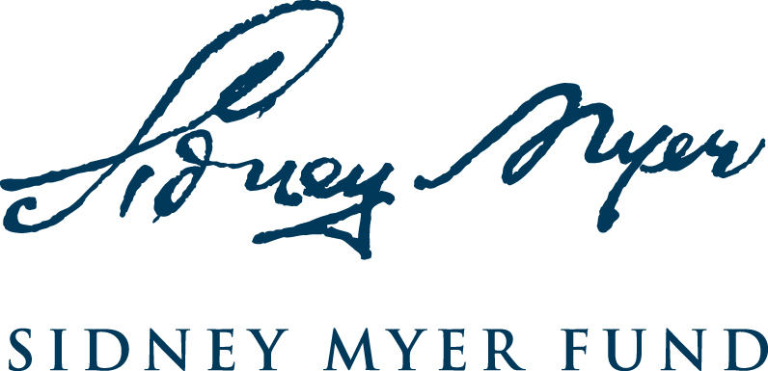

Contact Us
www.tna.org.au

Twitter: @theatrenetworka
Facebook: @theatrenetworkaustralia
Instagram: @theatrenetworkaustralia
LinkedIn: www.linkedin.com/company/theatre-network-australia

G5/152 Sturt Street, Southbank VIC 3006
03 9947 1015
info@tna.org.au

Ballarat is spelt Ballaarat in Wadawurrung language. See: https://www.indigenous.gov.au/news-and-media/stories/there-are-four-%E2%80%99s-ballaarat-%E2%80%93-place Accessed: 29 Mar 2023

