Theatre Network Australia
Annual Report 2023

Acknowledgement of Country
Wherever we are in Australia, TNA acknowledges the traditional custodians of the lands we live on. We give thanks for the care and custodianship of the lands and waterways by Aboriginal and Torres Strait Islander people for tens of thousands of years. Our office is based on the southern banks of the Birrarung, so we especially acknowledge the Wurundjeri and Boon Wurrung people of the Kulin nation. We pay our respects to Elders past and present. Sovereignty was never ceded.
The Australian Performing Arts Forum 2023. Image Credit: Jade Ellis.

Contents
About TNA 4
Reports 5
Advocacy 11
Capacity Building 13
Circus and Physical Theatre 16
Young People and the Arts 22
Networks and Connections 24
Research and Resources 29
Reach 31
Communications 32
Governance and Management 34
Contact Us 38

About TNA
Founded by the sector in 2009, TNA is a leading service organisation for the small to medium and independent performing arts sector. TNA strengthens artists and arts organisations, influences cultural policy, facilitates critical debate and networking, and advocates for a safe, healthy, and relevant sector.

TNA believes in the central role that creativity plays in a society.

- We work towards a more diverse and fairer performing arts sector that puts First Nations people first
- We value independent artists, small to medium companies and large organisations, and we want greater interconnections between them
- We believe in life-long learning. We support different models of working, and we value flexibility
- We advocate for fair pay and conditions for our sector. We know that risk and experimentation are important
- We foster ongoing, respectful, and challenging conversations that connect us, open new ideas, and lead to a stronger sector

In practical terms, this means TNA:

- Runs industry forums and gatherings
- Delivers workshops on current issues for the sector
- Drives advocacy campaigns in partnership with other service organisations and the sector
- Undertakes and promotes research and benchmarking
- Provides advice to industry, the education sector and government
- Provides information and resources through our popular E-News and the online resource library

We design our work to address the gaps. Our approach is underpinned by a spirit of care, deep listening, and trust in the sector’s capacity to make progress.

‘Australia's creative arts industry is incredibly diverse and separated by vast distances. TNA connects us.’
—Jessica Blaxland Ashby

Reports

Chair’s Report
2023 was a year of beginnings and endings at Theatre Network Australia.

We began our two-year program of Circus and Physical Theatre (CaPT) capacity building initiatives, bringing four new dedicated staff members into TNA. The CaPT initiatives have created new pathways for riggers and independent producers, new advocacy and research resources, and the beginnings of a First Nations Circle for the CaPT sector.

After nearly a decade of advice, consultation and indefatigable work by TNA, artists and colleagues across the sector, we also saw a new National Cultural Policy launched.

We piloted LeaderShift, a new culturally safe leadership program delivered by Veronica Pardo. Eleven arts organisations from around the country journeyed though improving their practices and building a more equitable future.

In September, we brought 342 artists, arts workers, creatives and elders together under the Brisbane sun for the Australian Performing Arts Forum. We welcomed old and new faces into the fold. It was an inspiring three days of exchange, robust discussion, reconnecting with friends and collaborators not seen since before the pandemic.

After 14 years at the helm, Nicole Beyer gave notice of her intention to step down as Executive Director at the end of the year, initiating a national recruitment process led by the TNA Board. Sue Giles stepped up to become Interim Chair. The Board showed its commitment and care during this time, being deeply involved and connected, with all sharing the responsibility for maintaining a consistent and communicative approach.

The appointment of Erica McCalman and Joshua Lowe as Co-CEOs was announced just before the farewell party for Nicole Beyer. A new era had begun. Nicole’s party was a true acknowledgement of the spirit, energy, love, and care Nicole brought to the organisation. We celebrated her astute, strategic mind and her instinct for relationships that made her lobbying and communication legendary.

We would like to extend our heartfelt thanks to the TNA staff: Josh, Steph, Yuhui, and Wen-Juenn, as well as our CaPT team Christy, Lauren, Charice, and Christian for their hard work, trust in the process, and steadfast loyalty to the sector this year.

To our members and fellow travellers, we are always honoured to serve you and the sector.

The TNA board is a collection of beautiful minds with experience in a broad range of areas that serve the sector strongly and with great insight. It's a fascinating board to be part of and we thank you all for your commitment.

We are proud of the year that has been and the process we have all been part of; good careful transition planning, having the right people in the right places, effective work with government and with Creative Australia, and working on issues that strike at our strength and unity.

Erica McCalman Sue Giles
Chair (May 2022–Oct 2023) Interim Chair (Oct 2023–Mar 2024)

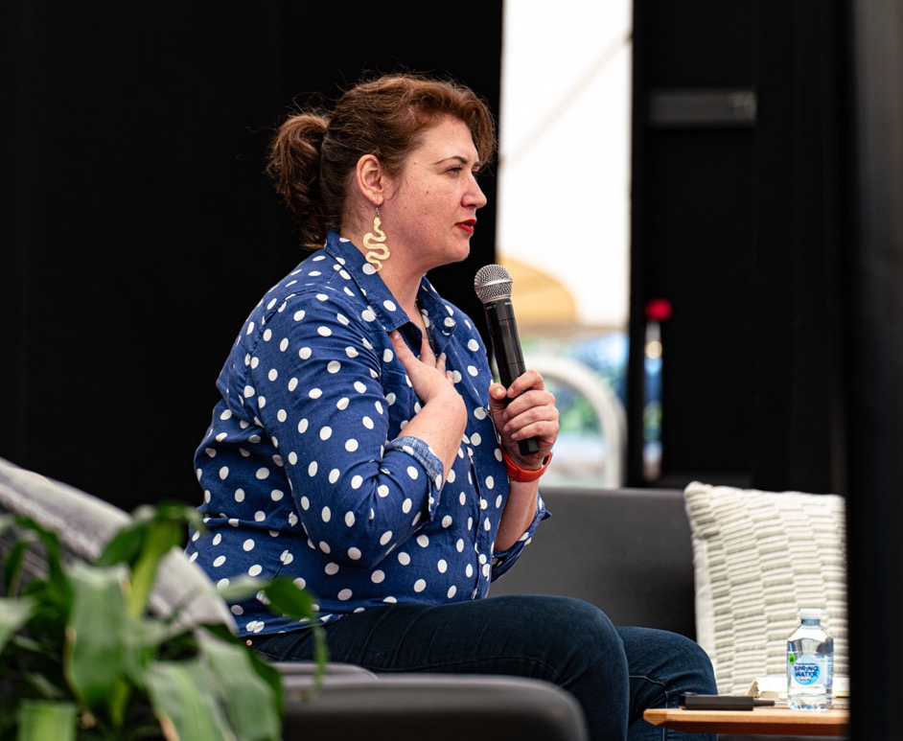
Erica McCalman speaking at the Australian Performing Arts Forum. Image Credit: Jade Ellis.

Executive Director’s Report

So here it is, my last Annual Report with TNA. Please indulge me if I reflect on more than just the year of 2023.

I started this role in April 2009, part-time, at a desk in the Chamber Made office at the Meat Market. My salary was paid through Arena Theatre. I had an Advisory Committee, a laptop, a notebook and a pen. The founding committee must be applauded for getting the 18-month grant that made TNV possible. Simon Abrahams, Sarah Austin, Maude Davey, Rose Godde, Fiona Maxwell, Erin Milne, Alice Nash, Chris Thompson and Geoffrey Williams. You sat around a table, dreamed a dream, and you made this thing happen. We are eternally grateful to you all.

On day one, after setting up some meetings I went and bought a diary. Then I started working on a breakfast session to be held at the upcoming (a week later!) Australian Theatre Forum, run by the Australia Council for the Arts. The session was to ‘throw around ideas for creating a national peak body for theatre’.

Well, we did that! I think what resonated with the sector, first in Victoria then nationwide, was simply having someone on your side, someone who spoke up for you, and someone to call on when needed. People valued belonging to a network and having opportunities to share with peers in large and small ways. None of that has changed, but as TNA has grown, we have been able to do more strategic work, take on work for the performance for/with/by young people sector, take on work for the circus and physical theatre sector, and build relationships with hundreds of individuals and organisations across the country who help us achieve our goals.

2023 has felt like an appropriate cross-section of my nearly 15 years with TNA. It started with the long-awaited launch of Revive, the National Cultural Policy. Being at the Espy Hotel in St Kilda with my colleagues from across the country who had advocated for this ambitious plan for our nation’s arts and culture, was a sweet moment. Towards the end of the year, gathering with 350 colleagues in Meanjin at our first in-person Australian Performing Arts Forum in six years was also soul-feeding. In between, there were all the usual periods of urgent advocacy to do. We did our eighth small-to-medium salary survey, we started a new two-year capacity building program for circus and physical theatre, we launched LeaderShift to support a cohort of diverse emerging leaders and their CEOs, and we continued to meet with colleagues around the country at various events, markets, and gatherings.

There are so many people to thank as I sign off. I can’t name everyone but there are some I can’t not name. From that founding Committee, Simon and Alice stayed the course and as Chair and Deputy Chair, saw TNV become an organisation, and become fully national as TNA in 2015. They were joined by Jill Smith who stayed with the board for ten years, including as Chair for four years. This triumvirate was my brains trust and we remain deep friends forever. There have been 39 TNA board members since 2009, all bringing personal and sector knowledge and insight to keep TNA going strong. I am deeply grateful to them all, especially the executive members who give that bit extra. They include our very first Chair Fiona Maxwell; Erin Milne, who recruited me; Brad Spolding, who remains one of TNA’s key supporters; Annette Vieusseux, who was Chair for a period; and Lyn Wallis who supported TNA through her role at the Australia Council and then on the Board.

The current Board, of course, I want to thank for seeing us through the COVID-19 era. There is so much more work to do now in supporting mental wellbeing, in planning in a way that is agile, in looking at risk management in a new way.

Lou Oppenheim has been with the TNA board for eight years and is the most incredible Treasurer and general wise counsel that I could wish for. Sue Giles as interim Chair and Australia’s ASSITEJ representative has beautifully guided TNA to step up its support for the performance with/for/by young people sector. Erica McCalman as Chair for a short period was the perfect leader to steer us from 2022, exemplifying the wisdom and gravitas of our First Nations leaders that we as a community need at the helm (and which she will continue to be as Co-CEO). Caroline Bowditch is a national legend and I have had the true pleasure of working with and learning from her since the 1990s, through to her role on the TNA board. Cassie McGannon (Deputy Chair), Alex Desebrock, Nithya Nagarajan, Harley Mann, Zainab Syed, Liesel Zink, Carin Mistry, Tim Stitz, and new members Anthony Peluso and Emily Coleman, I salute you for your commitment and your support.

There are so many colleagues I have worked with who I am indebted to, but I just can’t list you all here. Colleagues at Creative Australia and Creative Victoria, Ministers, Advisors, other peak bodies who worked on ‘Free The Arts’ and other campaigns with TNA, colleagues at APAM and Arts Access Victoria and other partner organisations, venues and festivals, funders in other states, philanthropic supporters including the Sidney Myer Fund team, the AICV peaks, and producing companies and independents who take on advocacy as well as their daily work.

Past staff hold a special place in my heart: Bethany, Simone, Jamie, Kath, Tessa, Rani, Steph C, Ang, Kim, Anna, and contractors Kate, Veronica, Kieran, Jonny, Min and Sam. TNA wouldn’t be here without all of your work and love. Special thanks to our amazing ATF, APAF and project contractors too.

There are ten of us now at TNA—mostly part-timers—and the work culture and passion for making our sector better is so embedded across the organisation that it’s okay for me to leave. I want to thank, from the bottom of my heart, Josh, Yuhui, Steph, Wen-Juenn, Carmen, Lauren, Christy, Charice and Christian for yet another year of giving your all to your sector. I will miss you all! This team of amazing people, with Josh and Erica as Co-CEOs, are going to continue to do the essential work of TNA well into the future.

The small to medium and independent sector still feels fragile after the ravages of COVID-19 and lockdowns, but there are green-shoots that give me hope. In addition to Revive, many states are developing new arts policies; there are more longer-term funding programs for independent artists; digital connections between artists and companies across the country and internationally are booming; there is also a refocus on the local, on working with your own community; there is an exciting time ahead to think about the role artists can play in AI, in providing the narratives and creative solutions for prompting for example; and there are some specific things that will help—a new works of scale fund, more money for small to medium companies, and changes like Centrelink recognising arts work as valid work. There’s still work to be done in equity and racial justice; we need to do better at thinking generationally about our planet, but we have the wisdom of our First Nations colleagues to guide us in that, and people are starting to hold organisations to account. There is a huge sector of amazing artists and companies still telling stories that need to be told and giving audiences new ways of looking at the world.

I am so grateful to all of our members and the wider sector for your collegiality over these past 15 years. I will see you on the other side!

Nicole Beyer
Executive Director
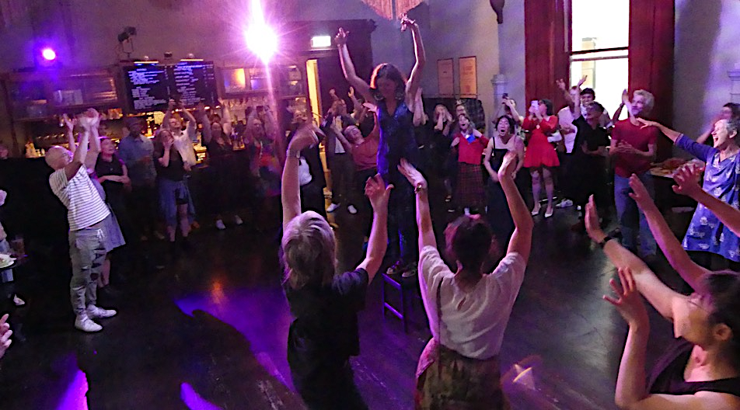
Nicole’s Farewell Party. Image Credit: Tim Stitz.

Treasurer’s Report
I am pleased to report that TNA (Theatre Network Au Inc.) has returned a modest surplus of $19,266 for 2023, on a turnover of $1,119,101. This means that the organisation now has total reserves of $195,024.

TNA’s total revenue in 2023 was $1,119,101 (2022: $848,896). This increase is due to the additional delivery of Circus and Physical Theatre (CaPT) programming, alongside the Australian Performing Arts Forum (APAF), with a commensurate increase also in costs ($1,091,273 in 2023 compared to $855,182 in 2022).

I congratulate the former and current executive team for their ongoing outward focused, strategic, and financially sustainable management and for providing the organisation a strong foundation on which to continue its contribution to the sector.

Finally, we are sincerely grateful to all our partners, including our core recurring funding partners Creative Australia, who allow us to service the national agenda, and Creative Victoria, for our home state programs and support of Victorian companies and independent artists and producers. Going forward, we particularly acknowledge multi-year support from Creative Australia from 2025-2028, which will ensure the organisation’s ongoing ability to plan and deliver longer term initiatives for the benefit of the broader sector.

Following the resignation of previous auditors, Sean Denham and Associates, the 2023 audit was undertaken by Gianna Rosica Pty Ltd with Roslyn Buzza. A full copy of the audited statements is available on request.
Lou Oppenheim
Treasurer

Advocacy
‘TNA's advocacy and genuine desire for diversity and access—organisationally and across our industry as a whole—is exemplary.’
—Andrea James, Griffin Theatre Company
Advocating for the sector, in particular emphasising the needs and public value of the small to medium and independent sector, is one of TNA’s key roles. We provide high level policy advice to government, funding program input and feedback, advice on mechanisms such as advisory group design and communications strategies, advocacy on urgent sector issues, and intel for opportunities for the sector.

‘Revive’, the National Cultural Policy
In February, the government launched ‘Revive’, the country’s first national cultural policy in a decade. In the lead up, TNA advocated heavily with other peak bodies for the National Cultural Policy, and co-ordinated a joint submission to the budget process. After the launch, TNA read and combined analysis, and created an overview for members on what the policy might mean for the sector over the next five years. We looked at gaps and strengths, and we submitted our submission for The Senate Inquiry into the National Cultural Policy. We welcomed the investment in creativity, which included a First Nations led board, but raised concerns about the lack of commitment in youth arts, climate action, racial equity, and international touring and exchange.

‘The Voice’ Referendum
In the lead up to the ‘The Voice’ Referendum, many performing arts organisations considered if they should be making statements. In response, TNA compiled a list of resources on The Voice, and summarised key details to our members. Additionally, we hosted a webinar led by Michael Lavarch AO, and a peer discussion facilitated by Erica McCalman.

Submissions
In 2023, we made submissions to the Federal Youth Engagement Strategy, ANZCO Review, the Tasmanian State Budget, and the Modern Awards Review:
- Federal Youth Engagement Strategy
A big piece of work in 2023 was TNA’s consultation and submission to the Federal Office for Youth’s new Federal Youth Engagement Strategy, which called for a creative industries youth advisory group to be added to the five existing groups. Later in the year, the Federal Office for Youth announced this new advisory group.
- ANZCO Review
Our submission to the ANZCO Review was to ensure that the performing arts workforce was accurately represented. Our submission recommended adding 39 new occupations, updating 10 existing occupations, and some structural changes to how occupations were grouped.
- Tasmanian State Budget
Data from that ABS indicated that in 2021-22, Tasmania had the lowest Arts expenditure per capita of any state or territory. TNA provided input and assistance to the work of Cathryn Williams (DRILL General Manager) to put together a submission to the Tasmanian State Budget Community Consultation. In our submission, we recommended an increase to arts and cultural investment, ongoing annual indexation, and renewed investment.
- Modern Awards Review
Following the Federal Government’s commitment in REVIVE, the Fair Work Commission undertook a review of the Modern Awards. Alongside Live Performance Australia and MEAA, TNA was part of the consultation process to represent the national performing arts sector. TNA made a written submission responding to key questions in the discussion paper, and a further submission on additional information, which advocated specifically for Producers and Arts Administrators to be more clearly identified within the Live Performance Award’s lists of indicative positions.

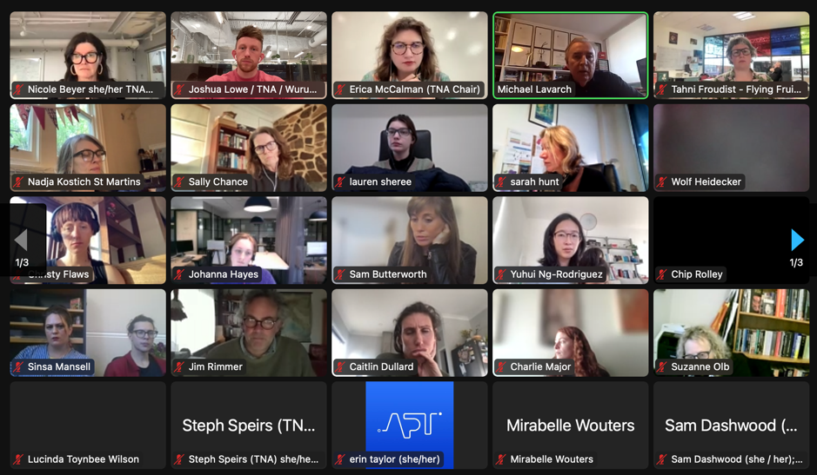
TNA’s Voice Referendum webinar.

Capacity Building

Supporting Equity and Inclusion
TNA strives to promote equity, justice, access, and inclusion across all our programs. Our Equity Action Plan (EQAP) guides this work. Throughout TNA’s programs, we ensure we address our five access and equity objectives:

- First Nations First
- Justice and Diversity
- Safe Theatres/Workplaces
- Access and Inclusion
- Gender Equity

All our Position Descriptions align to these objectives, and we report on the EQAP outcomes annually. We shared a 2023 update of the EQAP, which includes refreshed organisational commitments such as expanding our EQAP Board agenda item to include discussion time on key readings, developing a cultural safety rider for new employees, and continuing with our targets for employment of and engagement with people from diverse communities.

LeaderShift
Our 2023 pilot of LeaderShift was conceived of as an intervention to the underrepresentation of leaders from diverse backgrounds in the performing arts. We were aware that underrepresentation was not necessarily due to low number of diverse leaders, but to the systems that support and privilege white, cis, and non-disabled identities. Our intervention would support existing diverse leaders with tools and peer support, while simultaneously engaging their organisations’ CEOs in the Culturally Safe Leadership Program that asked them to examine their leadership and business models, and to make a commitment to implementing changes that prioritise equity and cultural safety.
We engaged a group of 11 diverse mid-career arts professionals, working in performing arts organisations, in roles with decision-making power. Participants met monthly for peer-learning and professional development, facilitated by consultant Veronica Pardo. These sessions featured guest speakers including Amrit Gill, Annette Shun Wah, Sonya Suares, and Priya Srinivasan, on topics such as cultural safety models and strategies, authentic leadership, and alliance building. Participants were also provided $3,000 for additional professional development.
Our cohort participants for 2023 were:

- Ari Palani at La Boite with CEO Courtney Stewart
- Asha Bee Abraham at Footscray Community Arts with Co-CEOs Daniel Santangeli and Bec Cole
- Bernadette Fam at Malthouse Theatre with CEO Matthew Lutton
- Caro Duca at The Blue Room Theatre with CEOs Katt Osbourne and Sukhjit Kalsa
- Heath Wilder at Sydney Theatre Company with CEO Anne Dunn
- Jennifer Rani at Australian Plays Transform with CEO Erin Taylor
- Khym Scott at Griffin Theatre Company with CEO Julieanne Campbell
- Samira Farah at Arts House with Co-CEOs Nithya Nagarajan and Emily Sexton
- Shy Magsalin at Penrith Performing & Visual Arts with CEO Krissie Scudds
- Tasnim Hossain at Melbourne Theatre Company with CEO Anne-Louise Sarks
- Zainab Syed at Belvoir St Theatre with Co-CEOs Eamon Flack and Aaron Beach
‘I would seize any further opportunity for myself or members of our organisation to participate in further iterations of this program. This work must be thorough and ongoing. Thanks TNA—please do it again!’
—Erin Taylor, Australian Plays Transform

The Victorian Independent Producers Initiative (VIPI)
VIPI, a major four-year sector development program that TNA has delivered since mid-2019, wrapped up in 2023. The initiative was established to support independent producers in the performing arts in Victoria. It saw three rounds of the Producers Mentorship Program, and three rounds of the Unlocking Capacity Grant. Recipients in the third round of Unlocking Capacity will wrap up with their three-year funding in 2024.

In 2023, we focused on our VIPI Salons—professional development and networking events aimed at emerging producers and the wider performing arts sector. Most salons were co-run with CIPI, a counterpart focusing specifically on supporting independent producers in the Circus and Physical Theatre sector.

‘TNA makes a fantastic contribution to the performing arts. I think people don't realise exactly how much TNA does behind the scenes to just keep the industry buoyant — if you took away TNA, it would be like removing stitches from a garment. It would fall apart. […] To me, TNA is like a silent arts partner.’
—Clare Mendes, Independent Producer & Company Manager, Melbourne Writers’ Theatre
VIPI Producing Fundamentals 2023 at the Fringe Common Rooms. Image Credit: Jacinta Keefe.
TNA ran:
- Facilitating Conflict within Working Relationships with Kate Sulan
A free workshop for independent producers, who were often having to mediate the dynamics of a group, while creating, rehearsing, and performing a project. Kate Sulan shared facilitation principles, micro skills for facilitation, and conflict scenarios.
- Producing Fundamentals 2023
A full-day workshop of professional development and networking, with guest speakers Tony Yap, Freya Waterson, Alex Paige, Theo Cassady, Freya Waterson, Anna Nalpantidis, Creatrix Tiara, and a dedicated Circus and Physical Theatre breakout session with Steph Cox and Nic Clark. Over lunch, we paired emerging artists and producers to gain mentorship and receive advice from established producers.

- One-on-one Coaching Session
To end the year and wrap up the VIPI program, TNA ran one final coaching session, with 25 emerging producers paired with 25 established practitioners. Participants were paid for their time, and afternoon tea was provided.

‘I loved the informality and exceptional pairing (which everyone I spoke to commented on) …what a wonderfully diverse group of people.’
—Participant in Coaching Session

Circus and Physical Theatre
As the CaPT peak body in Australia, TNA is deeply committed to a strong future for the sector. In 2023, TNA began its two-year CaPT capacity building initiatives, managed in partnership with Creative Australia, including:

- CaPT Independent Producers Initiative (CIPI)
- The Australian First Nations Circle
- The Safe & Sustainable Circus Rigging Initiative
Alongside this, TNA’s CaPT Advisory Committee continues to hold deep and broad connections with independents, companies, and other stakeholders.

Circus and Physical Theatre (CaPT) Advisory Committee
TNA’s CaPT Advisory Committee was established in 2017 to maintain strong engagement and information exchange between TNA and the circus and physical theatre industry locally, nationally, and internationally. Meeting quarterly, the eight members are on a two-year tenure.

Highlights from the CaPT Committee’s work in 2023 included:
- Participating in consultations for the Sector Scan commissioned by Creative Australia and Creative Victoria
- Offering sector insights and provocations to the APAF curatorial team
- Sitting on selection panels for TNA’s application-based CaPT programs
- Driving the Access in Circus Workplaces project which launched in April 2024
- Contributing to TNA’s strategic planning process for 2025–28

Committee members

Meredith Bell (WA)
Anni Davey (VIC)
Lauren Eisinger (NSW)
Lisa Fa’lafi (NSW)
Darcy Grant (SA)
Harley Mann (VIC)
Loki Rickus (SA, from May)
Freyja Wild (TAS)
Amy Stone (2023 NICA observer
CaPT Independent Producers’ Initiative (CIPI)
Modelled on the Victorian Independent Producers Initiative, the CaPT Independent Producers’ Initiative supported CaPT independent producers across Australia, who work with artists in and from Victoria. CIPI had two components: the Emerging Producers Lab and the Salon Series.

The Emerging Producers Lab
Four emerging independent producers were supported with part-time wages and monthly professional development sessions in a co-learning environment, with guest mentors. The Lab ran for twelve months, wrapping up in March 2024.

The Emerging Producers Lab participants were: Karina Schiller, Harlow Carey, Samantha Martin, and Dylan Singh. Read more about them.
The session topics were:
- July: ‘Growth & Sustainability of Practice for CaPT Producers’
with independent producer Lauren Eisinger
- August: ‘Business Structures’
with Kate Larsen, followed by a panel discussion with Jascha Boyce (Gravity and Other Myths) and Hannah Cryle (independent CaPT artist and producer)
- September: ‘Audience Development’
with Monica Davidson (Creative Plus Business)
- October: ‘Touring Overseas & International Pathways’
with independent CaPT Producer Linda Catalano (Quiet Riot)
- November: Cultural Safety and Inclusivity’
with Natano Fa’anana (Casus Creations)
- December: One-on-one mentoring with industry mentors

‘My favourite part of this program so far is the variety of presenters and their practices… and hearing [about] their unique set of challenges and skills’.
—Dylan Singh, Emerging Producers Lab (EPL) Producer

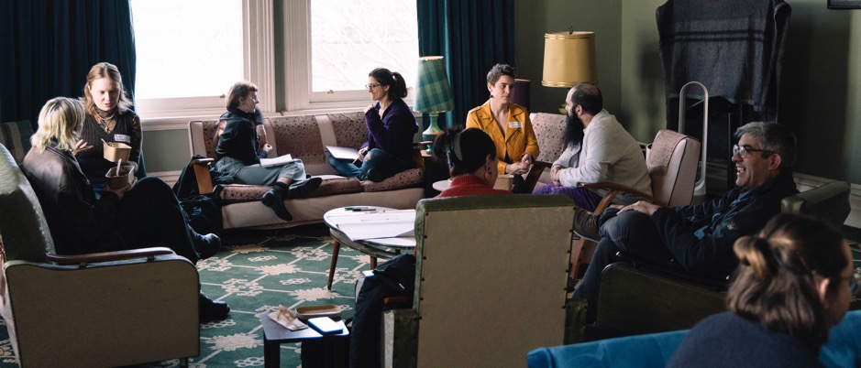
CaPT Salon at Producing Fundamentals. Image Credit: Jacinta Keefe.
The Salon Series
Like VIPI, the salon sessions were offered to the wider Victorian CaPT sector, with online salons open to the national sector. Some CaPT salon sessions ran in conjunction with the VIPI salons, while others addressed topics and skills specific to the CaPT sector. The series included a dedicated CaPT mentoring program, pairing established CaPT producers with emerging CaPT artists, a dedicated CaPT breakout session as part of Producing Fundamentals, and an online webinar on engaging with arts marketplaces. Additionally, CIPI ran a dedicated CaPT grant-writing salon ‘Be a Peer Assessor for the Day’, where participants were given three real grant applications to assess, discuss as a panel, and draw insights on to improve their grant writing.
Australian First Nations Circle for the CaPT Sector
‘Our common thread is that we are passionate physical storytellers, with a desire to see a healthy sector where mob can thrive. We want the sector to feel empowered with the right tools to support and champion us.’
—Lauren Swain, TNA Program Producer, First Nations Circle

The Australian First Nations Circle platforms First Nations voices in the CaPT sector, facilitating First Nations people making decisions that affect them. In line with this vision, the group is First Nations-led, and consists entirely of Australian First Nations representatives. The program has a dedicated First Nations Program Producer to coordinate the Circle.

As an Australian First Nations-only space, the Circle explores complex and widespread sector issues such as representation, cultural safety, and organisational accountability. Circle members are supported with co-designed professional development until the end of 2024.
As a national circle, recruitment aimed for a spread of representation across multiple states. Within the cohort, there are connections to Victoria, Queensland, New South Wales, Northern Territory and Western Australia. Support was provided to one Circle member who is a parent.

The Australian First Nations Circle is made up of: Ally Humphris, Dale Woodbridge-Brown, Ghenoa Gela, Janine Oxenham, Kirk Page, Lara Croydon, Maggie Church-Kopp and Tara Gower. Read more about them.

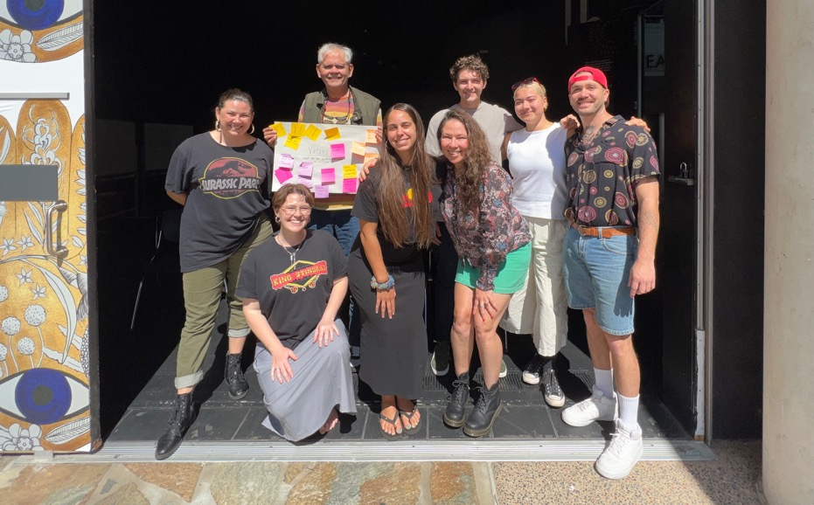
The Australian First Nations Circle. Image Credit: Lauren Swain.

Safe and Sustainable Rigging Initiative

Rigging Ticket Upgrade Program
There is a need for qualified and knowledgeable riggers in Victoria. In response to the Victorian Government’s Skills First funding, which provided subsidised accredited courses, TNA developed a Rigging Upgrade program to address the gaps in Skills First. This meant offering financial support for Intermediate Riggers to upgrade to Advanced tickets, and to support riggers based regionally with bursaries to allow them to access training.
Recipients of our Advanced Rigger Ticket Bursaries were: Andrew Dyson, Jane Schofield, Kyle Raftery, Liam Drennan, Mitch Jones, Sam Aldham and Thomas McDonald.
Recipients of our Regional Rigger Ticket Bursaries were: Benjamin Lewis, John Carberry and Tarn Scully.

Diverse New Rigger Scholarships
In response to the lack of diversity in circus rigging, TNA also offered scholarships to support two aspiring Victorian riggers to complete a Certificate III in Rigging. The scholarship includes a significant training stipend, a bursary to assist with travel and accommodation costs, financial support for access and equity barriers, and co-designed professional development and mentoring from experienced professionals.

Applications were open for four months to encourage as many applications as possible, and for TNA to identify and encourage a range of diverse applicants.
The recipients of the Diverse New Rigger Scholarships were Mel Tan and Catherine Horan-Blake. Read more about them.

‘You are a wizard, and this is such a game changer! Thank you for all your time and energy putting this together. It’s huge and we really appreciate it.’
—Malia Walsh

Access & Equity
TNA also sought to support access and equity in the CaPT sector in several informal and flexible ways. We facilitated a CaPT Advisory Committee Observer, awarded to final year NICA student, Amy Stone. Amy attended four of the CaPT Advisory Committee meetings, including a strategic planning session for TNA’s business plan. First Nations CaPT artist Johnny Brown and NICA graduate Grace Robins each had a mentoring session with Steph Speirs, our CaPT Program Manager. We also offered a bursary for a circus trainer with diverse lived experience to cover the costs associated with attending the Canberra Circus Festival Trainer Development Program; this was awarded to Rachel Peters.

Research and Resources for the CaPT Sector
We undertook research to better respond to the ongoing challenges the sector faced.
- Insurance
Responding to member concerns around the decreasing availability of appropriate and affordable insurance options for the CaPT sector, we consulted with artists, member companies, arts organisations, government, and brokers, researching options for insurance coverage. This work is ongoing, as we continue to investigate and advocate for sustainable insurance for the CaPT sector.
- Contracts in Circus Guide
TNA partnered with Arts Law Australia to create a guide sheet for Contracts in Circus. The guide is specifically tailored for independent CaPT practitioners and aims to equip artists with the information they need to ensure safe, equitable and sustainable working environments and relationships.

- Contracts & Industry Workshop for 3rd Year NICA Students
We ran a two-hour workshop for NICA students covering contracts, rates and working conditions of the CaPT sector. We created and provided accompanying guide sheets: Who Represents Me?, Understanding The CaPT Landscape, Finding The Right Info (Awards, Rates and Money Stuff), and our Contracts in Circus Guide.
- Parenting in Circus Guide
We gathered a collection of resources for Parents/Carers within the CaPT sector.
‘Woah, that contracting guide is FANTASTIC! Bravo you lot!’
—Luth Wolff

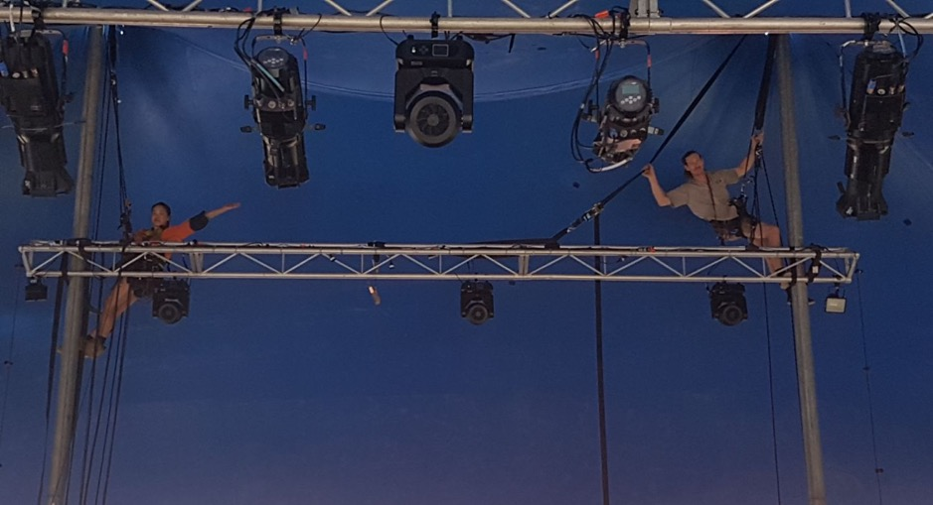
Scholarship recipient Mel Tan and TNA Program Producer Christian Schooneveldt-Reid. Image provided by Mel Tan.

Young People and the Arts

Visibility and Advocacy
TNA put considerable work behind our submission to the Federal Youth Engagement Strategy, starting conversations with multiple government stakeholders. A Federal youth advisory group for the creative industries was established, and Minister of the Arts gave $450,000 to Creative Australia to support youth engagement.

TNA continued to support the quarterly Performance with/for/by Young People Sector online gathering, hosted by Australian Theatre for Young People (ATYP). We also worked in partnership with ATYP to update our Performance With/For/By Young People Database, showcasing the great diversity of practice within the sector.

Youth arts representation at the Australian Performing Arts Forum (APAF) was prioritised through bursaries to attend, and pre-event resources to encourage youth arts delegates to be their own advocates.

ASSITEJ Advisory Committee
ASSITEJ International is the International Association of Theatre for Children and Young People, and TNA is the national centre for Australia, one of 83 centres globally. TNA members whose work involves children and young people automatically become members of ASSITEJ, and TNA keeps members updated and connected to international opportunities and information.

Established in 2020, TNA’s ASSITEJ Advisory Committee is made up of Theatre for Young Audiences and Youth Arts representatives from across the country. Together with ASSITEJ International President and Australian Representative, Sue Giles AM, we provide advocacy and leadership for the sector.

Committee members
Sue Giles AM (ASSITEJ International President & Australian Representative)

Kevin Du Preez (NSW)
John Marc Desengano (VIC)
Belinda Kelly (TAS)
Romi Kupfer (VIC)
Joshua Maxwell (NSW)
Fleur Kilpatrick (SA)
Fiona McDonald (QLD)

Directors in TYA International Exchange
Facilitated by TNA, Rita Pryce was selected through a competitive EOI process to be the Australian representative at the biennial Directors in TYA International Exchange, which took place from June 18–25 2023 in Marburg, Germany. 28 directors from all over the world travelled to Marburg for the exchange, which Australians have attended since 1984. Rita is a Kulkalgal and Kawrareg woman, born and raised in Zenadth Kes/Torres Strait Islands and based in Gimuy/Cairns, working as Artistic Director and CEO of the Pryce Centre for Culture and Arts. TNA secured funding from the Regional Arts Fund and Regional Arts Development Fund for Rita’s trip, as well as providing logistical support.

Youth Arts Chairs’ Network
TNA brought together 36 Chairs and Board members of youth arts and theatre for young audiences organisations in a newly formed network. Participants met for three online sessions for peer learning and discussion, with an emphasis on sharing best practices for governance and supporting the work of artists.

Youth Dance Australia
TNA continued and consolidated its support for Youth Dance Australia, a network of organisations and artists supporting best practice in dance with young people. TNA provided secretariat support for committee and sector meetings, payment for unsalaried committee members, and covered the costs of YDA’s website.

WA Consultation
TNA brought together the youth arts/theatre for young audiences sector in Western Australia for an online consultation session to inform a submission to the new WA Youth Action Plan. Following an in-person session in Perth, a submission was made in March 2024.

Networks and Connections
‘With TNA’s provocation considering legacy top of mind, this year’s forum is also inspired by the forums that came before, which were curated by some of the sharpest minds in our sector. This year, we continue a tradition of exchange—knowledge, ideas, practices, and provocations—that will shape the future of the performing arts sector.’
—Sanja Simić, Australian Performing Arts Forum Curator

Australian Performing Arts Forum (APAF)
In 2023, we held our seventh biennial national gathering, the Australian Performing Arts Forum (APAF), formerly known as the Australian Theatre Forum (ATF). Since 2009, we have run this gathering for the national performing arts sector, for arts organisations and artists across Australia. The iteration in 2023 was held in Brisbane during the Brisbane Festival, in partnership with Brisbane Powerhouse. 333 delegates attended.

For the program, TNA appointed Sanja Simić as Curator, and Emily Coleman as Associate Producer., Meredith Rehburg as Production Manager, Mik Hosking as Stage Manager, Sabella Segal as Stage Manager, Nadiah Idris as Event Co-ordinator, Soraya del Castillo as Access and Wellbeing Coordinator, and Claire Holland as Digital Co-ordinator.
‘Thank you for a brilliant APAF. As an indie delegate and early career artist, it was a privilege to be there and be among stimulating conversations. I just wanted to pass on how necessary it was for me to be there and how it has truly transformed my practice for the future.’
—Lachlan Driscoll

The provocation that underpinned the three days was ‘Considering Legacy’ with a day each looking at ‘today’, ‘tomorrow’, and ‘100 years from now’. Read the full program. Highlights included: the opening keynote ‘On Becoming Better Ancestors’ with a multi-generational panel of Aboriginal and Torres Strait Islander artists Hannah Belanszky, Sinsa Mansell, Rachael Maza AM and Chelsea Watego, moderated by Michelle Tuahine; peer-led breakout groups on co-designing the future of the arts; a keynote conversation on alternative realities with choreographer Maxine Doyle of Punchdrunk; and more. The program focused on artist-centred conversations, through artist-led assemblies, industry matchmaking, and spaces carved out for smaller group conversations.

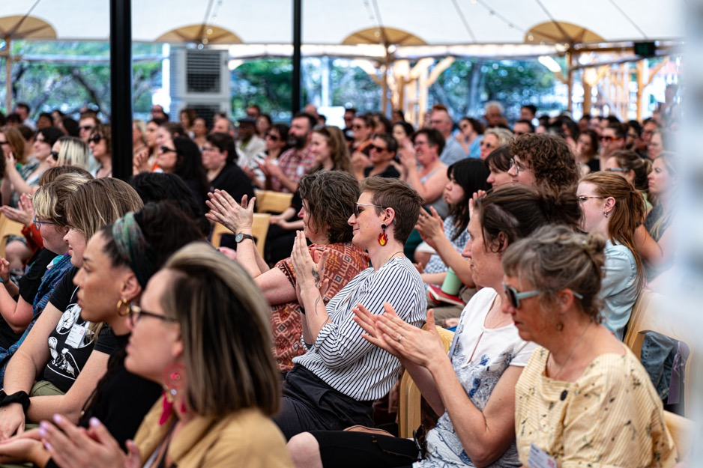
The Australian Performing Arts Forum 2023 delegates at the opening keynote ‘On Becoming Better Ancestors’. Image Credit: Jade Ellis.
Documentation from APAF, including recordings of sessions, such as ‘On Becoming Better Ancestors’ are available on the APAF website.
Alongside the TNA staff in attendance, TNA worked with the Victorian College of the Arts (VCA) to offer students in their final year of the Bachelor of Fine Arts (Theatre) a placement at APAF. The students gained an understanding of the sector ecology and the critical conversations occurring, while undertaking a range of tasks that supported the delivery of the event.

Arts Hub also reviewed the full program: Australia Performing Arts Forum 2023: An Overview and Summary.
‘Thank you, TNA, for all of the thought and planning that made the Australian Performing Arts Forum such a warm-hearted and inclusive experience. It was a true delight to connect & reconnect with colleagues with all the knowledge-sharing, learning and creativity it entailed outside of the day-to-day grind.’
—Belinda Locke

Access for Indies
In line with our Access and Equity objectives, TNA seeks to reduce the financial barriers experienced by many independent artists and producers in attending market development and professional development events. In 2023, we focused on supporting indies to attend our national performing arts gathering APAF.

113 indie delegates attended APAF, with registration fees heavily subsidised by TNA. Indie delegates were selected via an EOI process, with state-based panels convened to assess the EOIs. On behalf of delegates, we negotiated with state bodies and secured travel funding. 74 indies were supported with a travel/accommodation bursary, with indies from some states also receiving fees and per diems to attend. Excluding Brisbane-based indies who did not require travel support, 83% of indies received a travel bursary to attend APAF. In our feedback, indie delegates stressed how essential the bursary was in enabling them to attend.

‘Being an independent artist, who also works voluntarily as the AD of a small, mostly unfunded youth dance company means that I'm often not able to travel for summits or conferences such as this.’
— Kyall Shanks, Independent/Yellow Wheel

Of the indie delegates, 5.3% of indies were First Nations, more than the 3.2% estimate for the general Australian population. 17.7% of indies identified as disabled, above the 13% of people who are Deaf or Disabled in the working age population. 28.3% of indies were based regionally, equal to the 29% in the general population who live regionally. 28.3% of indies identified as Culturally and Linguistically Diverse, below the 42% in the national population.

A breakout group at The Australian Performing Arts Forum 2023. Image Credit: Jade Ellis.

Membership
TNA membership grew to 595 in 2023 (up 4.9% from 2022), including a net gain of 12 organisations and 16 independents. Increase in membership was distributed across artforms and states.

Our 384 individual members made up 65% of membership, continuing our strong subscriber base within the independent sector.

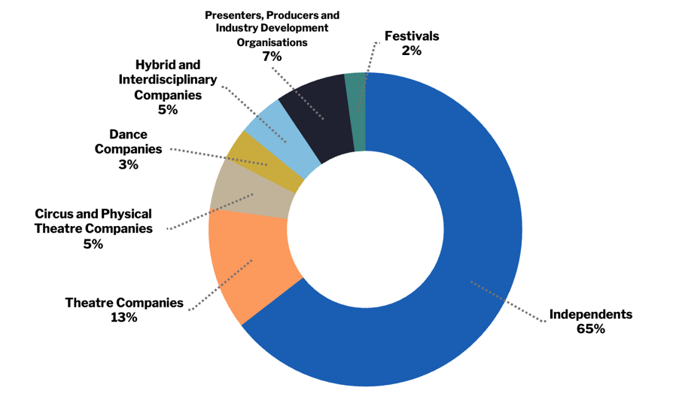
TNA 2023 membership breakdown by artform.

‘I am grateful for the significant role that TNA plays in bringing people together, facilitating learning opportunities, and meaningfully promoting and advocating for artists and arts workers. TNA are a great bridge, between people, ideas, and to new ways of doing things.’
—Kam Greville, Arts Wellbeing Collective

Awards
As part of our commitment to supporting artists across the sector, TNA supported a number of awards, including awards by Melbourne Fringe and the National Institute of Circus Arts (NICA). Each awardee received free TNA membership, mentoring and hot-desking. The NICA Outstanding Student Leader award included a CaPT Committee Observership opportunity for a final year student.

Melbourne Fringe Awards 2023
- Innovation in Circus
Le Freak, Themme Fatale and Elle Diablo, with Sarah Birdgirl, Dale Woodbridge-Brown, and Bella de Jac, produced by Olly Lawrence
- Innovation in Dance
~~~~~ “…derelict in uncharted space…”, Fayen d’Evie and Benjamin Hancock
- Innovation in Theatre
A Dodgeball named Desire, Bloomshed

NICA Awards 2023
- The NICA Outstanding Student Leader Award 2023
Amy Stone
- The NICA Graduate Award 2023
Grace Robins

Brisbane Dance Drinks
TNA, with support from Board member Liesel Zink, hosted an informal gathering for dance and physical theatre artists in Brisbane in June. Twenty people joined us at Metro Arts for drinks, followed by a performance of Break by Cecilia Martin and The Farm.

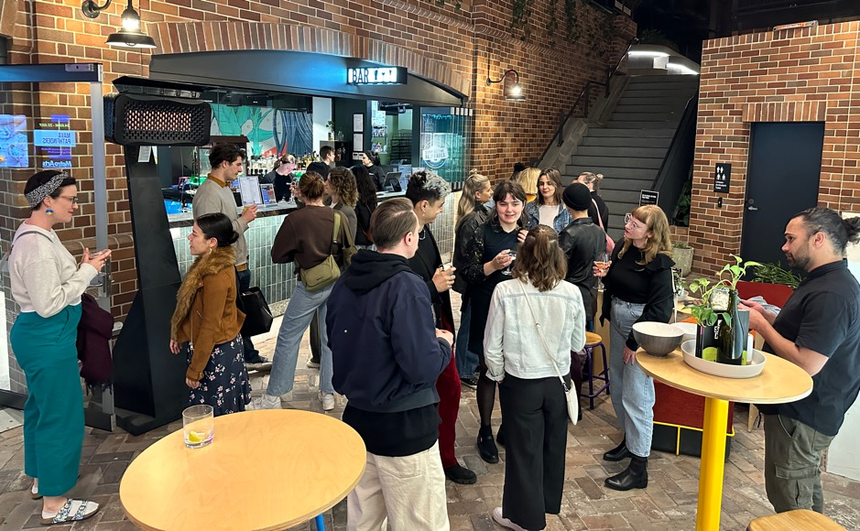
Brisbane dance drinks. Image credit: Joshua Lowe.

Research and Resources

Salary Survey Report for Not-for-Profit Small to Medium Arts Organisations
The Salary Survey Report captures the salaries, benefits, professional development budgets, tenure, and representation of small to medium organisations in the arts sector. In addition to benchmarking, it advocates for remuneration that is in line with similar roles in other sectors.
This is the eighth time that TNA has conducted this survey, which garnered 102 valid responses in 2023. The 2023 Report found that the salaries of all surveyed roles has increased since our 2021 Salary Survey report. Despite economic strain during the pandemic, 73.5% of organisations increased the salary of at least one staff member in the last year.

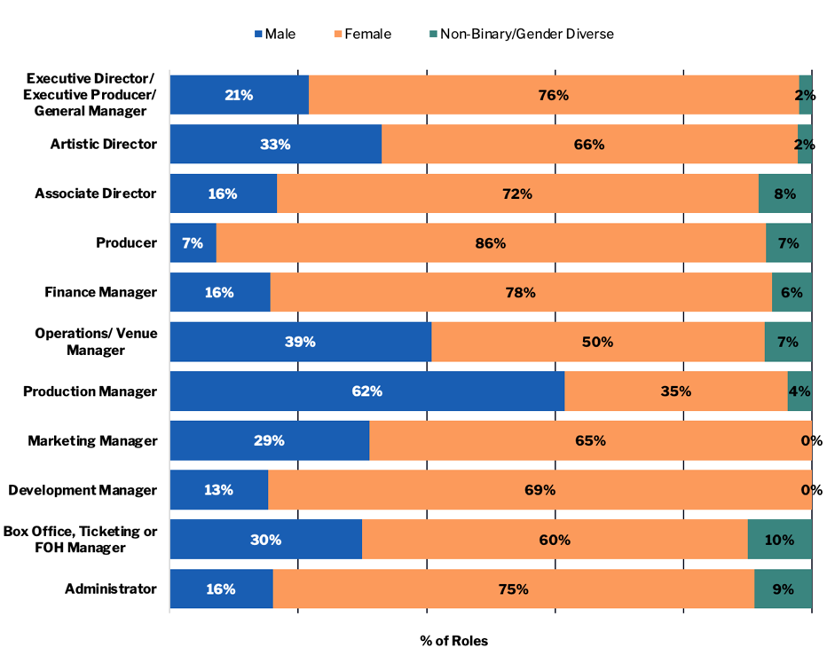
Gender representation per position from TNA’s 2023 Salary Survey Report.

Resources for the Sector
TNA continues to provide an extensive open-access library of sector-specific databases and resources. In 2023, our databases included:

- Policy Database: for performing arts organisations when developing their own policies, plans, and procedures.
- CaPT Performing Companies Database: a database of Australian Circus & Physical Theatre (CaPT) performing companies.

- Australian Youth Circus Sector (AYCS) / training database: for Australian youth circuses, circus schools and training centres.

- Performing with/ for / by Young People Companies: a database of companies that create and present artistic work with, for, and/or by young people.
- Producers’ Database: for independent performing arts producers who support independent artists, independent collectives, and independent companies.

- Designers’ Database: a response to the gender inequity within technical design in the performing arts, this list of female, non-binary and trans designers is intended as a resource for theatre companies, collectives, and individuals to hire more diversely in these areas.

- TNA sector resources: a range of resources collected by TNA to assist performing arts organisations and independents.

- CaPT Resources: a list of Circus and Physical Theatre resources, including TNA’s Contracts in Circus, and Parenting in Circus guide.

- TNA Member List: a list of all current TNA members by artform.
'We use your amazing Producer Database all the time! Such a great resource.’
—Selene Bateman, Auspicious Arts Projects

Reach

2023 Activities
National conferences 1
Peer learning & mentorship programs 5
VIPI/CIPI salons 4
CIPI Emerging Producer Labs 6
LeaderShift sessions 14
Member consultations and advice 283
Formal Presentations by staff 12
Sector support and advocacy meetings 5
Meetings with other peak bodies and service organisations 35
Industry surveys 1
Policy and resource listings 148
Media coverage 17
Government submissions 6

Participants
APAF 342
VIPI/CIPI Salons 75
CIPI Producers 4
LeaderShift 25
Youth Arts Chairs’ Network 36
Committee Members 25
Members & Artists in TNA Listings 921
TNA Member of the Month, ‘Behind the Scenes’ Vision Australia Radio 10

Recipients: Awards, Grants & Bursaries
APAF Supported Indies 113
Unlocking Capacity grants (through Creative Victoria) 7
TNA sponsored awards 6
Rigging Bursaries 10
Rigging Scholarships 2
First Nations Emerging CaPT Mentorship 1
NICA Observer placement 1
TYA Directors Seminar (Germany) 1
Communications
‘TNA's monthly newsletters are like the social pages for our sector.
I really do look forward to them so much each month.’
—Ilana Russell, Platform Arts

Keeping the Sector Connected
TNA continued to deliver targeted and timely communication to artists and companies via email and across our digital platforms. In 2023, we began to consider what ways and means to communicate TNA updates, and sector updates to the sector most efficiently. This consideration meant discontinuing our profile on ‘X’, previously known as Twitter, and communicating more on LinkedIn, where we noticed greater engagement in the sector.

In 2023, we added 170 subscribers to our monthly E-News, with our impressive open rate continuing to grow, peaking at 60%. Our ASSITEJ Bulletin subscribers increased by 16% and our CaPT Bulletin subscribers increased by 23%.

In addition, TNA sent out many member-only or special bulletins to specific segments of our database.

TNA was mentioned in the media at least 12 times in 2023.

Audience
E-News Subscribers 4,405
CAPT Bulletin Subscribers 903
ASSITEJ Bulletin Subscribers 1,091

Total Social Media Followers 7,562
Facebook 3,771
Instagram 2,593
LinkedIn 1,198

Communications
Number of E-News 12
Number of CAPT Bulletins 6
Number of ASSITEJ Bulletins 3
Member-Only Bulletins 9

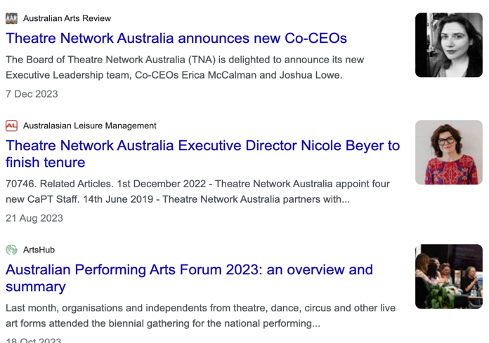

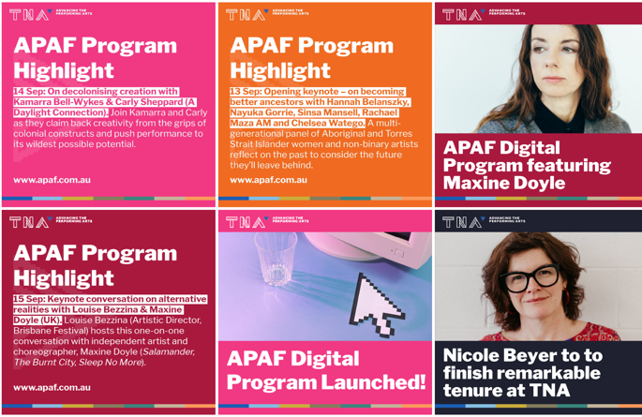
Screenshots of TNA in the media, and TNA’s Instagram posts.

Behind the Scenes — Vision Australia Radio
TNA’s monthly radio spot on Vision Australia’s ‘Behind the Scenes’ program, hosted by Chris Thompson, continued to update the sector and champion artists. Our ‘Member of the Month’ guests in 2023 were: Jascha Boyce, Liesel Zink, Aseel Tayah, Samantha Martin, Daniel Riley, Maryanne Sam, Sukhjit Khalsa, Sanja Simić and Emily Coleman for the Australian Performing Arts Forum, Melinda Hetzel, Alysha Herrmann, and Nicole Beyer.

Governance and Management

Operations
In 2023 TNA received $498,993 over two years from Creative Australia for a range of circus and physical theatre capacity building initiatives, alongside our existing multi-year funding from Creative Australia and Creative Victoria. Together with the Australian Performing Arts Forum (APAF), this represented a large increase in TNA’s operations and programming.

TNA’s four new part-time staff, employed to work on the circus and physical theatre initiatives over 2023 and 2024: Lauren Swain, Christy Flaws, Christian Schooneveldt-Reid, and Charice Rust. TNA was also joined for part of the year by APAF Curator Sanja Simić, and APAF Associate Producer, Emily Coleman.

December 2023 of course saw the departure of founding CEO Nicole Beyer, with Co-CEO’s Erica McCalman and Joshua Lowe (TNA General Manager) appointed to start in January 2024.

Governance
2023 saw quite a bit of movement on the TNA Board as we farewelled Zainab Syed and Robyn Gawenda, and welcomed Liesel Zink, Carin Mistry, Tim Stitz, Anthony Peluso, and Emily Coleman. The Board were tasked with managing the CEO recruitment and staff transition management plan, during which time Erica McCalman took a leave of absence from the Board and her role as Chair, being replaced as Interim Chair by Sue Giles.

TNA’s 2023 Board and Advisory Committees collectively have representation from all eight states and territories, as well as regional and remote members. Board members who are independent creatives and arts workers continue to be paid for each meeting attended under our Independent Sitting Fee.

Following the 2022 Board review, the Board successfully trialled moving to four meetings a year, while adding a number of new subcommittees to promote deeper engagement in specific governance matters.

Finances
TNA’s total revenue in 2023 was $1,119,101, up from $848,895 in 2022 due primarily to increased income from APAF, and the CaPT strategic initiatives funding.

TNA received $498,993 over the two-year period (2023–2024) from Creative Australia to support several new CaPT initiatives, including four new part-time staff for the CaPT program. APAF attracted $145,469 of additional funding, $75,469 of which went directly to artists as bursaries to attend, as well as $90,196 in registration fees. TNA membership income grew 11% to $68,385.

TNA posted a surplus in 2023 of $19,266. The Board had approved a deficit budget to invest some reserves from previous years in more activity, however with some conservative budgeting and higher income than anticipated we achieved a surplus.

A Climate for Art
With the growing climate crisis, TNA signed up as a pledged member of A Climate for Art, a fossil fuel divestment campaign for the arts industry organised by independent producers and VIPI alumni, Lana Nguyen and Eliki Reade. As part of this pledge, TNA moved its banking from ANZ to Bank Australia in 2023. Our email to ANZ CEO Shayne Elliott outlining why we were divesting from ANZ received an immediate reply.

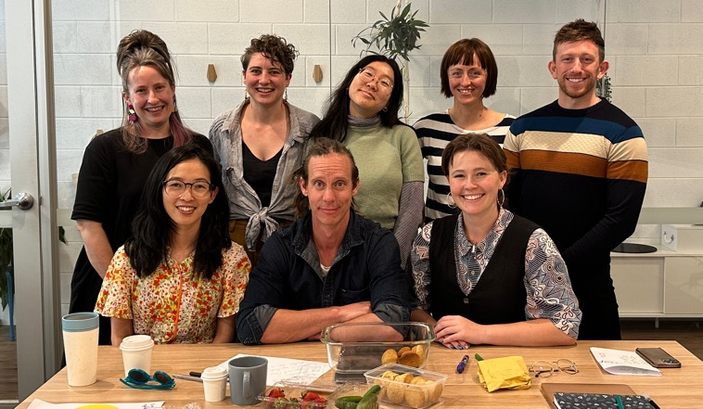
TNA Staff at end of year meeting. Image Credit: Nicole Beyer.

Staff
Nicole Beyer – Executive Director
Joshua Lowe – General Manager
Steph Speirs – Program Manager, CaPT and Events
Yuhui Ng-Rodriguez – Manager, Sector Development & Membership
Wen-Juenn Lee – Manager, VIPI & Communications
Christy Flaws – Program Producer, CaPT Strategy
Lauren Swain – Program Producer, Australian First Nations Circle
Christian Schooneveldt-Reid – Program Producer, Safe & Sustainable Circus Rigging
Charice Rust – Program Producer, CIPI

Casual & Contract Staff
Sam Ryan of SAYSO – Financial Management
Melinda Hetzel – Administrator
Carmen Lai – Administrator

APAF 2023
Sanja Simić – Curator
Emily Coleman – Associate Producer
Meredith Rehburg – Production Manager
Mik Hosking – Stage Manager
Sabella Segal – Stage Manager
Nadiah Idris – Event Co-ordinator
Claire Holland – Digital Co-ordinator
Soraya del Castillo – Access and Wellbeing Coordinator

Board
Sue Giles AM – Interim Chair
Cassie McGannon – Deputy Chair
Lou Oppenheim – Treasurer
Emily Coleman
Caroline Bowditch
Alex Desebrock
Carin Mistry
Nithya Nagarajan
Anthony Peluso
Tim Stitz
Liesel Zink

Life Members
Simon Abrahams
Sarah Austin
Alice Nash
Bethany Simons
Jill Smith AM
Brad Spolding
Nicole Beyer

2023 Partners
TNA works in a multitude of ways to support the sector, including partnering in big and small ways with our colleagues from other organisations. The following list includes organisations we connected with in 2023 to present an event, produce outcomes, or worked with to provide resources, awards, or other sector support.

Advocacy Networks & Partners
National Peak Body Consortium
Arts Industry Council Victoria (AICV)
A New Approach
Australian Theatre for Young People
Media, Entertainment & Arts Alliance (MEAA)
Screen Australia

Project Partners
ASSITEJ International
Australian Performing Arts Market (APAM)
Australian Theatre for Young People (ATYP)
Brisbane Powerhouse
Brisbane Festival
Creative Australia
Creative Victoria
Creative Victoria’s Healthy Workplaces Advisory Group
Melbourne Fringe
National Institute of Circus Arts (NICA)
Vision Australia Radio ‘Behind the Scenes’
Youth Dance Australia

Research And Education Partners
Deakin University’s Arts and Cultural Management Program
University of Melbourne

Funding Partners
Creative Australia
Creative Victoria
City of Melbourne – Creative Spaces
Arts Queensland
Arts South Australia
Arts Tasmania
Create NSW

Contact Us
www.tna.org.au

Facebook: @theatrenetworkaustralia
Instagram: @theatrenetworkaustralia
LinkedIn: www.linkedin.com/company/theatre-network-australia

G5/152 Sturt Street, Southbank VIC 3006
03 9947 1015
info@tna.org.au

